RESER STADIUM – First Floor
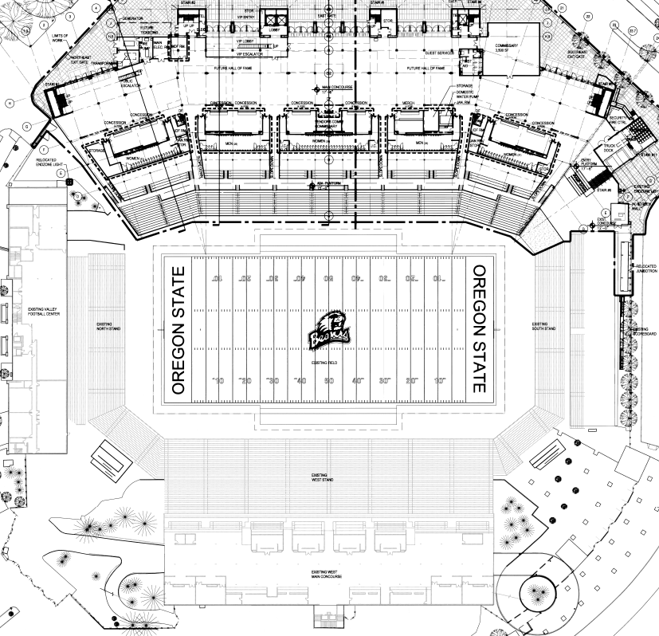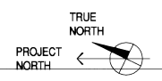
RESER STADIUM
EAST SIDE
MAIN CONCOURSE – 1ST FLOOR
CONCESSIONS

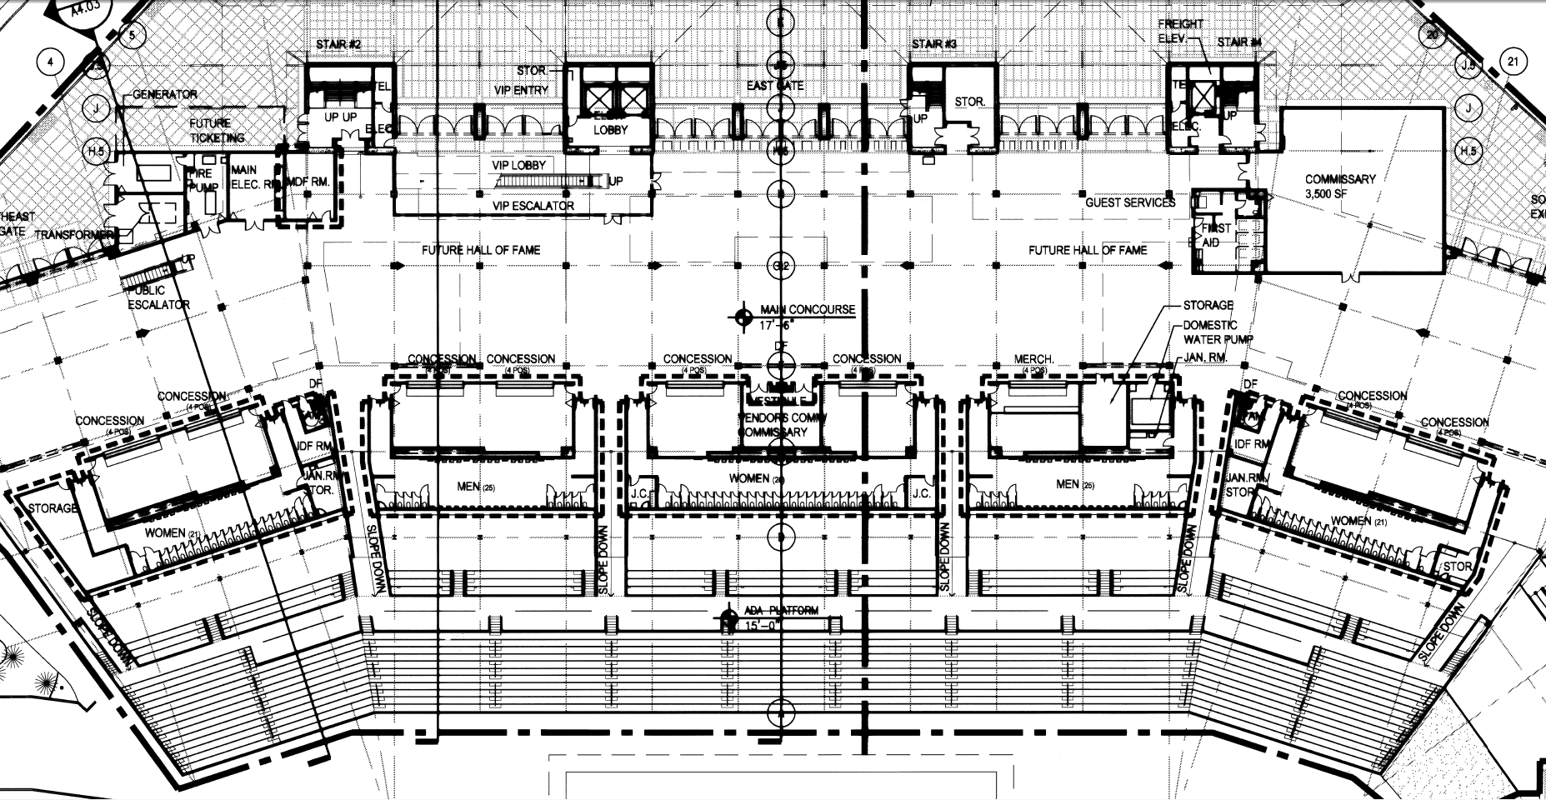

RESER STADIUM
EAST SIDE
MAIN CONCOURSE – 1ST FLOOR
CONCESSIONS - NORTH END (ENLARGED)

7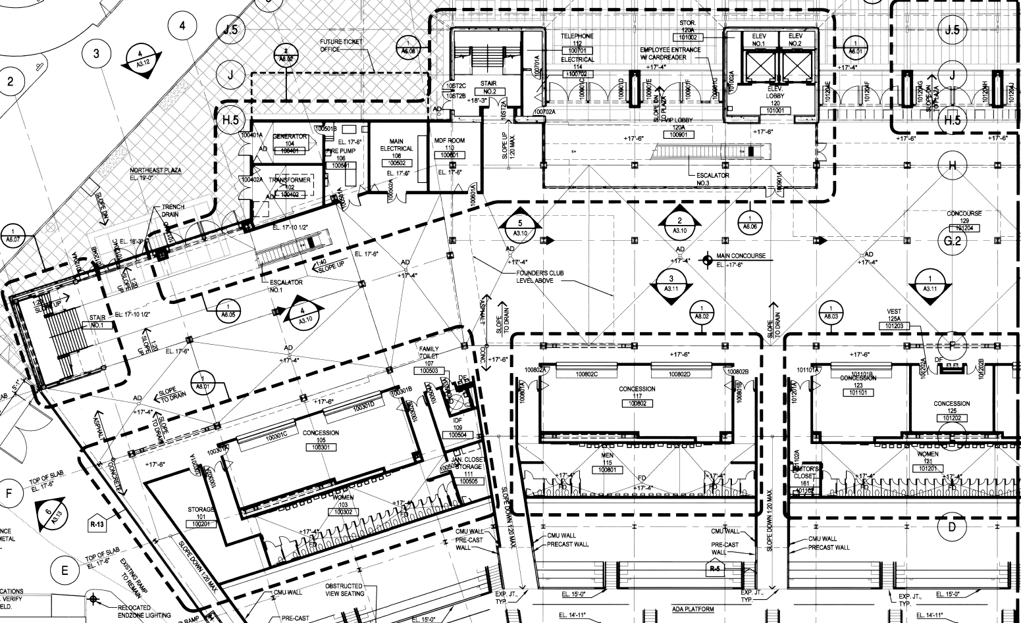

RESER STADIUM
EAST SIDE
MAIN CONCOURSE – 1ST FLOOR
CONCESSIONS - SOUTH END (ENLARGED)

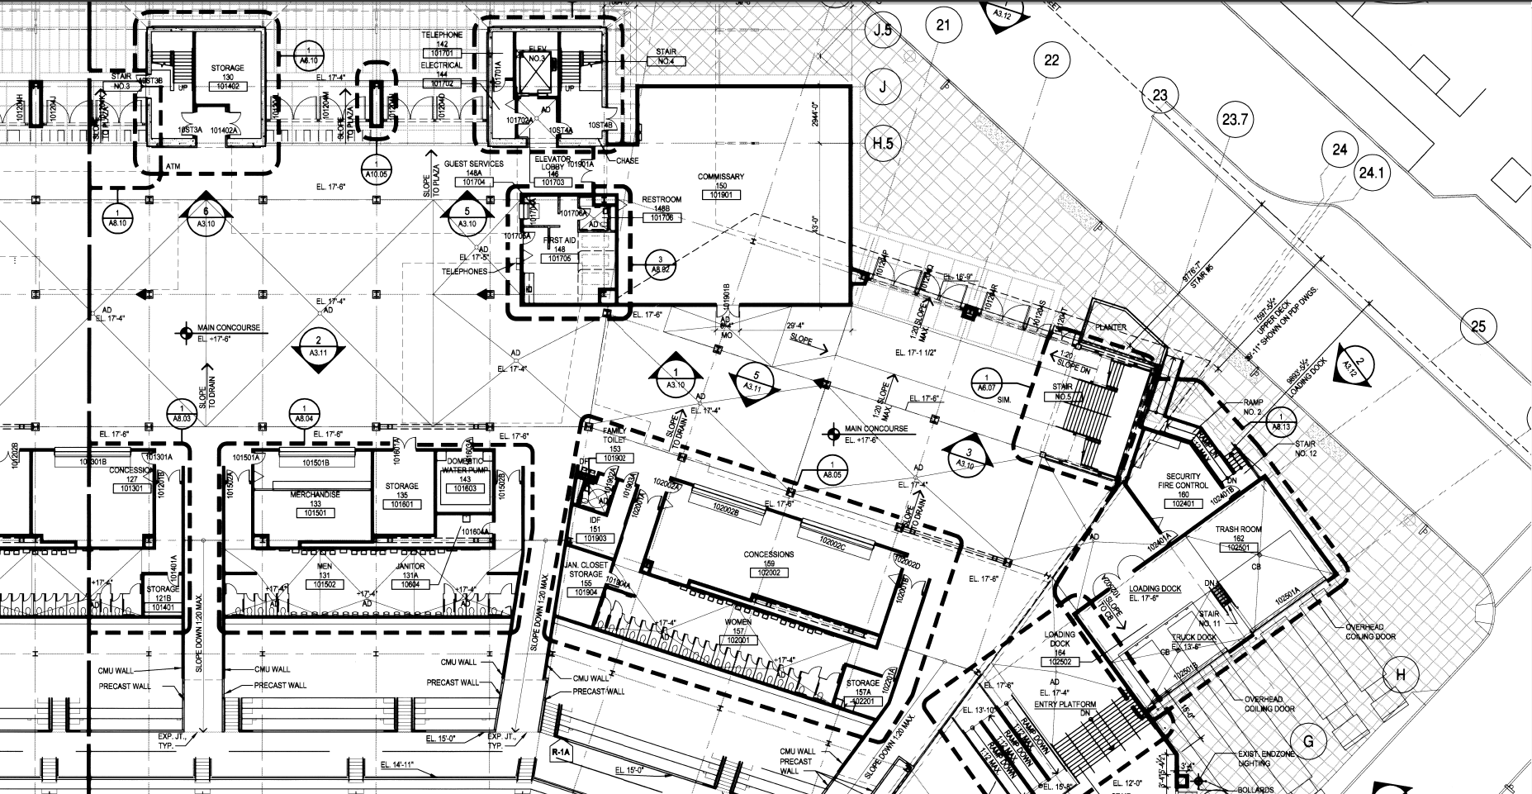

RESER STADIUM
EAST SIDE
MAIN CONCOURSE – 1ST FLOOR
CONCESSIONS - CONCESSION ROOM 105 (ENLARGED)

RESER STADIUM
EAST SIDE
MAIN CONCOURSE – 1ST FLOOR
CONCESSIONS - CONCESSION ROOM 117 (ENLARGED)

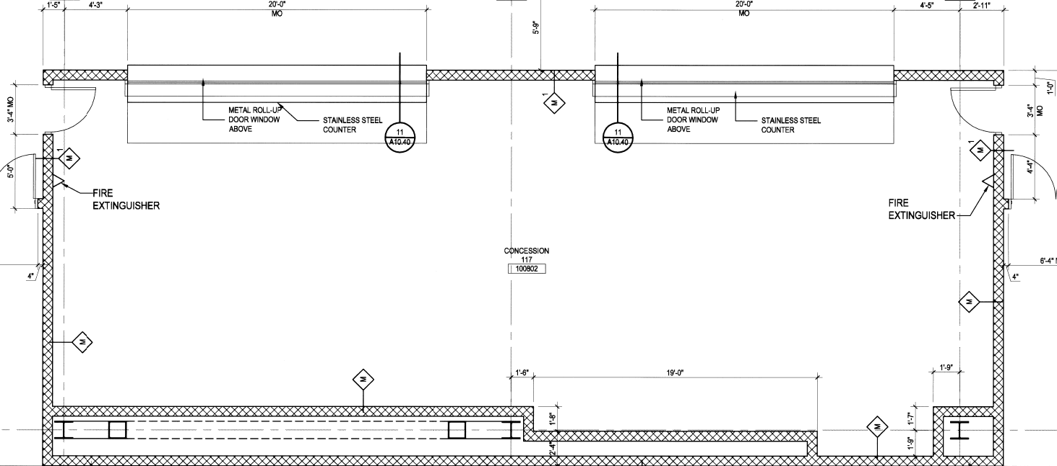

RESER STADIUM
EAST SIDE
MAIN CONCOURSE – 1ST FLOOR
CONCESSIONS - CONCESSION ROOM 123, 125 & 127 (ENLARGED)

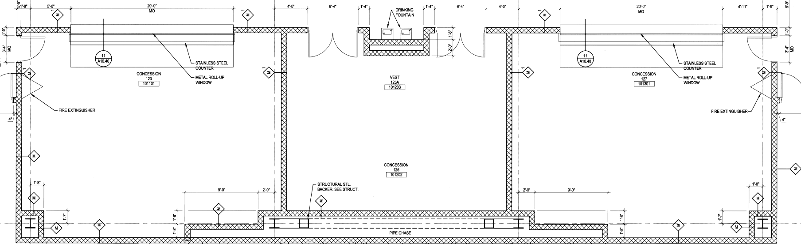

RESER STADIUM
EAST SIDE
MAIN CONCOURSE – 1ST FLOOR
CONCESSIONS - CONCESSION ROOM 159 (ENLARGED)

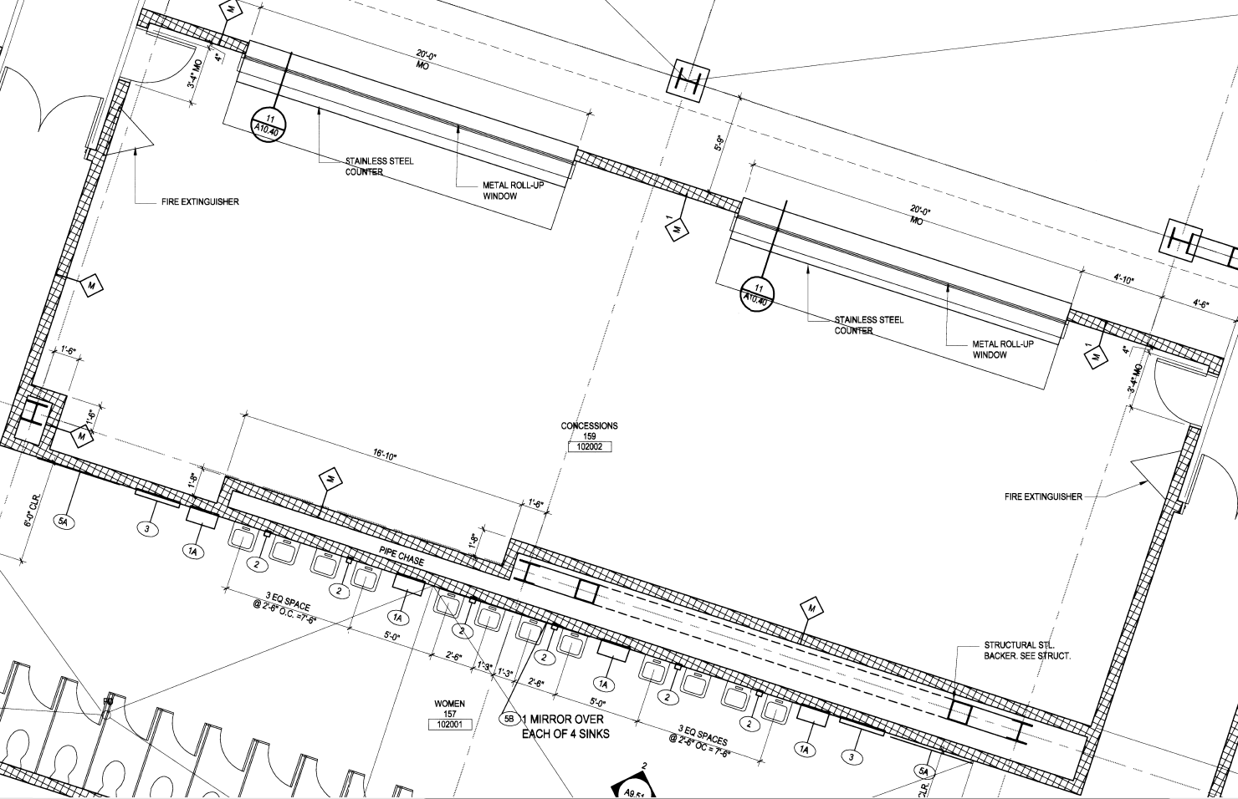

RESER STADIUM
EAST SIDE
FOUNDERS LOGE – 2ND FLOOR

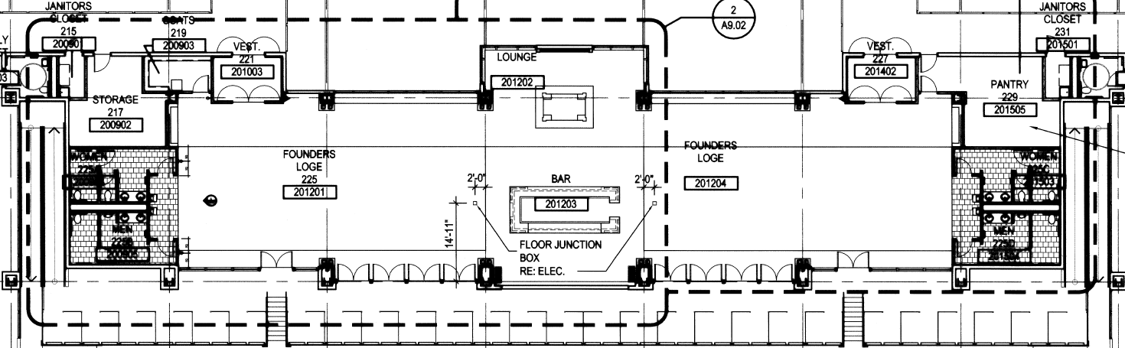

RESER STADIUM
EAST SIDE
FOUNDERS LOGE – 2ND FLOOR
NORTH END (ENLARGED)

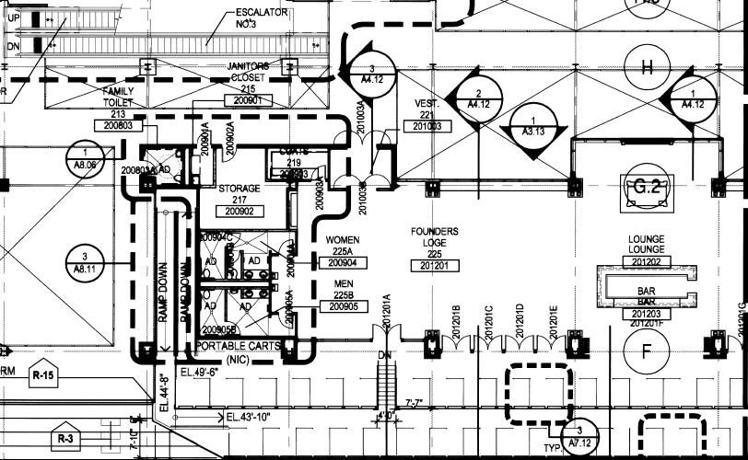
RESER STADIUM
EAST SIDE
FOUNDERS LOGE – 2ND FLOOR
SOUTH SIDE (ENLARGED)

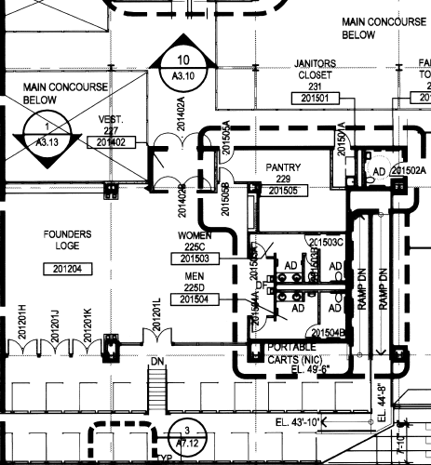
RESER STADIUM
EAST SIDE
FOUNDERS LOGE – 2ND FLOOR
PANTRY 229 (ENLARGED)

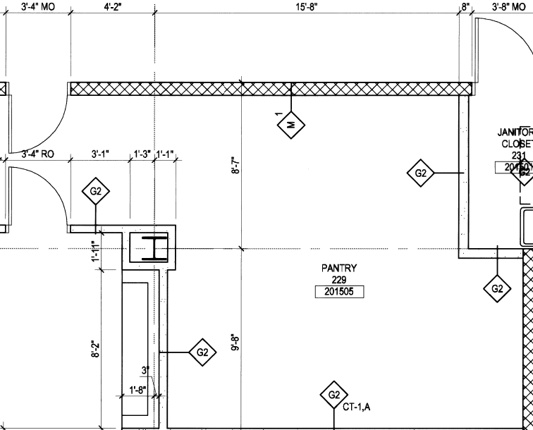

RESER STADIUM
EAST SIDE
CLUB LEVEL – 3RD FLOOR

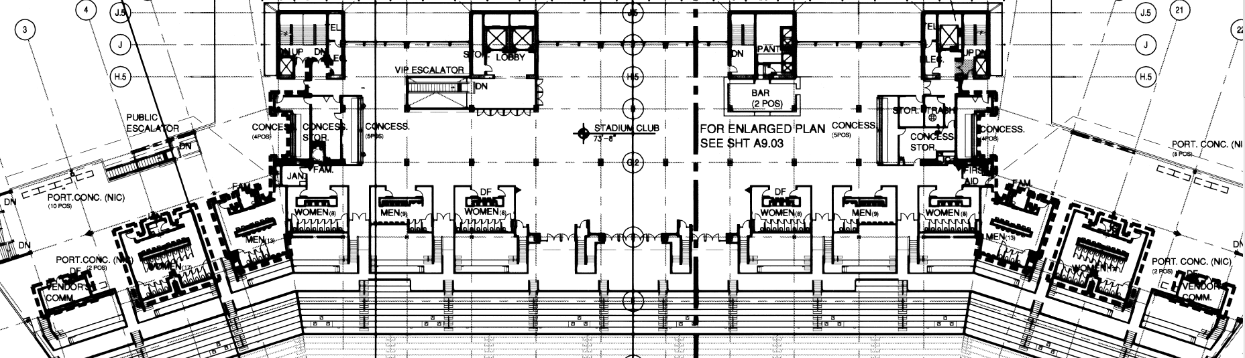

RESER STADIUM
EAST SIDE
CLUB LEVEL – 3RD FLOOR
NORTH END (ENLARGED)

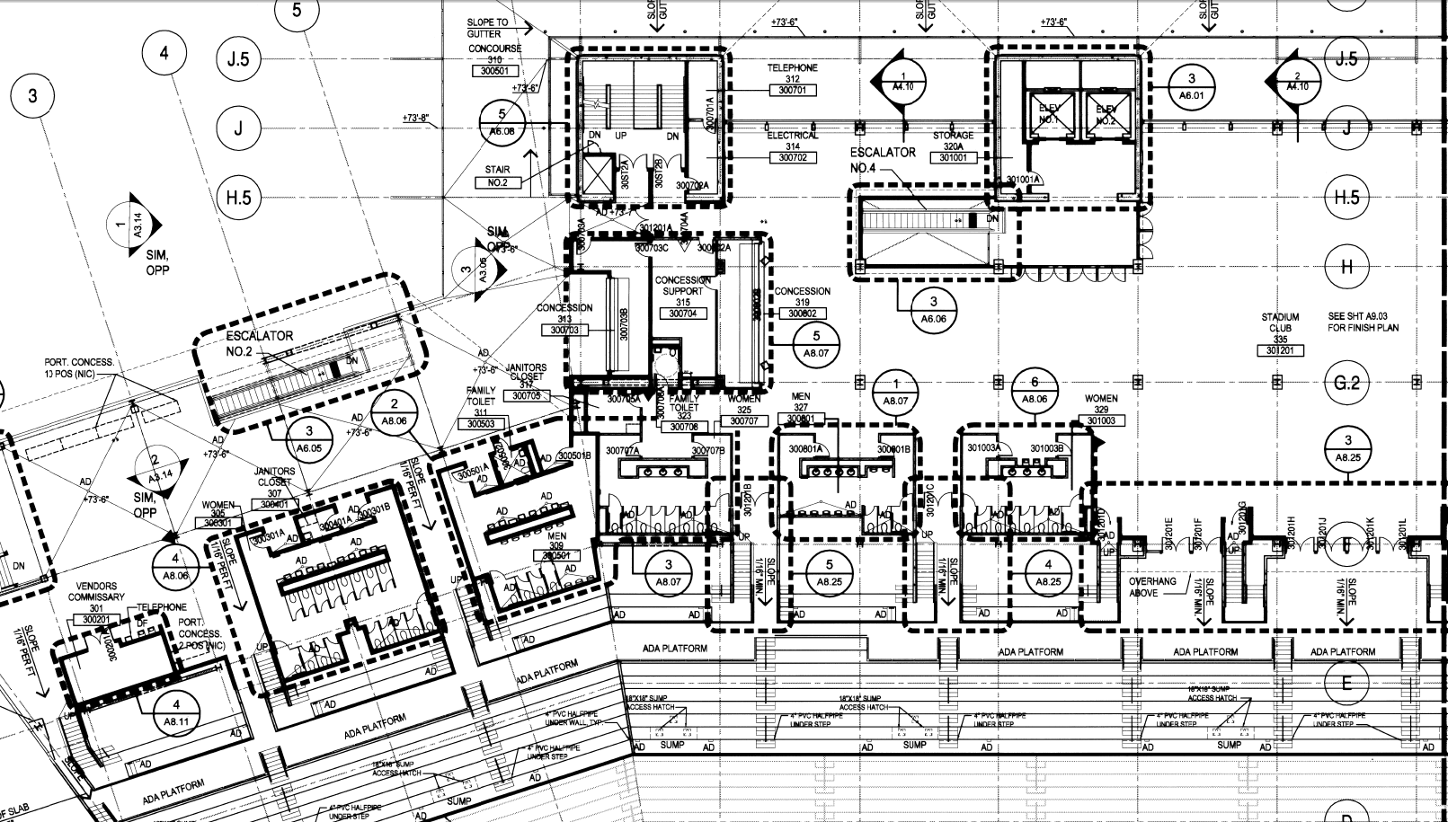

RESER STADIUM
EAST SIDE
CLUB LEVEL – 3RD FLOOR
SOUTH END (ENLARGED)

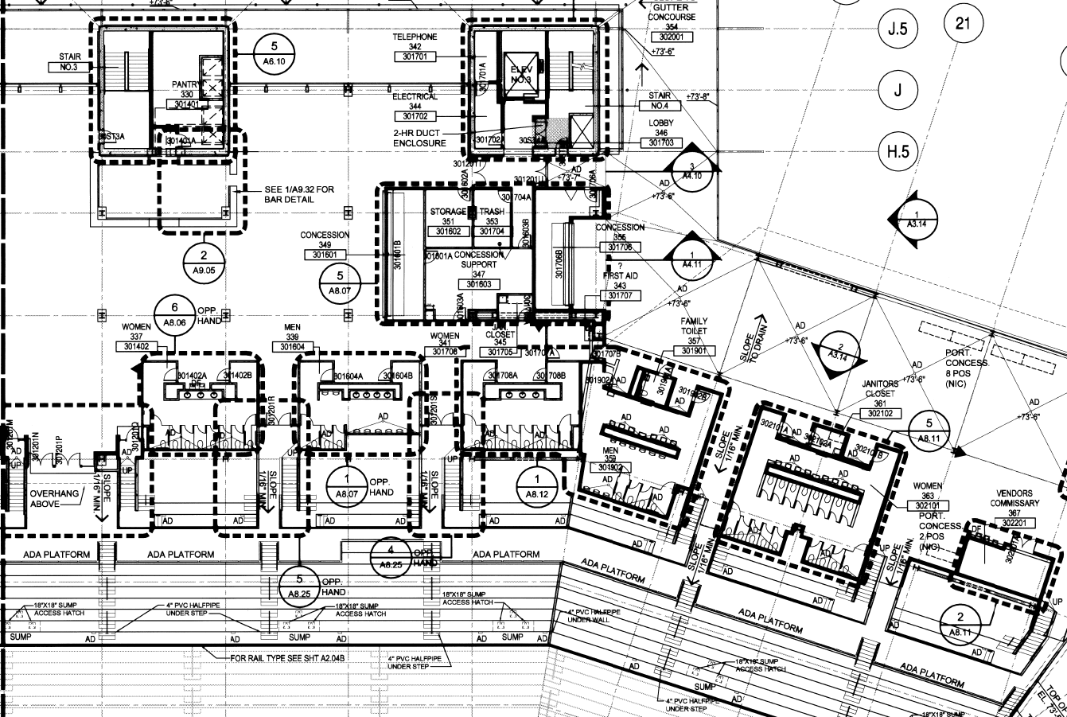

RESER STADIUM
EAST SIDE
CLUB LEVEL – 3RD FLOOR
CONCESSION 313, CONCESSION SUPPORT 315 & CONCESSION 319 (ENLARGED)

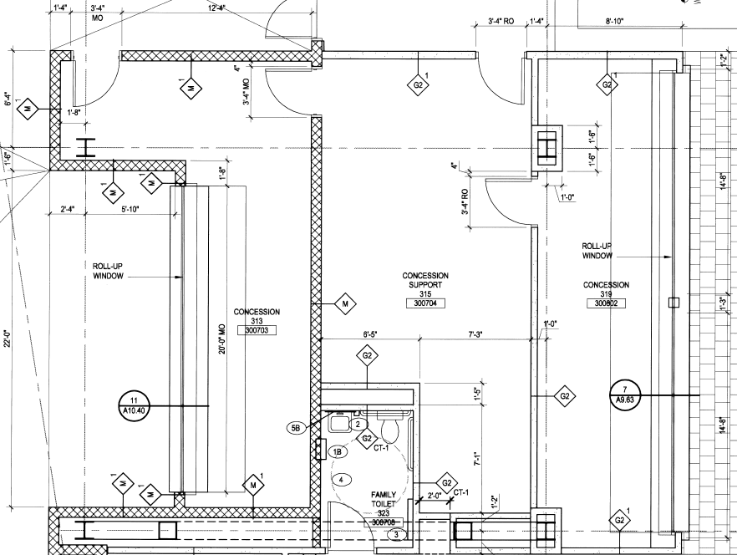

RESER STADIUM
EAST SIDE
CLUB LEVEL – 3RD FLOOR
PANTRY 330 (ENLARGED)

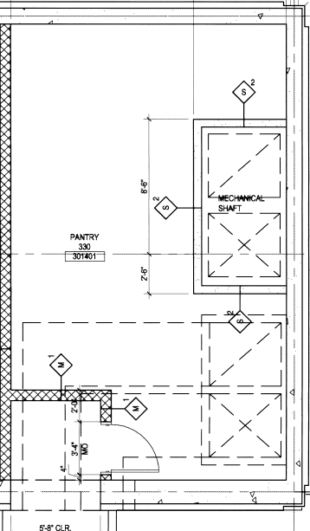

RESER STADIUM
EAST SIDE
CLUB LEVEL – 3RD FLOOR
CONCESSION SUPPORT 347 & CONCESSION 355 (ENLARGED)

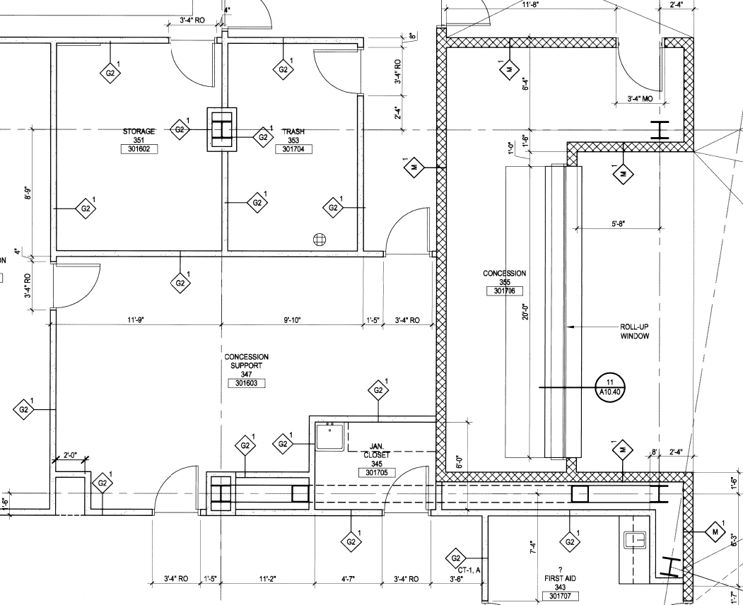

RESER STADIUM
EAST SIDE
SUITE LEVEL – 4TH FLOOR

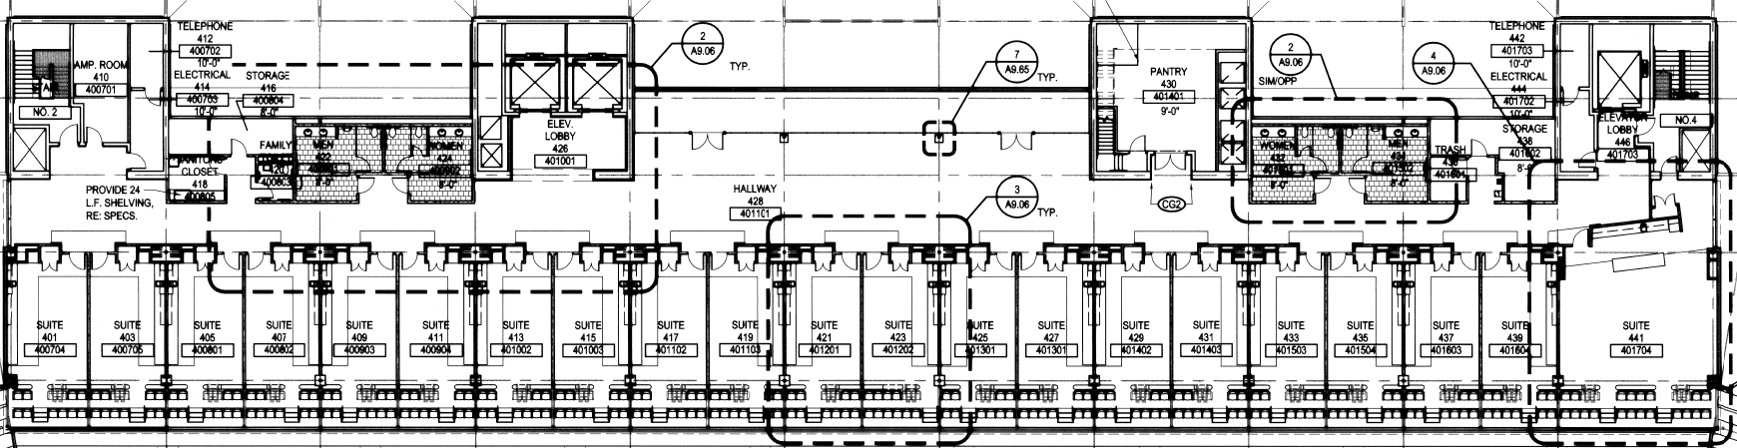

RESER STADIUM
EAST SIDE
SUITE LEVEL – 4TH FLOOR
PANTRY 430

RESER STADIUM
WEST SIDE
SUITE LEVEL – 4TH FLOOR

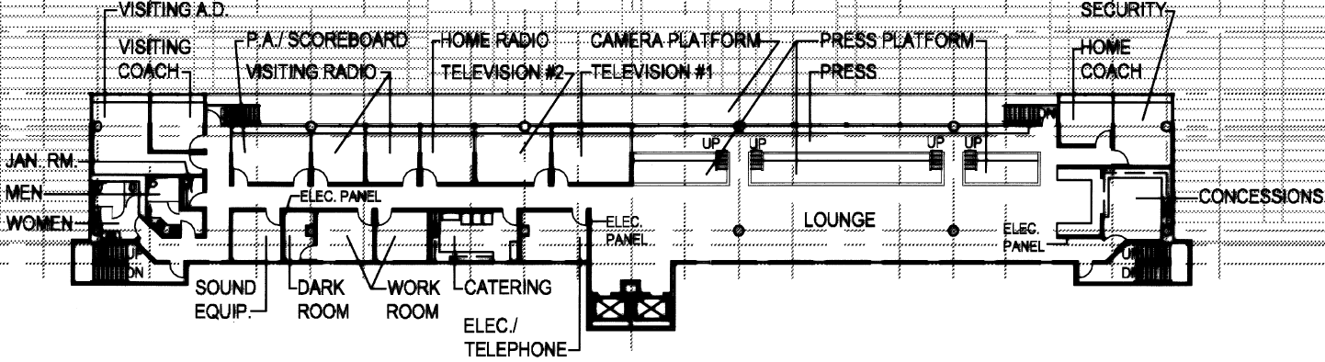

RESER STADIUM
SOUTH SIDE
MAIN CONCOURSE – 1ST FLOOR

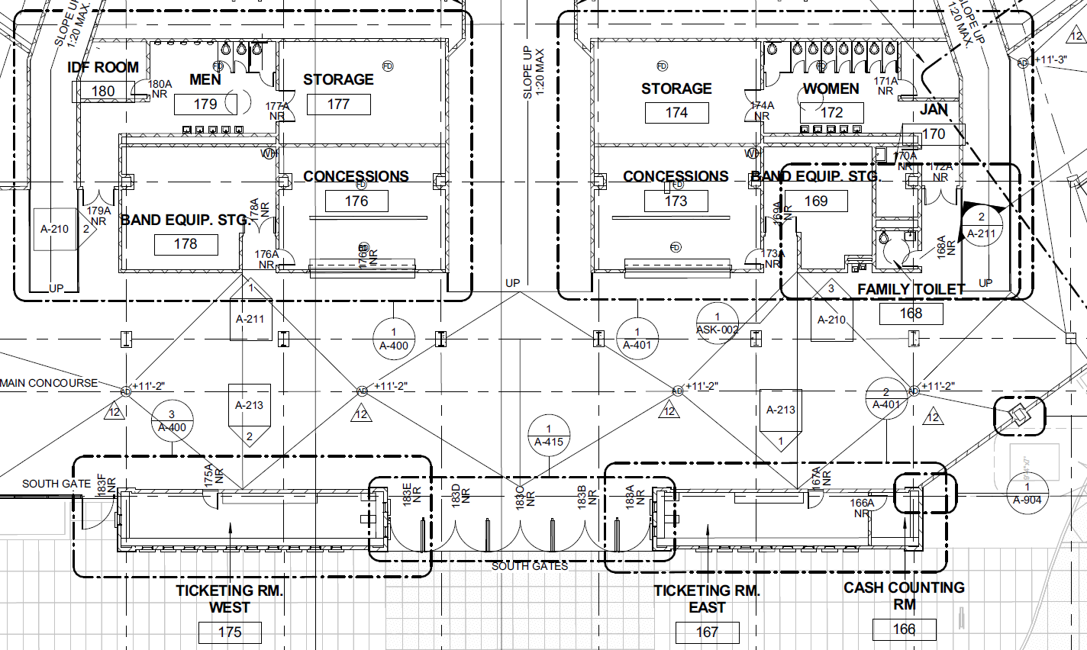

RESER STADIUM
NORTH SIDE
VALLEY FOOTBALL CENTER – 3RD FLOOR

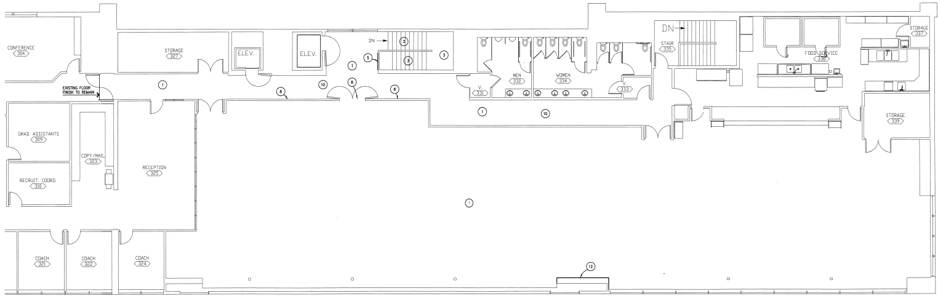

MERRIT TRUAX INDOOR PRACTICE FACILITY
WEST SIDE

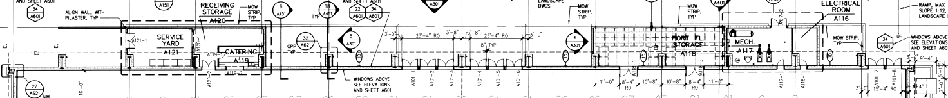

CATERING A119 & RECEIVING STORAGE A120 (ENLARGED)

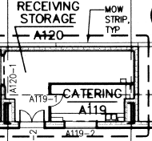

GILL COLISEUM
EAST SIDE
1ST FLOOR

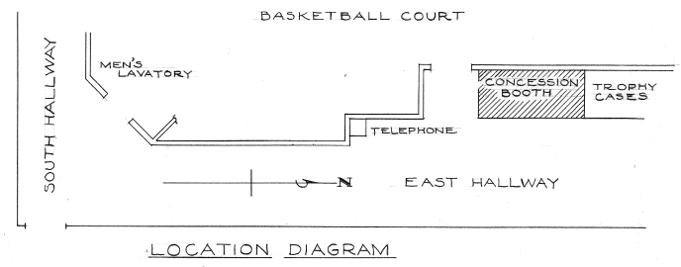

CONCESSION BOOTH (ENLARGED)

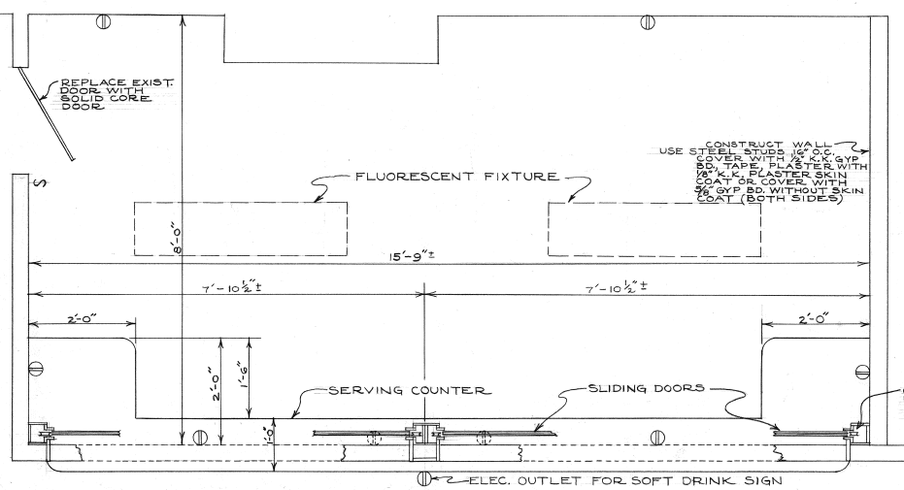
GOSS STADIUM
NORTH SIDE
1ST FLOOR CONCESSION AREA (ENLARGED)
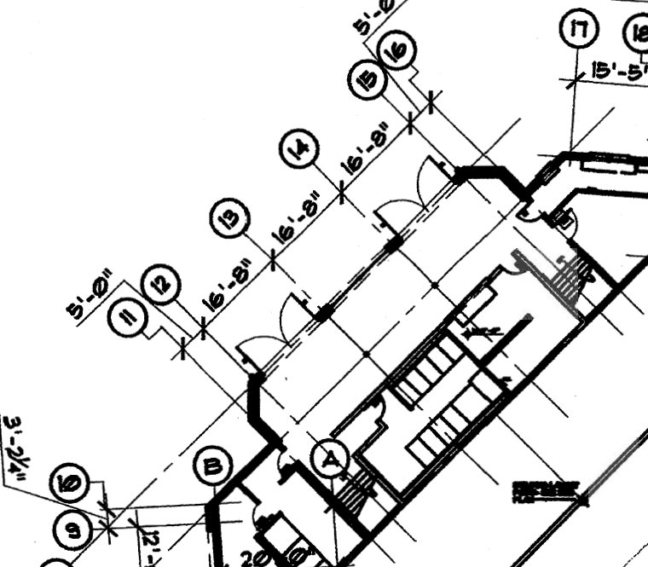
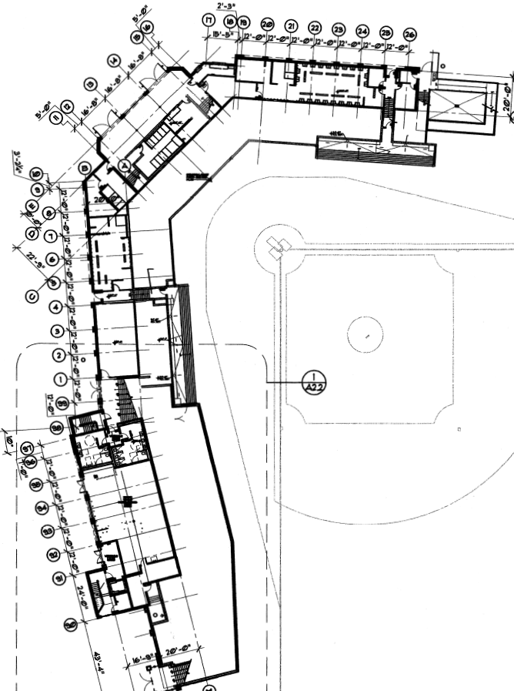

FUTURE GOSS EXPANSION DECK – SPRING 2015
