

**REQUEST FOR PROPOSAL**

**No. TG168647**

**Athletic Facilities**

**Concession and Catering Services**

**PROPOSAL DUE DATE AND TIME:**

February 26, 2015 (3:00 PM, PT)

OSU Procurement, Contracts and Materials Management Offices are open Monday through Friday 8:00 am-12:00 noon and 1:00 pm-5:00 pm.

Offices are closed during the 12:00 noon-1:00 pm lunch hour.

**SUBMITTAL LOCATION:**

Oregon State University

Procurement, Contracts and Materials Management

644 SW 13th Avenue

Corvallis, Oregon 97333

**1.0 GENERAL**

1.01 SCHEDULE OF EVENTS

* Issue Date January 8, 2015
* Pre-Proposal Conference January 22, 2015 (9:00 am, PT)
* Deadline for Requests for Clarification or Change February 5, 2015 (5:00 pm, PT)
* Proposal Due Date and Time February 26, 2015 (3:00 pm, PT)

This Schedule of Events is subject to change. Any changes will be made through the issuance of Written Addenda.

## 1.02 PRE-PROPOSAL CONFERENCE

## A **mandatory** pre-proposal conference will be held on January 22, 2015 (9:00 am, PT) at Reser Stadium, east side Founder’s Loge in Corvallis, Oregon. The east side Founder’s Loge is on the 2nd floor of Reser Stadium and can be accessed through the east side elevator. The mandatory pre-proposal conference will be followed by a walkthrough of the athletic facilities that are the subject of this Request for Proposal. Please bring a copy of the Request for Proposal with you to the pre-proposal conference for reference.

## Please allow plenty of time to park in the Reser Stadium parking lot. Vistor parking permits are $10 for the day. Permits may be purchased online prior to your arrival at <https://my.parking.oregonstate.edu/sales/daily/> or onsite in the parking garage at 26th and Washington Way where additional visitory parking may be found. If you will be staying at the Hilton Garden Inn complimentary parking is available in their parking lot as well.

**To have a Proposal considered Proposers must attend the entire mandatory pre-proposal conference.** The purpose of the meeting is to explain the Proposal requirements, and tour the facilities. While OSU will entertain questions at the pre-proposal meeting no verbal answers will serve to change the RFP. If Proposers detect any discrepancy between specifications or requirements of the RFP and verbal information given at the pre-proposal conference, then it is the responsibility of the Proposer to ensure their question has been submitted through the Requests for Clarification or Change process outlined in section 7.04 and addressed in a subsequent Addendum.

## 1.03 ISSUING OFFICE

The Procurement, Contracts and Materials Management (PCMM) department of Oregon State University (“OSU”) is the issuing office and is the sole point of contact for this Request for Proposal. All communications during this process are subject to section 7.02 Communications During RFP Process. Address all concerns or questions regarding this Request for Proposal to the Administrative Contact identified below.

1.04 ADMINISTRATIVE CONTACT

Name: Tamara J. Gash, CPPO

Title: Strategic Procurement Manager

Telephone: (541) 737-8044

Fax: (541) 737-2170

E-Mail: tamara.gash@oregonstate.edu

## 1.05 DEFINITIONS

As used in this Request for Proposal, the terms set forth below are defined as follows:

1. "Addenda" means an addition to, deletion from, a material change in, or general interest explanation of the Request for Proposal.
2. "Exhibits" means those documents which are attached to and incorporated as part of the Request for Proposal.
3. "Proposal" means an offer, binding on the Proposer and submitted in response to a Request for Proposal.
4. "Proposer" means an entity that submits a Proposal in response to a Request for Proposal.
5. "Proposal Due Date and Time" means the date and time specified in the Request for Proposal as the deadline for submitting Proposals.
6. "Request for Proposal" (RFP) means a Solicitation Document to obtain Written, competitive Proposals to be used as a basis for making an acquisition or entering into a Contract when price will not necessarily be the predominant award criteria.
7. "Responsible" means an entity that demonstrates their ability to perform satisfactorily under a Contract by meeting the applicable standards of responsibility outlined in OSU Standard 580-061-0130.
8. "Responsive" means a Proposal that has substantially complied in all material respects with the criteria outlined in the Request for Proposal.
9. “Written or Writing” means letters, characters, and symbols that are intended to represent or convey particular ideas or meanings and are made in electronic form or inscribed on paper by hand, print, type, or other method of impression.

# 2.0 INTRODUCTION AND BACKGROUND

2.01 INTRODUCTION

Procurement, Contracts and Materials Management is seeking Responsive Responsible Proposers to submit Proposals for the provision of concession and catering services for OSU athletic facilities including: Reser Stadium, Gill Coliseum, Goss Stadium, Whyte Track and Field Center, the Softball Complex and Paul Lorenz Field. OSU has contracted for concession and catering services under the existing contract since July 1, 2004. That contract will expire on June 30, 2015 and this RFP is to establish a new multi-year contract to begin service on July 1, 2015.

The objective of this RFP is to establish a contractual partnership that will build upon and enhance existing concessions and catering while creating an exceptional dining experience through development of facilities and menus. OSU is interested in Proposals which have an objective of increasing fan satisfaction by offering food and beverage products that have a high level of market appeal, broad selection, superior quality, original flavors and ‘regional concepts.’ OSU expects to maintain, at a minimum, the same degree of variety currently being offered, but Proposers should feel free to offer an expanded, diverse product mix that includes regional offerings, fan favorites, easy access and quick service food and beverage products.

Proposers must evaluate the condition of the existing concessions areas and propose any necessary modifications or enhancements to existing facilities. While OSU encourages renovations/enhancements to the concessions areas, the proposed changes by the successful Proposer must be approved in writing by OSU prior to implementation. Any such changes to the facilities will be at the sole expense of the successful Proposer. Any permanent facility improvements will become OSU property without any compensation or financial obligation to the successful Proposer.

## 2.02 OREGON STATE UNIVERSITY

Founded in 1868, Oregon State University is a comprehensive, research-extensive, public university located in Corvallis. OSU is one of only two American universities to hold the Land Grant, Sea Grant, Space Grant and Sun Grant designations. OSU is also the only Oregon institution to hold the Carnegie Foundation's top ranking for research universities, a recognition of the depth and quality of OSU's graduate education and research programs.

Through its centers, institutes, Extension offices and Experiment Stations, OSU has a presence in almost every one of Oregon's 36 counties, including its main campus in Corvallis, [the Hatfield Marine Sciences Center](http://hmsc.oregonstate.edu/) in Newport and [OSU-Cascades Campus](http://www.osucascades.edu/) in Bend. OSU offers undergraduate, masters and doctoral degrees through 12 academic colleges enrolling more than 26,000 students from every county in Oregon, every state in the country and more than 90 nations.

## 2.03 BACKGROUND

1. OSU Athletics

OSU is a member of the Pacific-12 Conference and offers a broad based intercollegiate athletics program that provides student athletes with opportunities in seventeen sports. This experience, at the highest level (Division I) of the National Collegiate Athletic Association (“NCAA”), enriches the collegiate experience for those who are privileged to participate while they pursue a quality education.

As of June 2013, the OSU Beavers have won one pre-NCAA team national championship and three NCAA team national championships. The 1926 wrestling team won the Amateur Athletic Association national championship, the 1961 men's cross-country team won the NCAA title, and most recently the baseball team won the 2006 and 2007 College World Series. Other notable performances include a second place finish in the 1973 and 1995 NCAA wrestling finals, two Final Four appearances by the men's basketball team, the football team defeating Notre Dame by a 32 point margin in the 2001 Fiesta Bowl (and finishing the season ranked #4 in the polls), five appearances in the College World Series by the baseball program, and several individual NCAA championship titles in gymnastics, wrestling, and track & field.

1. Athletic Facilities

The OSU athletic facilities (“Athletic Facilities”) covered by the contract, and noted on the map below, include:

1. Reser Stadium
2. Valley Football Center
3. Merrit Truax Indoor Practice Facility
4. Gill Coliseum
5. Goss Stadium
6. Whyte Track and Field Center
7. Softball Complex
8. Paul Lorenz Field

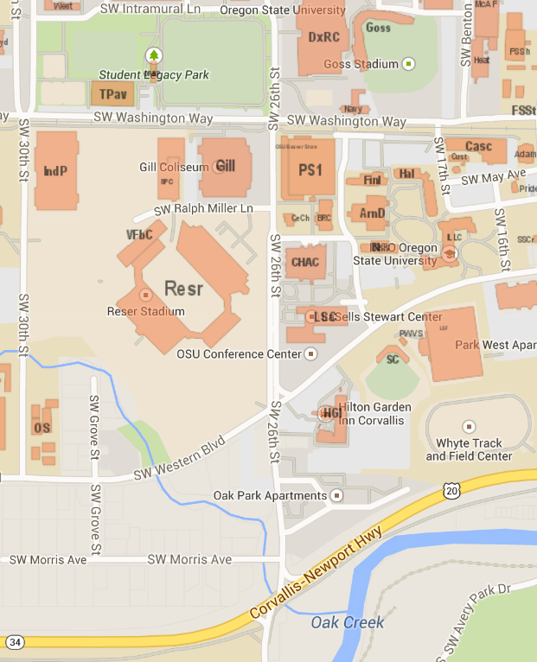

**3**

**1**

**2**

**4**

**5**

**6**

**7**

**8**

While all of these Athletic Facilities are included in the contract, certain locations, events and other exceptions are excluded from the contractor’s rights as indicated in the contract at **Exhibit A**. A brief outline of the each of the facilities and the historic concessions and catering follows.

1. Reser Stadium

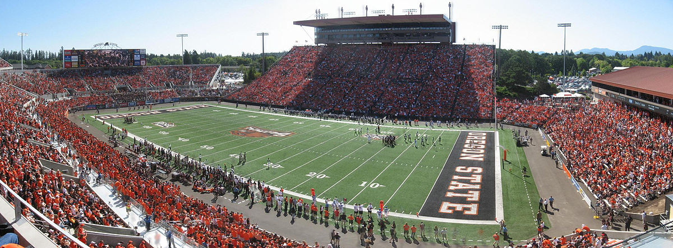

Reser Stadium is an outdoor athletic football stadium located on the northwest corner of the Oregon State Corvallis campus at the intersection of SW 26th Street and SW Western Boulevard. Reser Stadium has a current [seating capacity](http://en.wikipedia.org/wiki/Seating_capacity) of 45,674 and hosts OSU home football games, and various non-athletic events, particularly commencement which is held every June. Reser Stadium has several different locations for concessions and catering including the sections listed below. Portable carts, kiosks and tents have also been used on concourses surrounding the stadium.

1. West Side - Concourse - General Seating - Capacity 15,950

There are four concession stands with eight lines each.

1. West Side - Press Box - Capacity 350

A catered meal is served from the main kitchen. Menu consists of signature tomato soup, one hot entrée, salad and dessert. OSU Athletic Department is billed for this catering.

1. West Side – Skyboxes - Seating for 262

There are a total of 13 skyboxes. Of the 13 skyboxes, nine are available for sale to donors and have 18 seats each. Of the four remaining skyboxes, one is for the OSU Alumni Association and has 34 seats, one for the visiting Athletic Director and has 18 seats, one is for the OSU Athletic Director and has 30 seats, and one is the designated command center. All skyboxes may have additional guests. Skyboxes with 18 seats may have as many as eight additional guests per skybox. Other skyboxes may have a variable amount of guests. Skybox holders may bring in their own food and alcohol into the skyboxes as this area is an exception to the Contract. Contractor has exclusive rights to provide catering services in the skyboxes, if skybox holders elect to have catering services. The two skyboxes designated for the visiting and OSU Athletic Directors will require catering from the main kitchen at the expense of the OSU Athletic Department. On non-football days, this space is used for outside catered events such as meetings and banquets.

1. East Side - Lower Bowl - General Seating - Capacity 9,654

There are four concession stands with 32 to 38 points-of-sale. There are also 14 portable stands with 14 points-of-sale. This area also has a 500 sq. ft. commissary, 3,500 sq. ft. kitchen adjacent to the freight elevator and a separate 1,500 sq. ft. commissary.

1. East Side - Upper Bowl - General Seating - Capacity 4700

Approximately 4700 public seats divided into two sections at either end of the Club Lounge. There are two permanent concession stands with four point-of-sales each, six portable stands with 12 point-of-sales and a 250 sq. ft. vending room on each side.

1. East Side - Founders Loge (2nd Floor) - Capacity 312

The Founders Loge is comprised of 52 private boxes with four seats each. Each box has two additional pre-game guest passes per box (guests for pre-game only.) A pre-game buffet and game time snacks are served on non-disposable service ware (china/glass) courtesy of the OSU Athletic Department. Founders Loge ticket holders and guests are responsible for purchasing their own beer and wine. Food is prepared in the commissary kitchen and served from the two small holding pantries. Pantries would also be available to serve the 72 ADA seats outside of the Founders Loge. On non-football days, the Founders Loge is available for other events.

1. East Side – Upper Bowl - Club (3rd Floor) – Capacity 3200

The Club level has seating for 3200 with access to the Club Lounge, a 30,000 sq. ft. climate controlled lounge area complete with interactive games, video monitors, private restrooms and private stadium entrance with elevator service. The Club Lounge is open for members two hours prior to kick off and houses two concession stands with four point-of-sale, a beer and wine bar, and a non-cooking pantry behind the bar area. All food and beverages are provided on disposable service ware. Beer and wine must be consumed in the Club Lounge and may not be taken back to the Club seats. On non-football days, this space is used for outside catered events such as meetings and banquets. OSU Department of Athletics may purchase catered items (miscellaneous finger foods) from contractor to be provided to Club members at no cost.

1. East Side - Suite Level (4th Floor) – Seating for 354

The suite level is comprised of a total of 21 suites. Of the 21 suites, 20 are available for sale to donors and have 16 seats each. The remaining suite is designated as the President’s Box and has 34 seats. The suites with 16 seats may have as many as eight additional guests per suite. The President’s Box may have a variable amount of guests. Suite holders may bring in their own food and alcohol into the suites as this area is an exception to the Contract. Contractor has exclusive rights to provide catering services in the suites, if suite holders elect to have catering services. The President’s Box will require catering from the main kitchen. On non-football days, this space is used for outside catered events such as meetings and banquets.

1. North End Zone - Capacity 3,850

This area has one concession stand with four lines in the northeast corner.

1. South End Zone - Capacity 6,000

No permanent concession stands.

1. Valley Football Center

[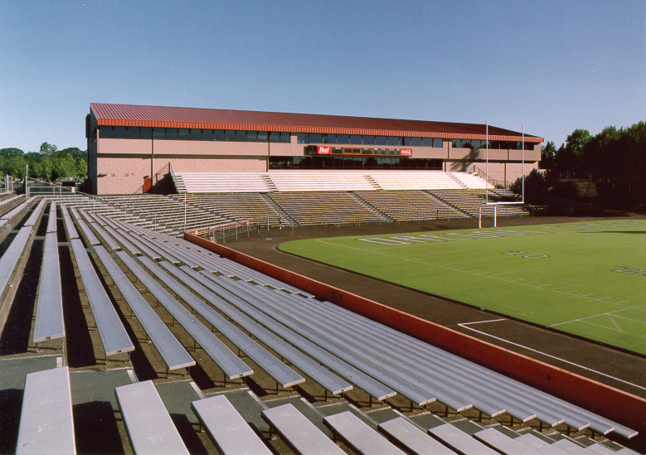](http://www.google.com/url?sa=i&rct=j&q=&esrc=s&frm=1&source=images&cd=&cad=rja&uact=8&ved=0CAcQjRw&url=http://carlsonveit.com/portfolio-items/osu-valley-football-center&ei=ANOIVIrBEsrgoASgkoCYDA&bvm=bv.81657216,d.cGU&psig=AFQjCNGQmAnr6sKdTAcsvwPWV2wU1KW6JQ&ust=1418339450014748)

The north end zone of Reser Stadium is home to the Valley Football Center, a three story facility that houses sports medicine, training, video, equipment, coach’s offices, team meeting rooms, player’s lounge, locker room and Athlete Training Table food preparation and service. There may be a renovation and expansion of this area in the future to develop a more functional locker room, an expanded equipment room, repurposed team meeting space, recruiting area, main entry point and bleacher seating updates for an improved fan experience. This renovation and expansion may change stadium seating capacity minimally, but there are no anticipated changes for concessions or catering operations.

1. 3rd Floor – Capacity 250

On OSU home football game days, this space is occupied by OSU Foundation where donors can dine and enjoy the game. Meals are served from the 3rd floor on-site kitchen with storage in the kitchen and pantry areas. On non-football days, this space is used for the Athlete Training Table.

1. 2nd Floor – Fan Cave/Player’s Lounge – Capacity 75

On OSU home football game days the OSU Athletic Department sales tickets for entrance into this area which is known as the Fan Cave. Food and beverages are provided in this space and paid for by the OSU Athletic Department. This area has a small serving area. On non-football days, this space is used as the Player’s Lounge.

1. Merrit Truax Indoor Practice Facility

[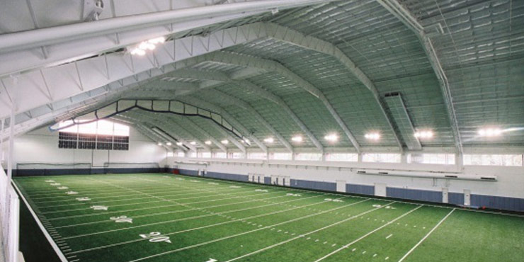](http://www.google.com/url?sa=i&rct=j&q=&esrc=s&frm=1&source=images&cd=&cad=rja&uact=8&docid=iAb5pAFCj7z-XM&tbnid=soLiJCiEXeAkwM:&ved=0CAUQjRw&url=http://www.slayden.com/oregon-state-university-truax-indoor-practice-facility/&ei=sVM0U5zqPMewoQSi4oHgAg&bvm=bv.63808443,d.cGU&psig=AFQjCNE8qdz-X0IShSufCiZlKFyraJM1LA&ust=1396024563890048)

The Merrit Truax Indoor Practice Facility is located on the southeast corner of the Oregon State Corvallis campus at the intersection SW 30th Street and SW Washington Way. The facility covers 85,000 sq. ft., has a capacity estimated at 1500 for events and has one small concession stand with limited storage. The facility is primarily used by the football program, as the building contains a regulation sized FieldTurf field. However, nearly all of the other intercollegiate programs sponsored by OSU utilize the structure.

The Truax Center is also home to football pregame functions, awards banquets and other special events. The football pre-game function serves approximately 1,000 people a tailgate style menu. The menu consists of a grill station with burgers, dogs and salads, a deli station with sandwiches salads and desserts, a hot entree station, three soda stations, and two beer and wine bars.

1. Gill Coliseum

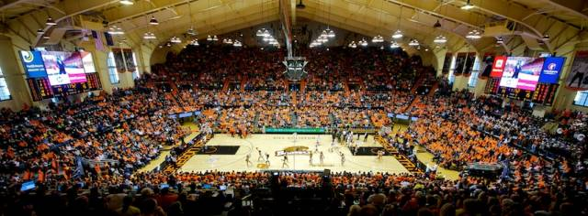

Gill Coliseum is an indoor athletic coliseum located on the southwest corner of the Oregon State Corvallis campus at the intersection of SW 26th Street and SW Washington Way. Gill Coliseum has a current seating [capacity](http://en.wikipedia.org/wiki/Seating_capacity) of 9,604 and houses OSU basketball games, gymnastics, wrestling and volleyball. The building also includes a weight room, equipment center, locker rooms and offices for the Department of Athletics and its teams. Apart from use from the Department of Athletics, Gill Coliseum is occasionally used for special cultural events. The arena has two concourses. The main concourse has two concession stands with four lines each. The upper concourse has three concession stands with four lines each and two one-line portable stands.

1. Goss Stadium

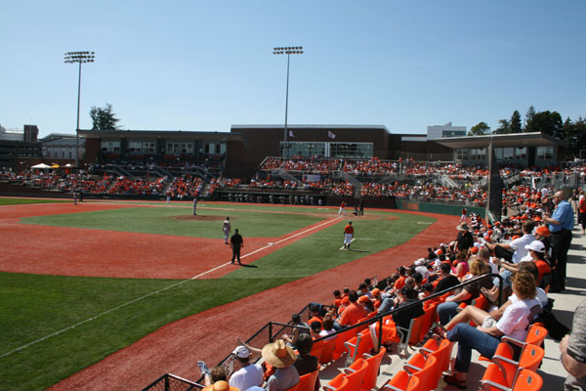

Goss Stadium is the home of the OSU baseball team and the West Coast League Corvallis Knights. It's been the home park of OSU baseball since 1907. Goss Stadium is located off of Washington Way near the center of the OSU campus. The stadium is located directly east of the Dixon Recreation Center (26th & Washington Way) and south of the Valley Library. Permanent seating capacity at Goss is now 3,248. The stadium features a club level with box seating, the Omaha Club Room, an academic center, players' lounge, memorabilia room, press box, concession area, home and visiting clubhouse, dugouts and batting cages. The Omaha Club Room has a capacity of 50 and could be used for catered events such as meetings and banquets when not being used during baseball games.

The concession area has one permanent concession stand with four lines. A renovation and expansion is in progress that will add a new concessions area on the left field where beer and wine will be served. The contractor will only be responsible for selling at OSU baseball games and will turn over concessions to the Corvallis Knights at the end of OSU baseball season.

1. Whyte Track and Field Center

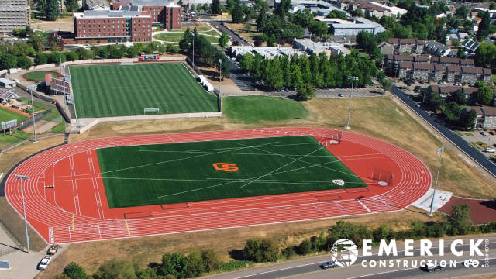

In September of 2012 OSU opened the Whyte Track and Field Center located at the northwest corner of 15th Street and Highway 20. The opening marked the completion of phase I of the project which included installation of an International Association of Athletics Federation certified Olympic-caliber polyurethane surface, a FieldTurf infield, a nine-lane track, high jump aprons, long jump, triple jump runways, pole vault runways, javelin runways, shot put throw sectors and dual discus rings. Phase II will include installation of grandstands with seating for 2000, a press box, scoreboard, a hammer throw area and other amenities. There are no permanent concession stands in this area. Contractor will need to use a portable trailer for concessions and storage.

1. Softball Complex

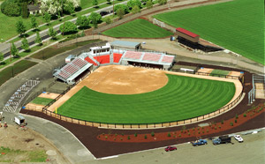 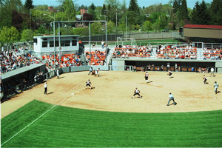

The OSU Softball Complex is located south of Highway 20 between SW 15th Street and SW 26th Street. The facility was home of the 2006 NCAA Regional and Super Regional Tournaments - with Oregon State winning both, and earning its first-ever trip to the NCAA Women's College World Series. Softball games include the OSAA state championships. The complex features 750 bleacher backed seats, restroom facility, sunken dugouts with a restroom for players and large storage areas. The closed press box facility allows ample seating for six scorers in the main booth with two smaller television/radio booths located on both sides. There are no permanent concession stands in this area. Contractor will need to use a portable trailer for concessions and storage.

1. Paul Lorenz Field

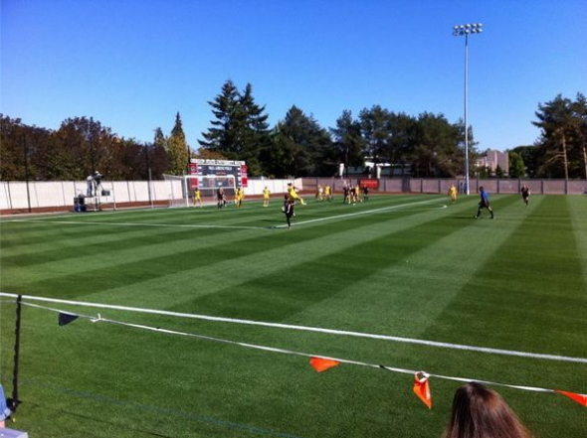

The OSU Paul Lorenz Field at Patrick Wayne Valley Stadium opened in the fall of 1996 and is located a block southeast of Reser Stadium. Patrick Wayne Valley Stadium seats 1,500 fans and has an enclosed press box on the west sideline and covered team benches on the east sideline. The facility has hosted NCAA Tournament matches, exhibitions against the Portland Timbers of Major League Soccer. There are no permanent concession stands in this area. Contractor will need to use a portable trailer for concessions and storage.

1. Attendance and Schedule

The OSU Athletic Facilities are home to a number of different sporting events with variable attendance. The total and average attendance at OSU athletic sports for the last two seasons is included below:

|  |  |  |  |  |  |
| --- | --- | --- | --- | --- | --- |
| **Sport** | **Year** | **Athletic Facility** | **# of Games** | **Total** | **Average** |
| FOOTBALL | 2013 | Reser Stadium | 6 | 257,784 | 42,964 |
| FOOTBALL | 2012 | Reser Stadium | 7 | 303,971 | 43,424 |
| MEN'S BASKETBALL | 2013-2014 | Gill Coliseum | 17 | 63,677 | 3,746 |
| MEN'S BASKETBALL | 2012-2013 | Gill Coliseum | 18 | 83,368 | 4,632 |
| WOMEN'S BASKETBALL | 2013-2014 | Gill Coliseum | 16 | 31,535 | 1,971 |
| WOMEN'S BASKETBALL | 2012-2013 | Gill Coliseum | 16 | 19,003 | 1,188 |
| GYMNASTICS | 2013 | Gill Coliseum | 6 | 20,496 | 3,416 |
| GYMNASTICS | 2012 | Gill Coliseum | 5 | 20,486 | 4,097 |
| VOLLEYBALL | 2013 | Gill Coliseum | 10 | 9932 | 993 |
| VOLLEYBALL | 2012 | Gill Coliseum | 10 | 11,625 | 1,163 |
| BASEBALL | 2013 | Goss Stadium | 32 | 82985 | 2,677 |
| BASEBALL | 2012 | Goss Stadium | 26 | 44327 | 1,927 |
| MEN'S SOCCER | 2013 | Paul Lorenz Field | 10 | 3865 | 429 |
| MEN'S SOCCER | 2012 | Paul Lorenz Field | 9 | 4516 | 502 |
| WOMEN'S SOCCER | 2013 | Paul Lorenz Field | 11 | 3722 | 414 |
| WOMEN'S SOCCER | 2012 | Paul Lorenz Field | 9 | 4251 | 531 |
| SOFTBALL | 2013 | Softball Facility | 14 | 3787 | 271 |
| SOFTBALL | 2012 | Softball Facility | 13 | 5229 | 402 |

There are at least six home football games each year and seven in years where OSU hosts the “Civil War” game between OSU and University of Oregon. The 2015 football schedule is:

| **Date** | **Time** | **Opponent** | **Location** |
| --- | --- | --- | --- |
| Sat, Sep 05 | TBD | Weber State | Corvallis, OR |
| Sat, Sep 19 | TBD | San Jose State | Corvallis, OR |
| Fri, Sep 25 | TBD | Stanford | Corvallis, OR |
| Sat, Oct 24 | TBD | Colorado | Corvallis, OR |
| Sat, Nov 07 | TBD | UCLA | Corvallis, OR |
| Sat, Nov 21 | TBD | Washington | Corvallis, OR |

For other sports, the future number of home games is provided below based off past year’s events. Schedules for the upcoming seasons have not been made at this time:

1. Men’s Basketball – 15 each year from November – March/April
2. Women’s Basketball – 15 each year from November – March/April
3. Gymnastics – 5 each year from November – March/April
4. Volleyball – 10 each year from August – November/December
5. Baseball – 24 each year from February – May/June
6. Men’s Soccer – 9 each year from August – November
7. Women’s Soccer – 9 each year from August – November
8. Softball – 13 each year from February – May
9. Wrestling – 6 each year from November – February/March
10. Track and Field – 1 a year at least until facility is finished and then from March – May/June
11. Menu and Sales

The concession menu currently being offered in Reser Stadium and the 2014-2015 concession price list is included in **Exhibit D**. The concession offerings in other facilities have similar core food and beverage products.

Sales have grown steadily since the contract began as shown in the table and graph below. A detail of the monthly sales and revenue by category for January 2013 through November 2014 is included at **Exhibit E**. Also, included at **Exhibit F**, is a detail of the event sales and revenue for the time period March 1, 2013 through February 10, 2014.

|  |  |
| --- | --- |
| Annual Sales & Revenue Total | |
| 2005 | $1,742,714.39 |
| 2006 | $2,161,297.67 |
| 2007 | $2,096,765.79 |
| 2008 | $2,343,997.26 |
| 2009 | $2,276,262.77 |
| 2010 | $2,412,779.84 |
| 2011 | $2,446,457.01 |
| 2012 | $2,675,674.00 |
| 2013 | $2,790,731.27 |

\

1. Athlete Training Table

Athlete training table is prepared and served at the Valley Football Center. Dinner is available Sunday through Thursday. Breakfast and lunch are available Monday through Thursday. OSU guarantees 90 person minimum for dinner and 100 person minimum for breakfast and lunch. OSU is charged either the actual number of attendees or the minimum guaranteed number, whichever is greater. Contractor bills the breakfast, lunch or dinner at the flat rate fee. The current flat rate fees are:

$12 for dinner Sunday

$5 for breakfast Monday

$8 for lunch Monday

Menus vary but are designed between the contractor and coaches as nutritional meals for the student athletes.

1. Equipment

The successful Proposer is responsible for providing all furnishings, fixtures and equipment required to provide the Services. OSU owns some equipment as listed in **Exhibit G** and is making OSU’s owned equipment available for sale to the successful Proposer. OSU’s equipment is available for sale as all or none and is “as-is” condition with no warranties. This equipment may be viewed at the pre-proposal conference. All equipment listed as owned by another company will not remain at the facilities unless the successful contractor works with the listed owner to acquire or retain usage of the equipment.

# 3.0 STATEMENT OF WORK

3.01 SAMPLE CONTRACT

A sample contract containing a statement of work and contractual terms and conditions is included at Exhibit A.

# 4.0 PROPOSER QUALIFICATIONS

4.01 MINIMUM QUALIFICATIONS

In order to qualify as a Responsive Proposer, the Proposer needs to meet the minimum qualifications below.

1. Proposer must have a minimum of three (3) years successful professional experience providing concessions and catering services at either professional athletic events, large collegiate athletic events, or equivalent large capacity (excess of 40,000 people) events.
2. Proposer must have experience working in a university environment with students, faculty, staff and the general public.
3. Proposer must have a minimum of one (1) year successful professional experience providing athlete training table services.

# 5.0 REQUIRED SUBMITTALS

## 5.01 QUANTITY OF PROPOSALS

Submit one (1) original hard copy Proposal, 5 duplicate copies and one (1) electronic copy (PDF format) on CD/DVD/flash drive. Original should contain signatures on any pages where a signature is required. Proposals should contain the submittals listed in this section below.

5.02 REQUIRED SUBMITTALS

It is the Proposer’s sole responsibility to submit information in fulfillment of the requirements of this Request for Proposal. If submittals are not substantially compliant in all material respects with the criteria outlined in the RFP, it will cause the Proposal to be deemed non-Responsive.

Proposers must submit the following information.

1. Experience and Qualifications
2. Statement of Proposer’s experience and qualifications including; company history, the administrative organization support structure, experience in concessions, catering and athlete training table, and a list of Proposer’s concession operations similar in size and scope to OSU.
3. Information about Proposer’s management personnel including; an outline of the functions and basic responsibilities of key management positions, names and brief experience of the key management team that is proposed for OSU operations, and resume of the proposed on-site manager.
4. Operations

Detailed information describing the manner in which the Proposer plans to discharge responsibilities under the Contract, including at a minimum:

1. A chart describing the proposed organizational structure.
2. A description of proposed on-site administrative and supervisory staff.
3. Recommended service level positions and general staffing ratios (e.g. number of concession workers per # of guests, servers and wait staff.)
4. Description of employee training and development programs.
5. A list of subcontractors that will be used in fulfillment of the operations.
6. Technology solutions utilized in operational plans or social media applications.
7. Use of marketing and promotional techniques to encourage sales.
8. Customer service plans and methods of measuring customer satisfaction.
9. Training table operations plan, proposed staffing, and details on collaborative efforts for nutritional needs.
10. Food and Beverage

The proposed food and beverage concepts for all venues, including:

1. A comprehensive list of all proposed menus to be served for concessions and catering including prices to be charged, portions and whether the menus will be prepared by the contractor or a subcontractor.
2. Proposed design concepts including location, types of foods and beverages served at the location, whether food and beverages will be served by contractor or subcontractors, and any moveable concessions operations.
3. Financial

The proposed financial offering for OSU’s consideration including:

1. Terms of the financial offer including the amount for fixed commission, percent commission of Gross Sales and the minimum annual guarantee for percent commission.
2. If offering facility improvements as part of the financial offer, indicate a description, timeframe and the total dollar amount of the proposed facility improvements.
3. If offering new furnishings, fixtures or equipment as part of the financial offer, indicate a description, timeframe and the total dollar amount of the proposed furnishings, fixtures or equipment.
4. Percent discount proposed for OSU’s catered food and beverages based on the Proposer’s catering services menu.
5. Proposed flat fee for breakfast, lunch and dinner for the Athlete Training Table based on a guaranteed minimums of 90, 100, and 100 person minimum guarantee respectively.
6. Proposed purchase price for OSU’s equipment in Exhibit G.
7. Exhibit B: Certifications, fully completed.
8. Exhibit C: References, fully completed.

# 6.0 EVALUATION

6.01 EVALUATION

The stages of review and evaluation are as follows:

1. Determination of Responsiveness:

OSU will first review all Proposals to determine Responsiveness. Proposals that do not comply with the instructions, that are materially incomplete, that do not meet the minimum requirements, or that are submitted by Proposers who does not meet minimum qualifications may be deemed non-Responsive. Written notice will be sent to Proposers whose Proposal is deemed non-Responsive identifying the reason. A Proposer has the right to appeal the decision pursuant to OSU Standard 580-061-130(5)(a).

1. First Stage Evaluation:

Those Proposals determined to be Responsive will be evaluated using the required submittals. Proposals will be scored based on the evaluation criteria listed below. Scores will be used to determine Proposers within a competitive range. The competitive range will be made of Proposers whose individual scores, when viewed together, form a group of the highest ranked Proposers above a natural break in the scores.

OSU reserves the right to ask follow-up questions of Proposers during first stage evaluations. The questions will be for the purpose of clarification of information already contained in submittals and not be an opportunity to submit additional documentation or change existing documentation.

OSU may award after the first stage evaluation to the highest ranked Proposer without moving on to the second stage evaluation. If this option is selected, Written notice of intent to award the Contract to the highest ranked Proposer will be provided to all Responsive Proposers, or an award may be made directly without notice of intent in those instances of a single Responsive Proposer.

1. Second Stage Evaluation:

If award is not made after the first stage evaluation, OSU may choose any of the following methods in which to proceed:

1. Issue a Written invitation to Proposers within the competitive range requesting an interview, presentation, site visit or any other evaluative method that is relevant to the goods or services solicited in the Request for Proposal. Written invitations will contain the evaluation criteria and scoring that will be used by the evaluation committee.
2. Engage in oral or Written discussions with and receive best and final Proposals from all Proposers in the Competitive Range or all Proposers submitting Responsive Proposals. Discussions may be conducted for the following purposes:

* Informing Proposers of deficiencies in their initial Proposals;
* Notifying Proposers of parts of their Proposals for which OSU would like additional information; or
* Otherwise allowing Proposers to develop revised Proposals that will allow OSU to obtain the best Proposal based on the requirements set forth in this Request for Proposal.

The conditions, terms, or price of the Proposal may be altered or otherwise changed during the course of the discussions provided the changes are within the scope of the Request for Proposal. Best and final Proposals will be scored based on the evaluation criteria listed below.

Points awarded in the first stage evaluation will not be carried to the second stage evaluation. If a second stage evaluation of all Proposers does not produce an award that is in OSU’s best interest, OSU may return to the first stage evaluation to advance additional Proposers to a second stage evaluation.

1. Additional Stages of Evaluation:

If after completion of the second stage of evaluation, an award is not made, OSU may add another stage of evaluation using any of the methods outlined in the second stage evaluation above.

6.02 EVALUATION CRITERIA

Points will be given in each criteria and a total score will be determined. The maximum points available for each criterion are identified below.

Evaluation Criteria Points

Experience and Qualifications 25

Operations 25

Food & Beverage 25

OSU’s Financial Considerations 25

**Total 100**

6.03 NEGOTIATIONS

OSU may commence serial negotiations with the highest ranked Proposer or commence simultaneous negotiations with all Responsive Proposers within the competitive range. OSU may negotiate:

1. The statement of Work;
2. The Contract price as it is affected by negotiating the statement of Work; and
3. Any other terms and conditions as determined by OSU.

6.04 INVESTIGATION OF REFERENCES

OSU reserves the right to investigate and to consider the references and the past performance of any Proposer with respect to such things as its performance or provision of similar goods or services, compliance with specifications and contractual obligations, and its lawful payment of suppliers, subcontractors, and workers. OSU may postpone the award or execution of the Contract after the announcement of the notice of intent to award in order to complete its investigation.

6.03 CONTRACT AWARD

Contract will be awarded to the Proposer who, in OSU’s opinion, meets the requirements and qualifications of the RFP and whose Proposal is in the best interest of OSU. If a successful Contract cannot be completed after award, OSU may conclude contract negotiations, rescind its award to that Proposer, and return to the most recent RFP evaluation stage to negotiate with another Proposer(s) for award.

# 7.0 INSTRUCTIONS TO PROPOSERS

7.01 APPLICABLE STATUTES AND RULES

This Request for Proposal is subject to the applicable provisions and requirements of OSU Standards, Policies and Procedures.

7.02 COMMUNICATIONS DURING RFP PROCESS

In order to ensure a fair and competitive environment, direct communication between OSU employees other than the Administrative Contact or other PCMM representative and any party in a position to create an unfair advantage to Proposer or disadvantage to other Proposers with respect to the RFP process or the award of a Contract is strictly prohibited. This restricted period of communication begins on the issue date of the solicitation and for Proposer(s) not selected for award ends with the conclusion of the protest period identified in OSU Standard 580-061-0145(3) and for Proposers(s) selected for award ends with the contract execution. This restriction does not apply to communications to other OSU employees during a Pre-Proposal conference or other situation where the Administrative Contact has expressly authorized direct communications with other staff. A Proposer who intentionally violates this requirement of the RFP process or otherwise deliberately or unintentionally benefits from such a violation by another party may have its Proposal rejected due to failing to comply with all prescribed solicitation procedures. The rules governing rejection of individual solicitation responses and potential appeals of such rejections are at OSU Standard 580-061-0130.

7.03 MANUFACTURER'S NAMES AND APPROVED EQUIVALENTS

Unless qualified by the provision "NO SUBSTITUTE" any manufacturers' names, trade name, brand names, information and/or catalogue numbers listed in a specification are for information and not intended to limit competition. Proposers may offer any brand for which they are an authorized representative, which meets or exceeds the specification for any item(s). If Proposals are based on equivalent products, indicate in the Proposal form the manufacturers' name and number. Proposers shall submit with their Proposal, sketches, and descriptive literature, and/or complete specifications. Reference to literature submitted with a previous Proposal will not satisfy this provision. Proposers shall also explain in detail the reason(s) why the proposed equivalent will meet the specifications and not be considered an exception thereto. Proposals that do not comply with these requirements are subject to rejection. Proposals lacking any written indication of intent to provide an alternate brand will be received and considered in complete compliance with the specification as listed in the RFP.

7.04 REQUESTS FOR CLARIFICATION OR CHANGE

Requests for clarification or change of the Request for Proposal must be in Writing and received by the Administrative Contact no later than the Deadline for Request for Clarification or Change as specified in the Schedule of Events. Such requests for clarification or change must include the reason for the Proposer’s request. OSU will consider all timely requests and, if acceptable to OSU, amend the Request for Proposal by issuing an Addendum. Envelopes, e-mails or faxes containing requests must be clearly marked as a Request for Clarification or Change and include the RFP Number and Title.

7.05 ADDENDA

Only documents issued as Written Addenda by PCMM serve to change the Request for Proposal in any way. No other direction received by the Proposer, written or verbal, serves to change the Request for Proposal. Addenda will be publicized on the OUS procurement website. Proposers are advised to consult the OUS procurement website prior to submitting a Proposal in order to ensure that all relevant Addenda have been incorporated into the Proposal. Proposers are not required to submit Addenda with their Proposal. However, Proposers are responsible for obtaining and incorporating any changes made by Addenda into their Proposal. Failure to do so may make the Proposal non-Responsive, which in turn may cause the Proposal to be rejected.

7.06 PREPARATION AND SIGNATURE

All documents requiring an authorized signature must be signed in ink by an authorized representative with authority to bind the Proposer. Signature certifies that the Proposer has read, fully understands, and agrees to be bound by the Request for Proposal and all Exhibits and Addenda to the Request for Proposal.

7.07 PUBLIC RECORD

Upon completion of the Request for Proposal process, information in all Proposals will become subject records under the Oregon Public Records Law. Only those items considered a “trade secret” under ORS 192.501(2), may be exempt from disclosure. If a Proposal contains what the Proposer considers a “trade secret” the Proposer must mark each sheet of information as such. Only bona fide trade secrets may be exempt and only if public interest does not require disclosure.

7.08 SUBMISSION

Proposals must be received in the PCMM office no later than the Proposal Due Date and Time; it is the Proposer’s responsibility to ensure that the Proposal is received prior to the Proposal Due Date and Time indicated in this RFP, regardless of the method used to submit the Proposal. Proposals may be submitted via the following method(s):

1. Hard copy in a sealed package or envelope dropped off in person or delivered to the submittal location listed on the Request for Proposal cover sheet. The package or envelope should be addressed to the Administrative Contact. It is highly recommended that the Proposer confirms receipt of the Proposal with the Administrative Contact prior to the Proposal Due Date and Time.

All Proposals, including those submitted through electronic methods (if allowed), must contain Written signatures indicating intent to be bound by the offer. If the Proposer submits multiple versions of the Proposal via different methods and does not explicitly direct OSU as to which version to use, OSU will determine which version of the Proposal will be used for evaluation.

7.09 MODIFICATION

Prior to submittal, Proposers should initial modifications or erasures in ink by the person signing the Proposal. After submittal but prior to the Proposal Due Date and Time, Proposals may be modified by submitting a Written notice indicating the modifications and a statement that the modification amends and supersedes the prior Proposal. After the Proposal Due Date and Time, Proposers may not modify their Proposal.

7.10 WITHDRAWALS

A Proposer may withdraw their Proposal by submitting a Written notice to the Administrative Contact identified in this Request for Proposal prior to the Proposal Due Date and Time. The Written notice must be on the Proposer’s letterhead and signed by an authorized representative of the Proposer. The Proposer, or authorized representative of the Proposer, may also withdraw their Proposal in person prior to the Proposal Due Date and Time, upon presentation of appropriate identification and evidence of authority to withdraw the Proposal satisfactory to OSU.

7.11 LATE SUBMITTALS

Proposals and Written notices of modification or withdrawal must be received no later than the Proposal Due Date and Time (in the case of electronic submissions, the time/date stamp of the email received at the PCMM office must be no later than the Proposal Due Date and Time). OSU may not accept or consider late Proposals, modifications, or withdrawals except as permitted in OSU Standard 580-061-0120. Sole responsibility rests with the Proposer to ensure OSU’s receipt of its Proposal prior to the Proposal Due Date and Time. OSU shall not be responsible for any delays or misdeliveries caused by common carriers or by transmission errors, malfunctions, or electronic delays. Any risks associated with physical delivery or electronic transmission of the Proposal are borne by the Proposer.

7.12 PROPOSAL OPENING

Proposals will be opened immediately following the Proposal Due Date and Time at the Submittal Location. Proposer may attend the Proposal opening. Only the names of the Proposers submitting Proposals will be announced. No other information regarding the content of the Proposals will be available.

7.13 PROPOSALS ARE OFFERS

The Proposal is the Proposer’s offer to enter into a Contract pursuant to the terms and conditions specified in the Request for Proposal, its Exhibits, and Addenda. The offer is binding on the Proposer for one hundred twenty (120) days. OSU’s award of the Contract constitutes acceptance of the offer and binds the Proposer. The Proposal must be a complete offer and fully Responsive to the Request for Proposal.

7.14 CONTINGENT PROPOSALS

Proposer shall not make its Proposal contingent upon OSU’s acceptance of specifications or contract terms that conflict with or are in addition to those in the Request for Proposal, its Exhibits, or Addenda.

7.15 RIGHT TO REJECT

OSU may reject, in whole or in part, any Proposal not in compliance with the Request for Proposal, Exhibits, or Addenda, if upon OSU’s Written finding that it is in the public interest to do so. OSU may reject all Proposals for good cause, if upon OSU’s Written finding that it is in the public interest to do so. Notification of rejection of all Proposals, along with the good cause justification and finding of public interest, will be sent to all who submitted a Proposal.

7.16 AWARDS

OSU reserves the right to make award(s) by individual item, group of items, all or none, or any combination thereof. OSU reserves the right to delete any item from the award when deemed to be in the best interest of OSU.

7.17 LEGAL REVIEW

Prior to execution of any Contract resulting from this Request for Proposal, the Contract may be reviewed by a qualified attorney for OSU pursuant to the applicable Oregon Revised Statutes and Oregon Administrative Rules. Legal review may result in changes to the terms and conditions specified in the Request for Proposal, Exhibits, and Addenda.

7.18 PROPOSAL RESULTS

A Written notice of intent to award will be issued to all Proposers. The Proposal file will be available for Proposer’s review during the protest period at the PCMM Department. Proposers must make an appointment with the Administrative Contact to view the Proposal file. After the protest period, the file will be available by making a Public Records Request to OSU Office of General Counsel.

7.19 PROPOSAL PREPARATION COST

OSU is not liable for costs incurred by the Proposer during the Request for Proposal process.

7.20 PROPOSAL CANCELLATION

If a Request for Proposal is cancelled prior to the Proposal Due Date and Time, all Proposals that may have already been received will be returned to the Proposers. If a Request for Proposal is cancelled after the Proposal Due Date and Time or all Proposals are rejected, the Proposals received will be retained and become part of OSU’s permanent Proposal file.

7.21 PROTEST OF CONTRACTOR SELECTION, CONTRACT AWARD

Any Proposer who feels adversely affected or aggrieved may submit a protest within three (3) business days after OSU issues a notice of intent to award a Contract. The protest must be clearly identified as a protest, identify the type and nature of the protest, and include the Request for Proposal number and title. The rules governing protests are at OSU Standard 580-061-0145.

# EXHIBIT A

# TERMS AND CONDITIONS / SAMPLE CONTRACT

*[Remainder of this page left intentionally blank]*

**EXHIBIT B**

**CERTIFICATIONS**

By signature on this certification the undersigned certifies that they are authorized to act on behalf of the Proposer and that under penalty of perjury the undersigned will comply with the following:

SECTION I. AFFIRMATIVE ACTION

The undersigned hereby certifies that they have not discriminated against Minority, Women or Emerging Small Business Enterprises in obtaining any required subcontracts, pursuant to OSU Standard 580-061-0030 (3).

**SECTION II. COMPLIANCE WITH SOLICITATION**

The undersigned agrees and certifies that they:

1. Have read, fully understands and agrees to be bound by the Request for Proposal and all Exhibits and Addenda to the Request for Proposal; and

2. Are an authorized representative of the Proposer, that the information provided is true and accurate, and that providing incorrect or incomplete information may be cause for rejection of the Proposal or Contract termination; and

3. Will furnish the designated item(s) and/or service(s) in accordance with the Request for Proposal and the Contract; and

4. Has provided a correct Federal Employer Identification Number or Social Security Number with the Proposal.

**SECTION III. PERMISSIVE COOPERATIVE PROCUREMENTS**

If Proposer is awarded a contract from this Request for Proposal, Proposer hereby (check one)

🞎 agrees

🞎 disagrees

to offer the resulting contractual terms and prices to other public institutions.

Authorized Signature: Date:

Name (Type or Print): Telephone:( )

Title: Fax:( )

FEIN ID# or SSN# (required): Email:

Company:

Address, City, State, Zip:

Construction Contractors Board (CCB) License Number (if applicable):

Business Designation (check one):

🞎 Corporation 🞎 Partnership 🞎 LLC 🞎 Sole Proprietorship 🞎 Non-Profit

# EXHIBIT C

# REFERENCES

**REFERENCE 1**

|  |  |  |  |  |
| --- | --- | --- | --- | --- |
| COMPANY: |  | | CONTACT NAME: |  |
| ADDRESS: |  | | PHONE NUMBER: |  |
| CITY, STATE ZIP: |  | | FAX NUMBER: |  |
| WEBSITE: |  | | E-MAIL: |  |
| GOODS OR SERVICES PROVIDED: | |  | | |
|  | | | | |

**REFERENCE 2**

|  |  |  |  |  |
| --- | --- | --- | --- | --- |
| COMPANY: |  | | CONTACT NAME: |  |
| ADDRESS: |  | | PHONE NUMBER: |  |
| CITY, STATE ZIP: |  | | FAX NUMBER: |  |
| WEBSITE: |  | | E-MAIL: |  |
| GOODS OR SERVICES PROVIDED: | |  | | |
|  | | | | |

**REFERENCE 3**

|  |  |  |  |  |
| --- | --- | --- | --- | --- |
| COMPANY: |  | | CONTACT NAME: |  |
| ADDRESS: |  | | PHONE NUMBER: |  |
| CITY, STATE ZIP: |  | | FAX NUMBER: |  |
| WEBSITE: |  | | E-MAIL: |  |
| GOODS OR SERVICES PROVIDED: | |  | | |
|  | | | | |

**EXHIBIT D**

**RESER MENU AND PRICING EXAMPLES**

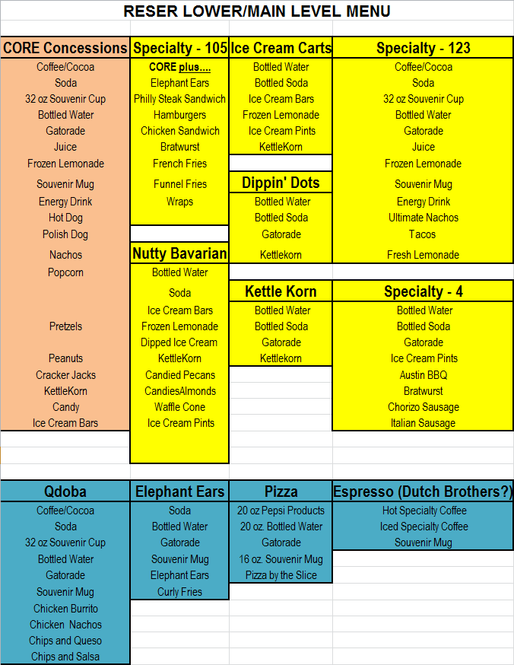

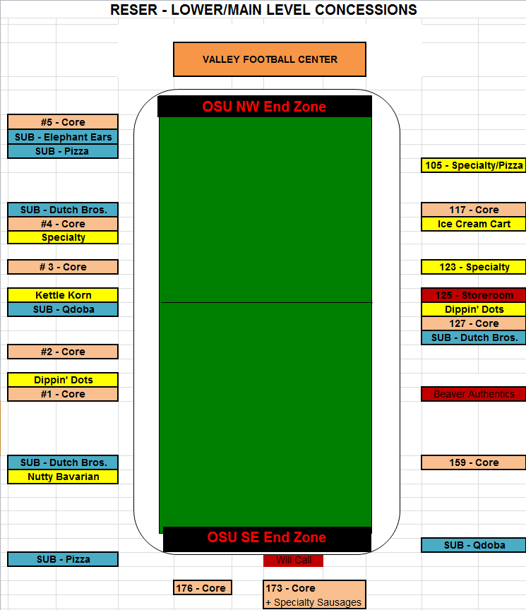

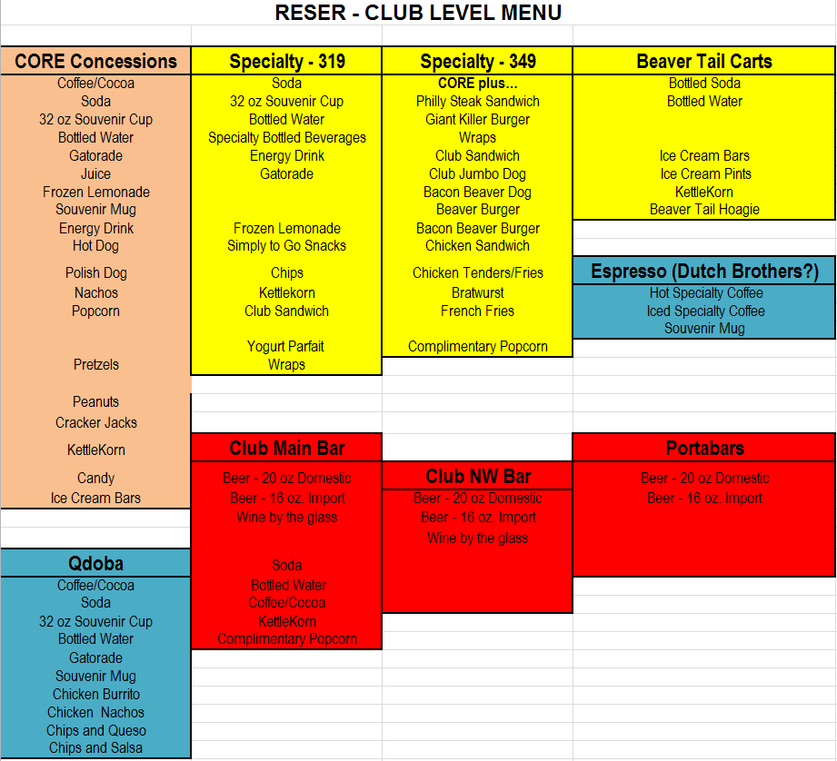

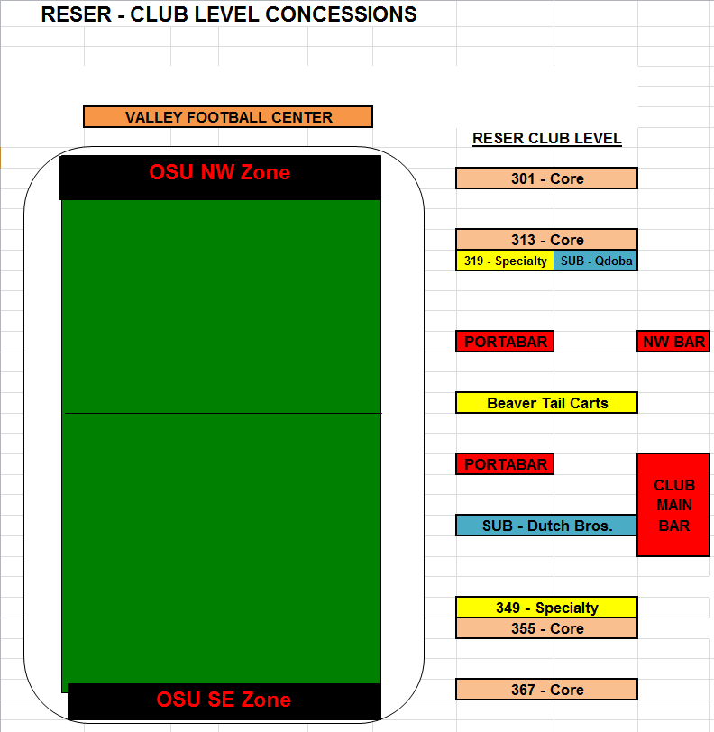

|  |  |  |  |  |
| --- | --- | --- | --- | --- |
| **Product** | **2014-2015 Prices** |  | **Product** | **2014-2015 Prices** |
| BEVERAGES |  |  | SPECIALTIES |  |
| 16 oz. Hot Cup | $4.00 |  | Premium I/C Bars | $4.00 |
| 20 oz. Fountain Soda | $4.00 |  | Pecans | $4.00 |
| 32 oz. Souvenir Cup | $5.00 |  | Almonds | $4.00 |
| 20 oz. Bottle Pepsi | $4.00 |  | Umpqua Pints | $6.00 |
| 20 oz. Bottle Diet Pepsi | $4.00 |  | Waffle Cone | $5.00 |
| 20 oz. Bottle Sierra Mist | $4.00 |  | IC Dish | $4.00 |
| 20 oz. Bottle Mt. Dew | $4.00 |  | Regular Cone | $3.00 |
| 20 oz. Bottled Water | $4.00 |  | Dip'n Dots | $5.00 |
| Gatorade | $4.00 |  | Philly Steak Sandwich | $8.00 |
| 16 oz. Juice | $4.00 |  | Sausage Concept | $8.00 |
| Fresh Lemonade | $6.00 |  | BBQ Pork Concept | $8.00 |
| Minute Maid Frozen | $5.00 |  | Chicken Sandwich | $7.00 |
| Souvenir Mug | $7.00 |  | Bratwurst | $7.00 |
| Energy Drink | $4.00 |  | Elephant Ears | $5.00 |
|  |  |  | French Fries | $5.00 |
| SANDWICHES |  |  | Bacon/Cheese Fries | $6.00 |
| 6:1 All Beef Dog | $4.00 |  | Personal Pizza | $7.00 |
| 5:1 Polish Dog | $5.00 |  | Wrap Concept | $7.00 |
| Chili-Cheese Dog | $5.00 |  | Club Sandwich | $7.00 |
|  |  |  | Cup of Fruit | $5.00 |
| SNACKS |  |  | Yogurt Parfait | $5.00 |
| Nacho Trays | $4.00 |  | Salad Concept | $7.00 |
| Regular Popcorn | $4.00 |  | Club Jumbo Dog | $5.00 |
| Endless Popcorn | $10.00 |  | Bacon Beaver Dog | $7.00 |
| Regular Pretzel | $4.00 |  | Cheese Burger | $8.00 |
| Cheese Cup | $1.00 |  | Bodacious Burger | $9.00 |
| Peanuts | $4.00 |  | Chicken Sandwich | $8.00 |
| Cracker Jacks | $4.00 |  | Chicken Tenders/Fries | $9.00 |
| KettleKorn | $6.00 |  | Garlic Fries | $6.00 |
|  |  |  | Dip'n Dots | $5.00 |
| CANDY |  |  | Beaver Tail Hoagie | $10.00 |
| Red Vines | $4.00 |  | Gourmet Personal Pizza | $8.00 |
| M&M Peanut | $4.00 |  |  |  |
| M&M Plain | $4.00 |  | ALCOHOLIC BEVERAGES |  |
| Snickers | $4.00 |  | Beer Cup - 20 oz. Domestic | $7.00 |
| Sour Patch Kids | $4.00 |  | Beer Cup - 16 oz. Import | $7.00 |
| Skittles | $4.00 |  | Bottled Beer - Domestic | $5.00 |
| Reeses | $4.00 |  | Bottled Beer - Import | $6.00 |
|  |  |  | Wine Glass | $7.00 |
|  |  |  | Loge Wine Glass - Premium | $8.00 |
|  |  |  | WINE by the BOTTLE | $25.00 |

**EXHIBIT E**

**2013/2014 MONTHLY SALES AND REVENUE BY CATEGORY**

|  |  |  |  |  |  |  |  |
| --- | --- | --- | --- | --- | --- | --- | --- |
|  | Food Regular | Banquet & Catering | Food Breakfast |  |  | Subcontractor |  |
|  | (Catering for Athletics) | (Other Catering) | (Athlete Training Table) | Concessions | Miscellaneous | Commissions | Total |
| Jan-13 | $9,106.20 | $15,749.00 | $30,314.00 | $44,924.70 | $0.00 | $1,834.08 | $101,927.98 |
| Feb-13 | $5,258.30 | $7,221.25 | $35,822.00 | $42,173.41 | $0.00 | $1,820.00 | $92,294.96 |
| Mar-13 | $26,630.25 | $2,602.00 | $39,960.50 | $93,735.16 | $0.00 | $4,331.50 | $167,259.41 |
| Apr-13 | $31,159.25 | $8,741.00 | $55,988.00 | $57,488.50 | -$12.00 | $3,884.25 | $157,249.00 |
| May-13 | $7,831.50 | $28,650.30 | $50,062.00 | $49,251.00 | $0.00 | $3,256.00 | $139,050.80 |
| Jun-13 | $7,010.00 | $41,014.50 | $24,843.00 | $170,927.22 | -$1,421.93 | $7,234.75 | $249,607.54 |
| Jul-13 | $781.25 | $32,414.75 | $18,688.00 | $55,462.66 | $765.20 | $0.00 | $108,111.86 |
| Aug-13 | $0.00 | $20,721.90 | $170,744.00 | $43,708.00 | $0.00 | $0.00 | $235,173.90 |
| Sep-13 | $4,286.25 | $123,420.75 | $176,266.00 | $420,923.94 | -$6,261.89 | $21,898.35 | $740,533.40 |
| Oct-13 | $6,008.00 | $41,226.75 | $74,413.00 | $122,045.72 | $5,786.26 | $6,445.75 | $255,925.48 |
| Nov-13 | $6,302.65 | $80,161.85 | $80,029.00 | $270,684.89 | $37,816.78 | -$2,743.36 | $472,251.81 |
| Dec-13 | $3,238.40 | $515.50 | $41,186.00 | $26,405.23 | $0.00 | $0.00 | $71,345.13 |
|  |  |  |  |  |  |  |  |
|  | Food Regular | Banquet & Catering | Food Breakfast |  |  | Subcontractor |  |
|  | (Catering for Athletics) | (Other Catering) | (Athlete Training Table) | Concessions | Miscellaneous | Commissions | Total |
| Jan-14 | $12,873.50 | $8,694.00 | $51,991.00 | $44,175.62 | $0.00 | $1,447.00 | $119,181.12 |
| Feb-14 | $3,473.50 | $9,680.50 | $51,580.00 | $34,760.71 | $0.00 | $1,605.25 | $101,099.96 |
| Mar-14 | $24,428.50 | $6,165.50 | $52,418.50 | $105,404.31 | $0.00 | $4,071.25 | $192,488.06 |
| Apr-14 | $19,100.00 | $12,889.50 | $54,044.00 | $38,176.63 | $0.00 | $1,945.00 | $126,155.13 |
| May-14 | $3,259.50 | $27,274.80 | $47,900.00 | $48,817.05 | $0.00 | $2,799.50 | $130,050.85 |
| Jun-14 | $12,721.38 | $29,391.35 | $36,667.00 | $163,528.32 | $0.00 | $1,933.00 | $244,241.05 |
| Jul-14 | $2,030.00 | $4,421.50 | $32,637.00 | $47,825.25 | $0.00 | $0.00 | $86,913.75 |
| Aug-14 | $1,550.00 | $15,324.00 | $134,139.00 | $30,843.40 | $0.00 | $0.00 | $181,856.40 |
| Sep-14 | $12,351.50 | $81,318.75 | $162,709.00 | $288,425.24 | -$4,355.82 | $7,759.40 | $548,208.07 |
| Oct-14 | $5,753.25 | $53,321.58 | $63,522.50 | $118,081.20 | $25.67 | $28,232.00 | $268,936.20 |
| Nov-14 | $9,535.95 | $117,253.86 | $79,463.00 | $390,387.66 | -$6,759.97 | $10,016.00 | $599,896.50 |

**EXHIBIT F**

**2013/2014 CONCESSION AND CATERING EVENT SALES**





**EXHIBIT G**

**ATHLETIC FACILITIES - EQUIPMENT INVENTORY**

|  |  |  |  |  |  |  |  |  |  |  |
| --- | --- | --- | --- | --- | --- | --- | --- | --- | --- | --- |
| **Item** | **Gill** | **RCN** | **RCC** | **RCS** | **RCO** | **RCSW** | **RCom** | **VFC** | **Total** | **OWNED BY** |
| Draft Cabinet - 2 Tap |  |  | 3 |  |  |  |  |  | 3 | Columbia |
| Draft Cabinet - 4 Tap |  |  | 1 |  |  |  |  |  | 1 | Columbia |
| Freezer - Dip & Dot | 1 | 1 |  |  | 2 | 1 |  |  | 5 | Dip & Dots |
| Kiosk - Dip & Dot |  | 1 |  |  |  |  |  |  | 1 | Dip & Dots |
| Coffee Brewer | 7 | 5 | 2 |  | 3 | 1 | 1 | 2 | 21 | Dutch Bros. |
| Nacho Cheese | 4 | 15 | 6 | 7 | 17 | 2 |  |  | 51 | Gehls |
| Freezer - Counter | 4 | 5 | 1 | 2 |  |  |  |  | 12 | J & J |
| Freezer - Counter - Minute Maid |  | 1 |  | 2 | 6 | 1 |  |  | 10 | J & J |
| Airpot | 2 |  | 50 |  |  |  | 20 |  | 72 | OSU |
| Barbeque - Char Broiler - 12 Burners - UltraMax | 1 |  |  |  |  |  |  |  | 1 | OSU |
| Barbeque - Gas |  |  |  |  |  | 1 |  |  | 1 | OSU |
| Blender - Container |  |  |  |  |  |  |  | 6 | 6 | OSU |
| Blender - Industrial |  |  |  |  |  |  |  | 2 | 2 | OSU |
| Bowl - Stainless Steel - Large/Medium |  | 7 | 1 |  |  |  | 12 | 6 | 26 | OSU |
| Cake Stand - Glass |  |  |  |  |  |  | 3 |  | 3 | OSU |
| Can Opener |  | 10 | 1 | 1 | 2 |  |  | 1 | 15 | OSU |
| Chaffing Server - Old |  |  | 22 |  | 15 |  | 3 |  | 40 | OSU |
| Chaffing Server - Round |  |  |  |  |  |  | 2 |  | 2 | OSU |
| Cooler - Table Top |  |  |  |  |  | 1 |  |  | 1 | OSU |
| Creamer - Glass |  |  |  |  |  |  | 30 |  | 30 | OSU |
| Credit Card Terminal - Wired |  |  | 45 |  |  |  |  |  | 45 | OSU |
| Cups - Glass - Miscellaneous |  |  | 2 |  |  |  | 31 |  | 33 | OSU |
| Cutting Board |  | 6 |  |  |  |  | 11 | 9 | 26 | OSU |
| Drinking Cups - Plastic |  |  |  |  |  |  | 200 | 146 | 346 | OSU |
| Flipper |  |  | 3 |  | 2 | 2 | 8 | 6 | 21 | OSU |
| Food Processor - Berk | 1 | 1 |  |  |  |  |  |  | 2 | OSU |
| Freezer - 1 Door Standing - True | 2 | 5 | 1 |  |  |  |  |  | 8 | OSU |
| Freezer - 2 Door Standing - True | 2 | 3 |  | 2 |  |  |  | 1 | 8 | OSU |
| Freezer - Cabinet | 1 | 2 |  |  | 1 |  |  | 1 | 5 | OSU |
| Fryer - 2 Well - Pitco |  |  | 2 |  |  |  |  |  | 2 | OSU |
| Fryer - 3 Well - Pitco |  | 1 |  |  |  |  |  | 1 | 2 | OSU |
| Glass - Beer 16 oz. |  |  |  |  |  |  | 173 |  | 173 | OSU |
| Glass - Miscellaneous Wine |  |  |  |  |  |  | 180 | 61 | 241 | OSU |
| Glass - Tall Beer |  |  |  |  |  |  | 83 |  | 83 | OSU |
| Glass - Tall Drink |  |  |  |  |  |  | 143 |  | 143 | OSU |
| Glass - Tall Wine |  |  |  |  |  |  | 148 |  | 148 | OSU |
| Glass - Water |  |  |  |  |  |  | 295 |  | 295 | OSU |
| Grill - 5' Flat Top - Vulcan |  | 2 |  |  |  |  |  | 1 | 3 | OSU |
| Grill - Flat - Vulcan |  | 1 |  |  |  |  | 1 |  | 2 | OSU |
| Grill - Slats - Vulcan |  |  |  |  |  |  | 1 |  | 1 | OSU |
| Heat Lamp - One Bulb |  |  |  |  |  |  |  | 1 | 1 | OSU |
| Heat Lamp - Two Bulb |  |  |  |  |  |  | 2 | 2 | 4 | OSU |
| Heat Tray - Hatco |  | 1 |  |  |  |  |  |  | 1 | OSU |
| **Item** | **Gill** | **RCN** | **RCC** | **RCS** | **RCO** | **RCSW** | **RCom** | **VFC** | **Total** | **OWNED BY** |
| Holding Table - M2000 | 1 |  |  |  |  |  |  |  | 1 | OSU |
| Ice Bucket |  |  |  |  |  |  |  | 2 | 2 | OSU |
| Ice Maker |  |  |  |  |  |  |  | 1 | 1 | OSU |
| Knife | 2 | 4 | 5 |  | 2 |  | 10 | 15 | 38 | OSU |
| Ladle - Metal | 2 | 8 | 9 | 2 | 2 |  | 33 | 36 | 92 | OSU |
| Ladle - Plastic |  |  |  |  |  |  | 31 |  | 31 | OSU |
| Lid - 1/2 - Stainless Steel | 3 |  |  |  |  |  |  |  | 3 | OSU |
| Lid - 1/3 - Stainless Steel |  |  | 4 |  |  |  |  |  | 4 | OSU |
| Lid - 1/6 - Stainless Steel |  |  |  |  | 1 |  |  |  | 1 | OSU |
| Lid - Full - Stainless Steel |  |  |  |  |  | 2 |  |  | 2 | OSU |
| Measuring Cup - Plastic | 1 | 4 |  |  |  |  | 2 | 9 | 16 | OSU |
| Metal Rack - 4 Shelf |  | 32 | 6 | 2 | 7 | 4 | 16 | 11 | 78 | OSU |
| Metal Rack - Green |  | 1 | 8 |  | 2 |  | 16 |  | 27 | OSU |
| Metal Rack - Rolling - 4 Shelf |  | 1 | 1 |  |  |  |  | 3 | 5 | OSU |
| Microwave | 1 |  |  |  |  |  |  | 1 | 2 | OSU |
| Miscellaneous Utensils |  |  |  |  |  |  | 3 | 2 | 5 | OSU |
| Mixer - Power - Large - RoboCoupe |  |  |  |  |  |  |  | 1 | 1 | OSU |
| Mixer - Power - Small - RoboCoupe |  |  |  |  |  |  |  | 1 | 1 | OSU |
| Mixer - Power - Stainless Steel - Hobart |  |  |  |  |  |  | 1 | 1 | 2 | OSU |
| Oven - Blodgett |  |  |  |  |  |  | 4 |  | 4 | OSU |
| Oven - Blodgett |  |  |  |  |  |  | 4 |  | 4 | OSU |
| Oven - Convection - Hobart |  |  |  |  |  |  |  | 1 | 1 | OSU |
| Pan - 1/2 - Stainless Steel | 5 | 29 | 4 | 3 | 4 | 1 | 79 | 132 | 257 | OSU |
| Pan - 1/3 - Stainless Steel | 2 | 4 | 4 | 6 | 3 | 4 |  | 33 | 56 | OSU |
| Pan - 1/6 - Stainless Steel |  | 2 |  |  |  |  |  | 16 | 18 | OSU |
| Pan - Full - Stainless Steel | 8 | 59 |  | 7 | 15 | 6 | 113 | 129 | 337 | OSU |
| Parfait - Sundae Dish - Glass |  |  |  |  |  |  | 6 |  | 6 | OSU |
| Pitchers - Clear Plastic |  | 6 | 7 |  | 2 |  | 131 | 74 | 220 | OSU |
| Pizza Cutter |  | 2 |  |  | 2 |  |  |  | 4 | OSU |
| Plate - Bowl |  |  |  |  |  |  |  | 57 | 57 | OSU |
| Plate - Large |  |  |  |  |  |  | 361 | 202 | 563 | OSU |
| Plate - Medium |  |  |  |  |  |  | 470 |  | 470 | OSU |
| Plate - Small |  |  |  |  |  |  | 96 |  | 96 | OSU |
| Plate - Small |  |  |  |  |  |  | 320 |  | 320 | OSU |
| Plate - Tea Cup |  |  |  |  |  |  | 218 |  | 218 | OSU |
| Plates - Clear Plastic |  |  |  |  |  |  | 43 |  | 43 | OSU |
| Popcorn Base - 214 |  |  | 1 |  |  |  |  |  | 1 | OSU |
| Popcorn Maker - 618 | 10 | 8 | 4 | 3 | 8 | 1 |  |  | 34 | OSU |
| Popcorn Scoop | 10 | 8 | 4 | 3 | 8 | 1 | 2 |  | 36 | OSU |
| Pot - Tilting Glazing - Groen |  |  |  |  |  |  | 1 |  | 1 | OSU |
| Pretzel 560 Oven | 3 | 14 | 8 | 3 | 12 | 2 |  |  | 42 | OSU |
| Pretzel 850 Server | 7 | 8 | 4 | 2 | 17 | 2 |  |  | 40 | OSU |
| Punch Bowl |  |  |  |  |  |  | 1 |  | 1 | OSU |
| Radio - Small | 20 |  |  |  |  |  |  |  | 20 | OSU |
| Roller Grill - Small - Star |  | 3 |  |  |  |  |  |  | 3 | OSU |
| **Item** | **Gill** | **RCN** | **RCC** | **RCS** | **RCO** | **RCSW** | **RCom** | **VFC** | **Total** | **OWNED BY** |
| Rolling Rack - Beaver - Wire |  |  |  | 1 | 2 |  |  |  | 3 | OSU |
| Scoop - 4 oz. |  | 5 | 1 |  | 1 |  |  |  | 7 | OSU |
| Server - Chrome - 2 Light |  |  |  |  |  |  |  | 3 | 3 | OSU |
| Server - Square/Oblong White - Large |  |  |  |  |  |  | 1 | 2 | 3 | OSU |
| Server - Square/Oblong White - Small |  |  |  |  |  |  | 4 | 10 | 14 | OSU |
| Server - Water/Juice - Glass |  |  |  |  |  |  | 4 | 1 | 5 | OSU |
| Server- Small - Glass |  |  |  |  |  |  | 41 |  | 41 | OSU |
| Serving - Miscellaneous - Metal |  |  | 7 |  |  |  | 5 |  | 12 | OSU |
| Serving Bowl - Clear Plastic - Large |  |  |  |  |  |  |  | 7 | 7 | OSU |
| Serving Bowl - Clear Plastic - Medium |  |  |  |  |  |  |  | 2 | 2 | OSU |
| Serving Bowl - Oblong - Large |  |  |  |  |  |  |  | 16 | 16 | OSU |
| Serving Bowl - Oblong - Medium |  |  |  |  |  |  |  | 21 | 21 | OSU |
| Serving Bowl - Oblong - Small |  |  |  |  |  |  |  | 4 | 4 | OSU |
| Serving Bowl - White - Large |  |  |  |  |  |  | 18 | 1 | 19 | OSU |
| Serving Bowl - White - Medium |  |  |  |  |  |  | 29 | 17 | 46 | OSU |
| Serving Platter - Metal |  |  |  |  |  |  | 46 |  | 46 | OSU |
| Serving Spoon - Metal |  | 1 |  | 2 |  |  | 41 | 66 | 110 | OSU |
| Serving Spoon - Plastic |  | 15 |  |  |  |  | 27 | 63 | 105 | OSU |
| Serving Tray - Plastic - Large |  |  |  |  |  |  | 12 | 12 | 24 | OSU |
| Serving Tray - Plastic - Medium |  |  |  |  |  |  | 12 |  | 12 | OSU |
| Sheet Pan - Large |  | 37 | 10 | 5 | 10 |  | 131 | 143 | 336 | OSU |
| Shelf - Short 2x4 - Aluminum |  | 2 | 2 |  |  |  |  |  | 4 | OSU |
| Short Metal Rolling Cart |  |  |  |  | 1 |  |  |  | 1 | OSU |
| Silverware-Banquet-Fork-Large |  |  |  |  |  |  | 10 | 185 | 195 | OSU |
| Silverware-Banquet-Fork-Small |  |  |  |  |  |  | 30 | 81 | 111 | OSU |
| Silverware-Banquet-Knife |  |  |  |  |  |  | 65 | 368 | 433 | OSU |
| Silverware-Banquet-Spoon-Large |  |  |  |  |  |  | 286 | 378 | 664 | OSU |
| Silverware-Banquet-Spoon-Small |  |  |  |  |  |  |  | 41 | 41 | OSU |
| Silverware-Utility-Fork-Large |  |  |  |  |  |  |  | 365 | 365 | OSU |
| Silverware-Utility-Knife |  |  |  |  |  |  |  | 228 | 228 | OSU |
| Silverware-Utility-Spoon-Large |  |  |  |  |  |  |  | 126 | 126 | OSU |
| Slicer - Meat - Hobart |  |  |  |  |  |  | 1 | 1 | 2 | OSU |
| Spatula |  | 7 | 21 | 3 | 4 |  | 5 | 11 | 51 | OSU |
| Speed Rack (for Sheet Pans) |  | 3 |  |  |  |  | 12 | 4 | 19 | OSU |
| Stainless Ketchup Pump |  |  |  |  |  |  |  | 8 | 8 | OSU |
| Stainless Steel Serving Table | 1 |  |  |  |  |  |  |  | 1 | OSU |
| Steamer - 2 Shelves |  | 2 |  |  | 4 |  |  |  | 6 | OSU |
| Steamer - Electric - Cleveland |  | 4 | 2 | 2 |  |  |  | 1 | 9 | OSU |
| Stove Top - Gas - Vulcan |  |  | 1 |  |  |  | 1 |  | 2 | OSU |
| Table - Stainless Rolling - 2X4 |  | 1 | 2 |  | 6 | 1 |  |  | 10 | OSU |
| Table - Stainless Steel - 2x2 |  | 1 | 1 |  | 2 |  |  |  | 4 | OSU |
| Table - Stainless Steel - 3x8 | 1 | 1 |  |  |  |  | 4 | 1 | 7 | OSU |
| Table - Stainless Steel - 4x2/4x3 | 3 | 2 |  |  |  |  | 2 | 2 | 9 | OSU |
| Tea Cup |  |  |  |  |  |  | 317 |  | 317 | OSU |
| Toaster |  |  |  |  |  |  |  | 2 | 2 | OSU |
| **Item** | **Gill** | **RCN** | **RCC** | **RCS** | **RCO** | **RCSW** | **RCom** | **VFC** | **Total** | **OWNED BY** |
| Tong - Metal | 3 | 12 | 21 | 11 | 35 | 3 | 106 | 17 | 208 | OSU |
| Tong - Plastic | 3 |  |  |  | 5 |  | 81 | 84 | 173 | OSU |
| Tray - Round – Large |  |  |  |  |  |  | 3 | 8 | 11 | OSU |
| Tray - Round – Small |  |  |  |  | 17 |  |  |  | 17 | OSU |
| Tray - Square – Large | 5 | 16 |  |  | 21 |  | 5 | 210 | 257 | OSU |
| Tray - Square – Small |  |  | 4 | 3 |  |  |  | 90 | 97 | OSU |
| Tub - Plastic w/Lid |  | 3 | 10 |  |  | 4 |  | 13 | 30 | OSU |
| Warmer - Flat Tray |  | 1 |  |  | 2 |  |  |  | 3 | OSU |
| Warmer - Lincat/Wyatt |  | 14 | 11 |  | 1 |  |  |  | 26 | OSU |
| Warmer - Standing Metro - Cres/Core | 6 | 10 |  | 1 | 1 |  | 13 | 2 | 33 | OSU |
| Warming Shelf | 3 | 2 |  |  |  |  |  |  | 5 | OSU |
| Wisk |  | 11 | 3 | 2 |  |  | 4 | 12 | 32 | OSU |
| Cold Beverage Server - Lemonade |  | 2 |  |  |  |  |  |  | 2 | Pepsi |
| Cooler - 1 door | 2 | 8 | 10 | 4 | 2 |  |  |  | 26 | Pepsi |
| Cooler - 2 door | 4 | 9 | 5 | 2 | 9 |  |  |  | 29 | Pepsi |
| Cooler - 3 door | 2 | 3 | 1 |  | 10 | 3 |  |  | 19 | Pepsi |
| Cooler - Rolling - 2 door | 1 | 2 |  | 2 | 1 |  |  |  | 6 | Pepsi |
| Ice Tea Dispenser - Lipton |  | 1 |  | 3 | 2 |  |  |  | 6 | Pepsi |
| Juice Dispenser - Dole |  | 1 |  |  |  |  |  | 1 | 2 | Pepsi |
| Soda Fountain | 8 | 16 | 8 | 4 | 17 | 3 |  | 2 | 58 | Pepsi |
| Ice Box | 2 | 5 | 1 |  | 3 |  |  |  | 11 | Reddy |
| Bin - Clear Plastic – Large |  |  |  |  |  |  |  | 4 | 4 | Sodexo |
| Bin - Clear Plastic – Medium |  |  |  |  |  |  |  | 11 | 11 | Sodexo |
| Bin - Clear Plastic - Small |  |  |  |  |  |  |  | 32 | 32 | Sodexo |
| Brush |  |  |  |  |  |  |  | 5 | 5 | Sodexo |
| Cambros - Hot 10 Qt. |  | 1 |  |  | 1 |  | 8 |  | 10 | Sodexo |
| Cambros - Hot 5 Qt. | 1 | 16 |  | 3 | 23 | 4 | 21 |  | 68 | Sodexo |
| Candy Rack | 4 | 9 | 6 | 2 | 30 | 3 |  |  | 54 | Sodexo |
| Cart - Heavy Plastic |  |  |  |  |  |  |  | 3 | 3 | Sodexo |
| Cash Cover |  | 27 | 10 | 8 | 37 | 5 |  |  | 87 | Sodexo |
| Cash Drawer |  | 27 | 10 | 8 | 37 | 5 |  |  | 87 | Sodexo |
| Cash Register |  |  | 4 |  |  |  |  |  | 4 | Sodexo |
| Chaffing Server - New |  |  | 2 |  |  |  |  |  | 2 | Sodexo |
| Chair | 8 |  |  |  |  |  |  |  | 8 | Sodexo |
| Chip Rack | 4 | 8 | 4 | 1 | 9 |  |  |  | 26 | Sodexo |
| Coffee Grinder |  |  |  | 2 |  |  | 1 | 1 | 4 | Sodexo |
| Coffee Server - Single |  |  |  |  |  |  |  | 1 | 1 | Sodexo |
| Condiment Pump | 12 | 15 | 12 | 6 | 48 | 3 |  |  | 96 | Sodexo |
| Container - Square Plastic – Large |  |  |  |  |  | 2 |  |  | 2 | Sodexo |
| Container - Square Plastic – Medium |  |  |  |  | 5 | 8 |  |  | 13 | Sodexo |
| Container - Square Plastic – Small |  |  |  | 2 | 9 |  |  |  | 11 | Sodexo |
| Copy Machine | 1 |  |  |  |  |  |  |  | 1 | Sodexo |
| Credit Card Terminal - Wireless |  |  | 2 |  |  |  |  |  | 2 | Sodexo |
| Crock - Black | 2 | 39 |  | 3 | 13 | 4 |  | 39 | 100 | Sodexo |
| Crock Pot |  | 5 | 2 |  |  | 1 | 2 |  | 10 | Sodexo |
| **Item** | **Gill** | **RCN** | **RCC** | **RCS** | **RCO** | **RCSW** | **RCom** | **VFC** | **Total** | **OWNED BY** |
| Currency Counter | 1 |  |  |  |  |  |  |  | 1 | Sodexo |
| Digital Thermometer | 4 | 4 | 2 |  | 6 |  |  |  | 16 | Sodexo |
| Dutch Oven |  | 1 |  |  | 2 |  |  |  | 3 | Sodexo |
| Elect Skillet - Warn Sholtz | 2 |  |  |  |  |  |  |  | 2 | Sodexo |
| Food Display - Warm |  | 1 | 1 |  |  |  |  |  | 2 | Sodexo |
| Freight Cart |  | 5 |  |  | 1 |  |  |  | 6 | Sodexo |
| Garbage Can |  |  |  |  |  |  |  | 5 | 5 | Sodexo |
| Glove - Cooking | 8 |  |  |  |  |  |  | 9 | 17 | Sodexo |
| Glove - Slicing | 2 |  |  |  |  |  |  | 4 | 6 | Sodexo |
| Hand Truck | 1 |  |  |  | 2 |  |  |  | 3 | Sodexo |
| Hawking Tray - Mug | 1 |  | 1 |  | 14 | 9 |  |  | 25 | Sodexo |
| Hawking Tray - Soda |  |  | 29 |  | 1 | 10 |  |  | 40 | Sodexo |
| Hot Plate | 4 | 2 |  |  | 1 |  |  |  | 7 | Sodexo |
| Ice Scoop | 3 | 5 |  | 2 | 3 | 4 |  | 7 | 24 | Sodexo |
| Insulated Cold Holder - Plastic |  | 3 |  |  |  |  |  |  | 3 | Sodexo |
| Milk Dispenser - Double |  |  |  |  |  |  |  | 1 | 1 | Sodexo |
| Milk Dispenser - Single |  |  |  |  |  |  |  | 1 | 1 | Sodexo |
| Mop Bucket | 2 | 1 | 1 |  |  |  |  |  | 4 | Sodexo |
| Napkin Dispenser | 48 | 19 | 11 | 3 | 12 | 1 |  |  | 94 | Sodexo |
| Omelette Pan |  |  |  |  |  |  |  | 11 | 11 | Sodexo |
| Pan - Cooking - Round |  |  |  |  |  |  |  | 1 | 1 | Sodexo |
| Printer | 1 |  |  |  |  |  |  |  | 1 | Sodexo |
| Radio - Big | 15 |  |  |  |  |  |  |  | 15 | Sodexo |
| Relish Tray - 4 Slot |  | 2 | 5 | 2 | 4 |  |  |  | 13 | Sodexo |
| Roller Grill - Large - Star | 1 | 8 | 3 | 2 | 16 | 1 |  |  | 31 | Sodexo |
| Salt & Pepper - Glass Shaker |  |  |  |  |  |  |  | 30 | 30 | Sodexo |
| Sani Bucket |  | 75 | 11 |  | 2 | 4 | 26 |  | 118 | Sodexo |
| Serving Tray – Miscellaneous | 3 |  | 4 |  |  |  | 12 |  | 19 | Sodexo |
| Shelf - Glass Display | 1 | 2 | 1 |  | 1 | 1 |  |  | 6 | Sodexo |
| Sign Holder 8 1/2 x 11 | 17 |  |  |  |  |  |  |  | 17 | Sodexo |
| Silverware Tray – Black | 6 |  | 6 | 1 | 6 | 2 |  | 4 | 25 | Sodexo |
| Skillet - Cast Iron |  | 1 |  |  | 3 |  |  |  | 4 | Sodexo |
| Sneeze Guard | 2 | 4 | 2 |  | 5 |  |  | 5 | 18 | Sodexo |
| Soda Server - Blue BB | 1 |  |  |  |  |  |  |  | 1 | Sodexo |
| Soup Display - Glass |  |  |  |  |  |  |  | 1 | 1 | Sodexo |
| Sterno Serve - Rectangle |  |  |  |  |  |  |  | 11 | 11 | Sodexo |
| Sterno Serve - Round |  |  |  |  |  |  |  | 4 | 4 | Sodexo |
| Stock Pot - Stainless Steel | 2 | 4 |  |  |  | 2 |  | 3 | 11 | Sodexo |
| Table Card Holder - Clear Plastic |  |  |  |  |  |  |  | 26 | 26 | Sodexo |
| Tablecloths - Beaver | 1 | 6 | 4 |  | 3 | 7 |  | 11 | 32 | Sodexo |
| Time Clock | 1 |  |  |  |  |  |  |  | 1 | Sodexo |
| Timer |  |  | 1 |  |  |  |  |  | 1 | Sodexo |
| Tub - Clear - Lexan |  | 1 |  |  |  |  |  | 11 | 12 | Sodexo |
| Waffle Cone Maker - Electric | 2 | 1 |  |  |  |  |  |  | 3 | Sodexo |
| Waffle Maker |  |  |  |  |  |  |  | 2 | 2 | Sodexo |
| **Item** | **Gill** | **RCN** | **RCC** | **RCS** | **RCO** | **RCSW** | **RCom** | **VFC** | **Total** | **OWNED BY** |
| Warmer - Black Poly |  |  |  |  |  |  | 8 |  | 8 | Sodexo |
| Water Jug |  |  |  |  |  | 2 |  |  | 2 | Sodexo |
| Wicker Baskets - Assorted |  |  |  |  |  |  | 32 | 26 | 58 | Sodexo |
| Salad Bar |  |  |  |  |  |  |  | 1 | 1 | Sodexo-Wash |
| Sandwich Server |  |  |  |  |  |  |  | 1 | 1 | Sodexo-Wash |
| Freezer - Rolling |  |  | 4 | 2 | 6 | 2 |  | 1 | 15 | Umpqua |
| Freezer - Table Top Magnum | 1 | 11 | 1 | 1 | 3 |  |  |  | 17 | Umpqua |
|  |  |  |  |  |  |  |  |  |  |  |
|  |  |  |  |  |  |  |  |  |  |  |
| Abbreviations: |  |  |  |  |  |  |  |  |  |  |
| RCN = Reser Concession North End (Main concourse – new side) | | | | | | | | | | |
| RCC = Reser Concession Club/Loge/Suites (New side 2nd, 3rd, 4th floor) | | | | | | | | | | |
| RCS = Reser Concession South End | | | | | | | | | | |
| RCO = Reser Concession Old Side | | | | | | | | | | |
| RCSW = Reser Concession Southwest (between Valley Football Center and old side) | | | | | | | | | | |
| RCom = Reser Stadium Commissary/Kitchen (1st floor new side) | | | | | | | | | | |
| VFC = Valley Football Center Commissary/Kitchen | | | | | | | | | | |