UNIVERSITY OF OREGON

The

State Board of Higher Education acting by and through the

UNIVERSITY OF OREGON

(“University”)

REQUEST FOR PROPOSAL

(“RFP”)

**POURING RIGHTS RFP**

**PCS No. 470000-0023-RFP**

Proposals Due Not Later Than: **August 6, 2013, 5:00 (Pacific Daylight Time)**

at Issuing Office.

Postmarks will not be considered.

Issuing Office: **Purchasing and Contracting Services**

**720 E. 13th Ave., Suite 302**

**Eugene, OR 97405**

**submit1@uoregon.edu**

**Section I**

**OVERVIEW**

**1.1 Purpose and Profile**

**1.1.1** Purpose. The University is soliciting proposals from qualified proposers (“Proposer(s)”) on behalf of the **Division of Student Affairs including University Housing, EMU Student Union and Physical Education and Recreation in partnership with the Duck Store for** proposals from experienced and qualified beverage contractors to supply nationally branded soft drinks, other beverages, possibly snack vending to the University’s campus community through a pouring rights contract with the key departments listed above. At a minimum, the contract must ensure complete product selection and availability at a reasonable price to the University community, while providing financial benefits to both the University and the beverage contractor.

**1.1.2** Campus Profile: The University of Oregon, founded in 1876, is the state’s flagship Institution and the place where legends born. Located in Eugene, the 295-acre campus celebrates a commitment to preserving the environment and pursuing innovation in more than [260 academic programs](http://admissions.uoregon.edu/explore/majors) and more than 20 research centers and institutes. For a more in depth picture of the University, please see **Attachment A – UO Snapshot 2013.**

**1.1.3** Vending Locations. University currently has beverage and snack vending locations throughout campus. The current locations for beverage vending machines are shown on **Attachment B – Beverage Vending Machine Locations**. The current locations for snack vending machines are shown on **Attachment C – Snack Vending Machine Locations**. University reserves the right to modify beverage and snack vending machine locations.

**1.1.4** Division of Student Affairs - Beverage Alliance. At the heart of campus life is the Division of Student Affairs and its programs and services. The University Beverage Alliance includes representatives from the Division of Student Affairs including: University Housing, EMU Student Union, Physical Education and Recreation as well as a possible partnership with the Duck Store.The Beverage Alliance’s brand reach includes the majority of the University campus and access to the over 24,000 students and 4,500 staff and faculty.

Although as presented as a single RFP for comprehensive pouring rights, over the past ten years of University Growth-each above-named University department (Stakeholder) has developed an increasingly unique set of service needs, product purchasing practices, and retail strategies. For this reason, a separate paragraph about each department and its individual beverage focus follows.

University Housing.

University Housing is a financially self-supporting auxiliary of the University, providing on-campus housing and dining to 4,200 students through nine residence halls and dining venues. In addition to serving over 10,000 meals daily, University Housing provides campus-wide catering, and other retail food operations, camp and conference housing. See **Attachment D – University Housing – Beverage Requirements** for University Housing current fountain and bottle beverage usage and requirements.

EMU Student Union.

The Erb Memorial Union (EMU) Student Union is currently in the planning stages of a 100 million dollar renovation scheduled to be completed in 2016. EMU is the community center for the University’s Eugene campus. A building, a department, and a program, the EMU provides facilities, services, and out-of-classroom opportunities that enhance the University residential experience. The EMU hosts over 12,000 guests every day of the Academic Year.

The EMU Student Union includes:

* [Club Sports:](http://annualreport.uoregon.edu/club-sports/) 1,564 students participated in 48 Club Sports teams.
* [Craft Center:](http://annualreport.uoregon.edu/craft-center/) 2,425 University and community members participated in 302 Craft Center workshops.
* [Cultural Forum:](http://annualreport.uoregon.edu/cultural-forum/) Over 42,000 University and community members attended 140 Cultural Forum events.
* [Food Service:](http://annualreport.uoregon.edu/food-service/) 10 dining locations located in the Student Union and four other academic buildings on campus
* [KWVA:](http://annualreport.uoregon.edu/kwva-88-1fm/) 150 University and community volunteers kept KWVA on-air live 24/7, 365 days.
* [Outdoor Program:](http://annualreport.uoregon.edu/outdoor-program/) 1,152 UNIVERSITY and community members participated in 162 user-initiated trips.
* [Scheduling + Event Services:](http://annualreport.uoregon.edu/uo-scheduling-event-services/) Over 12,900 events were scheduled and supported; 4,188 were for student groups, 8,190 were for University departments and 379 were community groups.
* [Ticket Office:](http://annualreport.uoregon.edu/uo-ticket-office/) Provided services for over 300 University events; sold over 115,000 tickets to events on campus, in the community, and throughout the Northwest.

See **Attachment E** **– EMU (Food Services) – Beverage Requirements** for EMU current fountain and bottled beverage usage and requirements.

Physical Education and Recreation.

University’s Department of Physical Education and Recreation (PE & Rec) is currently undergoing a 50 million dollar renovation and is one of the largest collegiate recreation and for-credit Physical Education programs in the United States. The PE & Rec center is a focal point on campus with activity hours from 6am to midnight.

PE & Rec hosts:

* Over 30,000 individual students, campus, and community members are served annually by the PE & Rec facilities, programs and services. The PE & Rec Center’s daily use average is more than 4,800 visits, with a total of 871,205 visits per year. These totals do not include auxiliary facilities and outdoor spaces.
* Over 10,000 students compete in Intramural Sports and 30,706 participations in Rec Fitness Group X Workouts annually.
* The Rock Climbing wall and boulder certifies 3,391 users with 4,237 participations per quarter.
* Offers over 530 courses annually in 12 activity areas. These courses reach over 15,000 students.

The Duck Store – (aka Campus Book Store).

Originally established in 1920 as a student co-op, The Duck Store is now a 501(c)3 nonprofit, collectively operated by University students, staff and faculty. The Duck Store has 8 locations in Eugene, Portland and Bend, and a vibrant web store ([uoduckstore.com](https://uospiritduck.uoduckstore.com/)). The Duck Store is the largest provider of Duck merchandise in the world.

See **Attachment F – The Duck Store – Beverage Requirements** for the Duck Store current beverage usage and requirements.

**1.2 University Goals**. The University is seeking a contractor that will provide the maximum financial return to the University in exchange for the contractor receiving exclusive pouring rights (as defined in this RFP), substantial product sales, and marketing exposure through affiliation with a leading Pac 12 university. In addition to desiring a solution that will maximize the return to the University, it is equally important that the solution is one which is equitable to each of the Stakeholders. This value should be expressed in various ways, but must include the following:

* Compensation for exclusive pouring rights with pouring rights pre-payments
* Marketing rights to promote beverage brands on campus
* Competitive product pricing
* Expertise in supporting the University’s beverage sales goals
* Competitive commissions
* Excellent service, dispensing equipment, point of sale refrigerators, and equipment support
* Annual amount of complimentary or in-kind beverage support,
* Support for the Universities Sustainability and Healthy Campus initiatives
* Annual support of student events and other logistical support necessary to serve the institution’s high volume periods and festivals.
* Creativity in marketing

It is the University’s intention to put in place a single contract with negotiated exclusivity and offering the best complete package and benefits. If through the University’s evaluation under this RFP it is determined that a single contractor relationship does not serve to maximize these goals, University may enter into a contract with more than one contractor for different pieces of the solution and negotiated exclusivity.

**1.3 Schedule of Events.** These dates are for reference only; University may change these dates at its discretion. Any changes to schedule dates will be posted on the OUS Procurement website: <https://secure.ous.edu/bid/opportunities/>

|  |  |
| --- | --- |
| Post RFP to above OUS website | Week of June 24, 2013 |
| Voluntary Pre-Proposal Conference  Exact time and location to be announced | Week of either July 1, 2013 or  July 8, 2013 |
| Deadline for proposer inquiries,  request for changes or protest of specifications | Ten business days prior to the proposal Closing Date and Time |
| Proposals Due | August 6, 2013,  by 5:00 pm (PDT) |
| Oral Presentations of those proposers in the Competitive Range | Anticipated week of August 12, 2013 |
| Evaluation Period | Weeks of August 12th & 19th |
| Notice of Intent to Award(s) | Anticipated to end by week of August 19th |
| Deadline to protest Award(s) | Three business days after issuance of Notice of Intent to Award(s) |
| Contract Execution | Anticipated week of August 27th |
| Installation | Anticipated between  September 1, 2013 through  September 20, 2013 |

**Section II**

**GENERAL INFORMATION**

* 1. Expected deliverables are listed in “Scope of Services,” below.
  2. It is anticipated that the term of the contract awarded under this RFP, will be for eight years with an option, at University’s sole discretion, to extend the contract for two additional two-year terms.
  3. For additional information or clarification of requirements contact:

Andre Moran

Purchasing & Contracts Manager

University Housing

Walton Complex

1220 University of Oregon

Eugene, OR 97403-1220

Fax: (541) 346-4268

andremor@uoregon.edu

* 1. This RFP will be posted on the Oregon University System (OUS) website, under “Business Opportunities,” accessible at <https://secure.ous.edu/bid/>. Any addenda including without limitation, extensions of closing date and time will be posted to the OUS website. Proposers are responsible for monitoring the OUS website on a periodic basis for any modifications to the RFP. University may not issue individual notifications.
  2. All proposals must be received by University's Issuing Office by **5:00 p.m. (PDT)** on or before **August 6, 2013** (“Closing Date and Time”). Postmarks will not be considered. Issuing Office mailing and delivery address and email are listed on the cover page and below.

**Purchasing and Contracting Services**

**720 E. 13th Ave., Suite 302**

**Eugene, OR 97405**

**submit1@uoregon.edu**

ELECTRONIC submissions are encouraged.

Office hours for receipt of proposals are: Monday through Friday 8 A.M. to 5 P.M.

**Section III**

**SCOPE OF SERVICES AND SUBMITTAL REQUIREMENTS**

Requirements may be designated as “Mandatory” (M) or “Evaluated” (E), or both (M/E).

**(M) - Mandatory Requirement.** The Proposer must meet this requirement. The determination as to whether the Proposer meets the mandatory specification rests solely with University. If University determines that a Proposer does not meet a mandatory requirement as specified, or has not included mandatory information, the proposal may be deemed non-responsive, and no further evaluation will occur. In addition, wherever the words “must,” “shall,” or “will” appear this denotes a Mandatory requirement.

**(E) - Evaluated.** Proposers are expected to provide comprehensive written responses to evaluated specifications. Points will be awarded based on the degree to which the University’s evaluators determine that the Proposer meets the requirement. A Proposer which does not respond to an evaluated specification will receive no points for that specification.

**Proposers must include the following information:**

* 1. Proposals will include the business name, address and telephone number and email of the Proposer, and a cover letter summarizing the proposal. **(M)**
  2. **Proposer Entity Verification:**

**3.2.1** If the Proposer is an entity other than a sole proprietorship, Proposer must submit

evidence in the form of a Secretary Certificate (or equivalent documentation) that the individual submitting the proposal is authorized to act for and bind the Proposer in all matters relating to the proposal and possible subsequent contract. This type of written documentation is commonly in the form of a Secretary’s Certificate or Officer’s Certificate issued by the board or committee governing the entity. The written documentation, however, is not required to be in any particular form as long as it clearly shows the individual signing the proposal has authority to bind the Proposer. **(M)**

**3.2.2** If Proposer is an entity other than a sole proprietorship and the entity was not organized or incorporated in the State of Oregon, Proposer is required to provide written evidence that Proposer is in good standing in its state of organization or incorporation. This type of written documentation is commonly in the form of a certificate of good standing. The written documentation, however, is not required to be a certificate of good standing. For example: A corporation incorporated in Delaware could go to the Delaware Secretary of State’s website, perform a business entity search on itself, and submit with its proposal a copy of the record retrieved from that site. **(M)**

**3.2.3** Proposer must not be listed on the Federal Excluded Parties or Debarred Contractors listing. Proposer must not be excluded from contract awards by either the federal government or the State of Oregon. No written response from Proposer is necessary for this part of Section 3.2.3. Upon closing of this RFP, and as part of University’s initial review of mandatory requirements, University will verify whether Proposer is excluded from contract awards by either the federal government or the State of Oregon. **(M)**

* 1. Proposer must submit sufficient evidence of financial capability to meet the responsibilities to perform the contract which may include balance sheets, income statements, financial statements, independent financial compilation/review or other financial information whereby University can determine Proposer’s credit rating or financial capability.  It will be at University sole discretion to determine if evidence submitted is sufficient to determine financial capability. University reserves the right to request further information as needed for clarification purposes. The successful Proposer to which the contract is awarded may, at the discretion of University, be required to provide periodic (in no case more than two (2) times per year) updates to the financial capabilities report submitted pursuant to this RFP. **(M)**
  2. Proposals must set forth the qualifications of the Proposer to perform the contract, including providing a firm resume. Proposers will verify that the Proposer has any and all licenses (including, but not limited to, software licenses) necessary for the work contemplated under this RFP, as applicable. **(M/E – 3.4 and 3.5 are a combined 10% of score)**
     1. Proposer will list names, titles, and qualifications of the key personnel and any subcontractors (such as installers and repair technicians) who will be assigned to this project. Include concise business biographies or resumes of the key personnel who will be doing the work described in the proposal. This information must include their areas of expertise, and their experience with projects of similar scope and nature.
     2. Resources available to Proposer to perform the scope of work and to assure meeting an aggressive transition and implementation schedule; include as part of your response to this item the specific implementation schedule for your proposed campus beverage program on the University of Oregon campus, including the ability to meet the anticipated schedule.
     3. Proposals must include a description of the Proposer’s experience performing projects similar in type and magnitude to the subject of this RFP. Proposer’s description must include a minimum of three examples demonstrating the above experience.
  3. Proposals must include a list of three clients and contact information for whom similar projects have been completed by the Proposer. These clients may be contacted by University for an evaluation and assessment of the Proposer's performance. **(M/E - 3.4 and 3.5 are a combined 10% of the score)**
  4. Highly competitive product pricing **(M/E – 3.6, 3.7, 3.8, 3.9, and 3.10 are a combined 30% of score)**
     1. Cost of Product. Please use **Worksheet 1 – Vendor Product Pricing Worksheet** to provide the cost of product as requested in this RFP. University requires a minimum of a three (3) year commitment for the cost of all beverages to be purchased by University under a pouring rights contract awarded pursuant this RFP. Each Proposal must identify a proposed pricing structure for all beverages and syrups sold, packaged, manufactured, distributed, or otherwise offered by Proposer, as well as additional beverages that are available through Proposer’s contractor agreements, alliances, or other cooperative efforts. The pricing structure must include specific pricing commitments and incentives, and clearly identify the beverage category, package size and case count (if applicable), and cost of each beverage product offered by Proposer. The maximum allowable pricing increases after any fixed commitment will be limited to the change in the food and beverage measurement on the Consumer Price Index for All Urban Consumers (CPI_U) published at <http://www.bls.gov/cpi/>.

Pricing commitments shall be made without regard to which Beverage Alliance operations may provide or sell the beverages. The cost of product must include transportation and delivery charges F.O.B. destinations named in this RFP. No additional charges will be allowed for fuel, packing, unloading, storage or partial shipments. Proposal must include any container return allowances that may be in effect. The cost schedule must also provide sufficient detail to identity costs of all products and any volume incentives.

As provided above in Section I of this RFP, the current available beverage volume information is provided in **Attachments B** through **F**. It is anticipated that University and the successful proposer(s) will work together to continue to increase the beverage sales and volume over the life of the awarded pouring rights contract(s).

Proposer agrees that any pouring rights contract awarded pursuant to this RFP will contain a clause that allows University automatically to be entitled to any price reductions in an amount at least equal to any lower prices made available to any other customer of comparable volume.

* + 1. Price Inclusions. Fountain syrup prices shall include the provision of compostable cups and straws, and a preference for compostable lids at no extra cost to the University. Cups bearing the logo of the Contractor and equivalent number of lids and straws shall be supplied to the various locations indicated for service. Cup and lid dispensers must be provided when requested, at Contractor’s cost.
    2. Vending Pricing. Proposers must include proposed pricing for all beverage vending product categories, and include assumptions and recommendations regarding pricing options.
    3. Selling Price. UNIVERSITY reserves the right to determine all selling prices.

**3.7 Competitive Commissions (M/E – 3.6, 3.7, 3.8, 3.9, and 3.10 are a combined 30% of score)**

**3.7.1** Commissions. Proposers must identify proposed aggregate annual vending guarantee and/or commission rates for each beverage vending product category. The commission schedule(s) must reflect alternative proposed vend prices and corresponding commission ranges for each product category. It must also include an estimated mix of product category sales during the life of any awarded pouring rights contract.

Commission must be stated as a percentage of gross sales without deduction of any costs by the contractor, including, but not limited to, applicable taxes.

**3.7.2** Commission Payments. Payment for commissions earned by University is due by the tenth day of the following month in which the revenue was collected. Included with the payment must be an accounting of the meter/counter readings and that month's revenue for each vending machine collected. Causes of abnormal revenues or meter readings must be noted and explained.

Losses incurred from the operation of vending equipment due to theft, flood, fire, vandalism, or damage must be absorbed by the contractor and are not to be factors in the computation of University commissions.

**3.8 Product Selection** **(M/E – 3.6, 3.7, 3.8, 3.9, and 3.10 are a combined 30% of score)**

**3.8.1** Beverage Product Selection.

* Fountain Syrup: All Bag in Box (BIB) fountain syrup used in post mix beverage dispensing systems or canisters used in pre-mix dispensing systems.
* Carbonated Soft Drinks: All refrigerated carbonated flavored drinks
* Non-Carbonated Soft Drinks: All refrigerated non-carbonated flavored drinks, i.e., tea, fruit punch, lemonade.
* Sports Drinks: Non-carbonated refrigerated drinks intended to replenish nutrients lost through heavy exertion or sports.
* Juice: Non-carbonated refrigerated drinks containing at least 70% natural juice by volume.
* Water: All bottled water including, enhanced, spring, mineral and sparking.
* Energy Drinks: All drinks containing additives or stimulants associated with activity.

**3.8.2** Proposer must identify (by complete description including name, SKU, size, packaging) all beverages, including juice and isotonic beverages, packaged, manufactured or distributed by Proposer. Please include additional beverages available to University through Proposer’s subcontracts, contractor agreements, or other cooperative efforts. As part of any pouring rights contract to be awarded pursuant to this RFP, University will identify the products to be included in such contract and the related negotiated exclusivity. Future beverages packaged, manufactured or distributed by the contractor as well as other future beverages available through other arrangements made by the contractor may be added to the contract through the new products process outlined in Section 3.8.3 below.

University shall be the sole judge of quality and equivalency of products offered. In case of any difference of opinion regarding quality of product or interpretation of general conditions and specifications, the decision of University shall be final and binding.

Proposal should include all storage and handling instructions that pertain to the beverages supplied.

The contractor and University will mutually determine flavors to be dispensed at each location whether vending, fountain, retail or other. University shall have final decision making authority.

**3.8.3** Adding New Products. University recognizes that, regardless of the defined beverages under contract and the related negotiated exclusivity, the market for products offered by the contractor and customer demand will change and new products will become available that University and contractor wish to include or exclude under the contract. When these instances and opportunities occur, University will welcome a proposal of product addition to the contract by the contractor. This proposal will be submitted by contractor to the University and will include, at a minimum the full product(s) description and proposed compensation to University for adding the product(s). University will decide whether or not to accept the proposal and amend the contract. In the cases where both parties wish to "test" products at University, a trial period proposal may be submitted to University through the same process.

**3.8.4** Product Mix and Volume Growth. University has historically strived to provide the best product mix for customer satisfaction and optimal sales. University is interested in Proposer's assumptions, ideas and plans for product mix in all vending categories. University will consider incentive programs related to defined growth objectives. University will, at its sole option, choose whether or not to participate in such incentive programs.

**3.8.5** Product Specifications. All beverages will be made available to University in packages and pursuant to specifications reasonably requested by University Please identify all specifications pertaining to the above products including portion size, packaging, and dispensing capability in concentration, if applicable, of each beverage. Each proposal must include a complete listing of all syrup and concentrate flavors offered by Proposer.

**3.8.6** Product Choice. University shall have final decision making authority to determine which beverage products will be sold or continue to be sold on campus.

**3.9 Retail, fountain and vending equipment requirements, maintenance and installation (M/E – 3.6, 3.7, 3.8, 3.9, and 3.10 are a combined 30% of score)**

**3.9.1** Equipment Requirements. The contractor will supply, install, service and maintain all University specified coolers, fountain units, vending machines, Bulk C02, display, and other such equipment used to sell, dispense or display beverages at no charge. Proposer should include with their proposal a description (pictures) of proposed equipment. All equipment used to sell, dispense or display beverages must be new, state of the art, and remain state of the art for the entire term of any resulting pouring rights contract. Fountain dispensing machines must include ice dispensing capability. The contractor must also furnish new racks, C02 handling components and any other equipment as deemed reasonably necessary by University at no charge. The vendor will furnish/deliver applicable loaner equipment in the case of a major breakdown, at no charge to the University. Backup C02 tanks are required in the dispensing systems. Some areas shall require self-contained refrigeration dispensers and stands. The selection of products to be dispensed and versatility of equipment required shall be determined by each member of the Beverage Alliance based upon reasonable customer needs. Specific equipment to be provided will be agreed upon by the contractor and each member of the Beverage Alliance. Dispensing equipment shall have a secured locking mechanism. Equipment provided must be compatible with the existing equipment or acceptable replacement agreed to by each Stakeholder Department. The University reserves the right to add member departments or change the dispensing equipment at any time as the need arises. The contractor will be required to supply portable fountain service equipment for University events that occur on campus.

All fountain dispensers shall be equipped with locks and/or shut off valves at no cost to University. The dispensers shall be filtered with a stainless steel, vented, double check backflow valve. All dispensers shall be equipped with separate water supply shut off.

Contractor will supply and install necessary syrup lines for the equipment in a manner that will not detract from decor of location. Contractor must coordinate and have approval of the University for placement.

Contractor will be responsible for installing C02 gas lines for C02 tanks to dispensing equipment where such installation is necessary. University will be responsible for providing passage through walls and ceilings. if required at installation sites. University reserves the right to withhold approval of dispensing equipment installation depending upon the total investment required. C02 and bulk C02 shall be provided as needed at no cost to University.

All fountain syrup dispensers shall be of current market technology and/or consistent with University’s installed infrastructure or needs as determined by University.

**3.9.2** Energy Star Certified vending equipment. It is preferred by University that all equipment used in the vending of beverages is Energy Star Certified. Proposal should include Proposer's commitment to supply, install, service, and maintain all new, Energy Star Certified vending equipment at no cost to University.

**3.9.3** Other Energy Star Certified equipment. It is preferred by University that all other equipment used to dispense and store beverages is Energy Star Certified. Proposal should include Proposer's commitment to supply, install, service, and maintain all new, Energy Star Certified dispensing and storage equipment at no cost to University.

**3.9.4** Equipment Responsibility. Ownership of all machines and equipment furnished by the contractor and placed on University property will remain with the contractor. Expenses resulting from any damage, including acts of vandalism or accident, will be the responsibility of the Contractor.

Contractor shall be responsible for any property damage that occurs during the installation or removal of any machine. Contractor will reimburse University if repairs are required.

Contractor shall be responsible for reimbursement to each member of the Beverage Alliance for the monthly cost of electricity consumed by the vending machines placed for that particular member. Monthly electricity costs will be based upon the model of the vending machine multiplied by the cost per kilowatt hour. This may range from $20-55 per machine per year. Significant energy savings will be achieved by using efficient machines, installation of motion detector capability, and by changing the settings on the machine to a slightly higher temperature or turning off the display light when the machine is installed in a well-lit corridor.

Contractor is responsible for the proper custody and care of any University owned property furnished for use in connection with the performance of a pouring rights contract and will reimburse University for its loss or damage.

Contractor will maintain all equipment at contractor’s expense. Equipment will be maintained in a clean and sanitary condition and in compliance with all local, county, state, and federal regulations.

Contractor will be responsible for ensuring all installations and maintenance meet all applicable building codes (including seismic building codes).

Contractor will promptly (within three business days) remove any contractor-provided equipment when requested by University to do so.

**3.9.5** Equipment Servicing. University is committed to exemplary service. Each Proposer is required to describe its service and quality control program for all beverage fountain equipment.

As part of the Annual Business Review (outlined in Section 3.10 below), contractor shall review a listing of all equipment currently placed at University and make suggestions for any upgrades or replacements to ensure they remain state-of-the-art. Contractor will supply an updated listing to University at least annually.

**3.9.6** Service Issues. Contractor will use its expertise to regularly recommend ways to upgrade services. At the Annual Business Review, contractor will review all services provided and suggest improvements available within the industry.

Contractor shall meet with University as often as is necessary to resolve any differences.

**3.9.7** Fountain Equipment Servicing. With respect to any and all University operations providing three meals per day, repair of fountain equipment must occur before the next scheduled meal service. Should contractor not perform the necessary repairs in the time-frame stated above, University reserves the right to hire a company of its choice to complete the necessary repairs and forward all invoices for related expenses to contractor for payment.

**3.9.8** Fountain Connections. University will furnish space, water, and electricity necessary for operation of equipment. Contractor will make final connections.

**3.9.9** Point of Sale Materials. All point of sale locations will require menu boards as needed. All menu boards will be provided to University as requested at no additional cost to University.

**3.9.10** Retail Equipment. Contractor will be required to provide any equipment for display or refrigeration of products. The specific type of machine(s) must be approved by University prior to installation. Generally, the requirement will be machines of current design or style and size that are best suited for each given location. The machines will be attractive, sanitary, safe, and reliable equipment of a type approved by a recognized State or local health department or testing laboratory. Proposal must specify type(s) of machines to be furnished by contractor.

* + 1. Retail Issues.
* Advertising for Bottle and Can Beverages: University will cooperate with the contractor to place advertisement material in campus convenience store locations in order to feature contractor’s products and stimulate sales. Any such advertising materials are subject to approval in advance by the University.
* Credit: The contractor will pick up and issue credit for items that are damaged, stale, or in the University opinion, slow sellers.

**3.9.12** Vending Issues. University offers a beverage and snack vending program which includes approximately 130 machines located in various buildings/departments across the campus and spaces leased by University. As noted above in Section 1 of this RFP, locations of the beverage and snack vending machines are detailed in **Attachments B and C**. University reserves the right to modify locations. Locations and numbers of vending machines on campus may be changed with University’s permission.

**3.9.13** Vending Equipment Identification for Issue Reporting. Each machine must be clearly identified with a number on its front so that reports of malfunctions can refer to a particular machine.

In a manner acceptable to University, each machine is to be clearly labeled near eye level in the vicinity of the coin/bill acceptor with the campus telephone number to report malfunctions, and the University location to receive refunds when money is accepted and no product or an unsatisfactory product is vended.

**3.9.14** Vending Equipment. Proposal should provide for equipment features such as labels, front facing, dollar bill validators, bill changers, 10 card technology, energy saving motion sensing devices, etc.

Proposer should include any recommendations regarding the placement and location of beverage vending equipment to most effectively promote beverage sales and service.

**3.9.15** Vending Service. Contractors must supply, install, fill, service and maintain all vending equipment. Contractor shall keep full service machines stocked so as to provide, under normal conditions, sufficient amounts of beverages, dispensed in conformity with all applicable federal, state, and local laws. University shall have the final authority to require increased service levels to deal with unacceptable frequencies of product "outages." Proposal should include recommendations for additional vending machine placement and new concepts to increase vending sales and volume.

Proposal must include an aggressive and timely service standard for a comprehensive, full service vending program. Include a plan for enforcing these standards and addressing problems as they arise over the life of the pouring rights contract.

Contractor shall establish a recurring inspection and preventative maintenance program to insure machines remain in sound operating condition. Throughout the term of the pouring rights contract, the Contractor will make periodic inspection visits with a University representative to evaluate machines for replacement or repair.

**3.9.16** Debit Card Technology. University requests each Proposer to identify its commitment to participate in the development and operation of a debit card and student card application to vending machines. Contractor must purchase and install in at least 75% of its vending equipment debit card technology.

**3.10 Operations and Management Plan. (M/E – 3.6, 3.7, 3.8, 3.9, and 3.10 are a combined 30% of score).**

**3.10.1** Commission for the Blind. It is University’s preference to includes beverage and snack vending as well as fountain and bottled retail vending and negotiated exclusivity under the same contract. University, however, is committed to providing the opportunity to allow the Commission for the Blind to partner with the successful proposer to provide beverage and snack vending services. Toward this end, University will provide a scoring preference of ten percent of the points available pursuant to Section 5.4.1 (i.e. 30 points of the total 300 points available for sections 3.6, 3.7, 3.8, 3.9, and 3.10) to the proposer who includes a partnership with the Commission for the Blind to provide vending services.

Below is the contact information for the Commission for the Blind:

Eric Morris, Director

Business Enterprise Program

Oregon Commission for the Blind

535 SE 12th Avenue,

Portland, OR 97214

Phone: (971) 673-1588

Fax: (503) 234-7468

Eric.Morris@state.or.us

**3.10.2** Annual Business Review. Contractor will be required to have a team of appropriately authorized individuals present on the University campus in Eugene, Oregon, on a minimum of an annual basis to perform an Annual Business Review. The Annual Business Review will address all Beverage Alliance members, programs, major events, outstanding issues/resolutions, and all other requirements of the pouring rights contract. The Annual Business Review will include a complete sales summary showing the volume of beverages and related merchandise sold through all retail and vending opportunities that are contractually or operationally affiliated with University.

**3.10.3** Financial Reporting and Control. Provide a listing (with examples and frequency of issuance) of reports that will be periodically furnished to University (e.g., sales reports, sales histories, promotional activities, etc.) At a minimum, contractor must electronically submit to University monthly sales and product movement reports.

University reserves the right to audit, through a designated auditor of its choosing, any aspect of the pouring rights. Contractor shall keep full, timely and accurate records in accordance with generally accepted accounting practices and satisfactory to University. As part of any audit, Contractor agrees to furnish University with all requested reports and documentation to verify pertinent financial information. Separate and consolidated operational reports and other supporting data will be provided to University for each beverage operation on University’s campus by contractor and/or any subcontractors. Please define resolution steps when reporting is not provided as requested or required or is inaccurate.

**3.11 Exclusivity. (M/E – 3.11, 3.12, 3.13, 3.14, 3.15, and 3.16 are a combined 60% of score)**

**3.11.1** Compensation for Exclusivity. The University acknowledges and recognizes the tremendous benefit of providing a level of exclusivity in the resulting pouring rights contact(s). University recognizes that this negotiated exclusivity will only be fully defined at the time of contract execution and may possibly result in multiple contracts. University’s objective, however, is to enter into a relationship with a single contractor to provide negotiated exclusivity to sell beverage products. University is interested in evaluating the financial benefits of the options listed below. In consideration for this exclusivity, campus exposure and support, University expects appropriate compensation. Please specify the amount and term of payments proposed by proposer for options 1, 2, and 3

* Option 1: 100% Exclusive Snack Vending, Beverage Vending, Fountain Beverages and Bottled Retail Beverages.
* Option 2: 100% Exclusive Snack Vending, Beverage Vending, Fountain Beverages and 80 % Exclusive Bottled Retail Beverages.
* Option 3: 100% Beverage Vending and Fountain Beverages and 80 % Exclusive Bottled Retail Beverages.

Please note the following beverages are exceptions to exclusivity options listed above: all fresh brewed tea and coffee; on-site blended drinks; milk and milk based products; alcoholic beverages; and other beverage types not covered by a resulting pouring rights contract.

**3.11.2** Compensation to Promote Brands, Marketing Opportunities and Sponsorship Opportunities. The University of Oregon intends to integrate the winning proposer with the following campus groups, events, facilities and audiences as part of a campus-wide sponsorship package. **Attachment G – Marketing and Sponsorship Opportunities** contains a partial listing of marketing and sponsorship opportunities and sponsorship inventory. Proposers should keep in mind that the University is a growing institution, and the partially listed inventory will evolve over time. Each proposer is requested to allocate their annual sponsorship and marketing contribution as part of this pouring rights deal across these different sponsorship inventory segments. Based on the information provided in this RFP, please complete **Worksheet 2 – Vendor Marketing and Sponsorship Opportunities.**

**3.12 Support for Healthy Campus Initiatives.** **(M/E – 3.11, 3.12, 3.13, 3.14, 3.15, and 3.16 are a combined 60% of score).** University seeks a beverage provider who recognizes the uniqueness of our campus and can partner with us in our community values, particularly as they relate to issues of sustainability, health and wellness.

The health and wellness of our staff, faculty, students and community are encouraged and fostered on campus. Our Healthy Campus Initiative is based on the belief that healthy students, faculty, and staff are more likely to achieve the ambitious goals set forth in campus strategic and academic plans.  Through collaborative efforts across campus, the Healthy Campus Initiative strives to create a culture in which the pursuit of a balanced lifestyle is valued, physical and mental health is fostered, and all members of the university community are encouraged to take responsibility for choosing to be well.

Please include in your proposal how your presence on campus will contribute to enhancing our Healthy Campus Initiatives.

**3.13 Support for Campus Sustainability Initiatives. (M/E – 3.11, 3.12, 3.13, 3.14, 3.15, and 3.16 are a combined 60% of score).** Sustainability, recycling and waste reduction is integral to life on University’s campus. Over one million square feet of buildings on campus are LEED rated. Each year over 810 tons of glass, plastic bottles, and other recyclables are diverted from the waste stream to be recycled and over 730 tons of waste is composted.. The University community values reuse whenever possible over single use items. The University supports and encourages the consumption of tap water. The University has installed over 75 drinking fountains or hydration stations with water bottle refill spigots across campus. We continue to add more with new construction and remodels. Each year we provide incoming first year students with refillable water bottles that includes a message encouraging the use of tap water.

Provide in your proposal how you will support University’s efforts to live sustainably through waste reduction, recycling and other efforts.

**3.14 Support for Student internships. (M/E – 3.11, 3.12, 3.13, 3.14, 3.15, and 3.16 are a combined 60% of score).** As part of Proposer’s proposal provide a plan for a student internship program which will be funded by the Proposer on an annual basis.

**3.15 Support for Diversity Initiatives. (M/E – 3.11, 3.12, 3.13, 3.14, 3.15, and 3.16 are a combined 60% of score).** The University is highly committed to equity, inclusion and diversity. We actively work to be a safe, welcoming, accessible, and fair environment; have diverse representation; consider the multicultural impact in all decision-making processes; understand and engage the advantages and strengths of a diverse organization.

As part of Proposer’s proposal, provide a plan to support and enhance the University’s high commitment to equity, inclusion and diversity.

**3.16 Additional Commitments and Unique Features. (M/E – 3.11, 3.12, 3.13, 3.14, 3.15, and 3.16 are a combined 60% of score).**

**3.16.1** In-Kind Support. The University facilitates a variety of initiatives and special events promoting academic excellence, student development, engagement, etc. In support of such events, the successful contractor will provide an annual level of in-kind services and products, such as special event trailer or other methods of special event distribution with either bottled, canned or fountain product, ice and cups for outdoor functions.

As part of Proposer’s proposal, detail the amount of in-kind support that will be made available to the University on an annual basis. In evaluating this section, all beverage product contributions and in-kind donations shall be valued at University contracted pricing.

**3.16.2** Additional Unique Features and Support. Proposer in Proposer’s proposal should identify other support in addition to the above requested support.

**Section IV**

**PROPOSAL PROCEDURES**

* 1. Proposals must be in writing and must be signed by an authorized representative of the Proposer. Alterations or erasures must be initialed in ink by the person signing the Proposal Statement. No verbal proposals will be accepted.
  2. If Proposer desires to submit more than one option under Section 3.10, Proposer may submit an alternative proposal pursuant to this Section 4.
  3. Proposals may be submitted manually or electronically. Proposers must submit the following Worksheets as part of Proposer’s proposal:
     1. **Worksheet 1 – Vendor Product Pricing** completed
     2. **Worksheet 2 – Vendor Marketing and Sponsorship Opportunities** completed
     3. **Worksheet 3 – Representations, Certifications, and Acknowledgements** completed and signed
  4. Proposers are encouraged to submit their proposals electronically to the e-mail address provided in Section I, above. The subject line must clearly state that it is a **PROPOSAL**, noting the RFP Project Name, RFP Number, and Closing Date and Time. Electronic proposals must be in MS Word or Excel. Supporting documentation such as graphics, pictures, and financial statements may be in .pdf or other appropriate format. All proposals submitted electronically must be submitted by individuals with authority to legally bind the Proposer.
  5. Proposers submitting manually must submit four copies of their proposal, as well as an electronic version on CD or USB device. All manual submissions must be submitted in a sealed envelope appropriately marked. All envelopes in which the RFP, Proposal Statement and your proposal are submitted MUST be clearly marked **PROPOSAL**, noting the RFP Project Name, RFP Number, and Closing Date and Time. University will not be responsible for the proper identification and handling of proposals not submitted in the designated manner or format as required by this RFP. It is the Proposer’s responsibility to ensure that the proposal is received by University at the required delivery point, prior to the Closing Date and Time as indicated in this RFP, regardless of method used to submit the proposal. All manual submissions will be made to the address indicated in **Section I** of this RFP.
  6. Unless Proposers are specifically authorized by this RFP to take exceptions or to leave terms open to negotiation, proposals will be a complete offer and will be subject to the terms of this RFP. Proposals must include all information required herein to be fully responsive to this RFP and to be evaluated and considered for award. Failure to do so may be deemed sufficient cause for rejection of the proposal as “non-responsive.”
  7. Although the general criteria to be used for final evaluation has been provided in this RFP; it is not intended to limit imagination or creativity in preparing a proposal that will accomplish the same goals and expectations.
  8. Submission of a proposal constitutes a firm, binding and irrevocable offer for a period of 90 days following the Closing Date and Time.
  9. Proposals may be withdrawn at any time prior to the scheduled Closing Date and Time. Withdrawal can only be accomplished by written notification, signed by an authorized representative. Notification of withdrawal may be submitted manually or electronically. The written notification must be received by University prior to the Closing Date and Time. The envelope or e-mail subject line must be clearly identified with the words “**PROPOSAL WITHDRAWAL**,” and must display the RFP Project Name, the RFP number, and proposal Closing Date and Time.
  10. Proposers may modify a previously submitted proposal prior to the Closing Date and Time. Modifications must be made in writing and signed by an authorized representative. Modifications may be submitted manually or electronically. The envelope or e-mail subject line must be clearly marked “**MODIFICATION**,” and must display the RFP Project Name, the RFP number, and the proposal Closing Date and Time. Verbal modifications or corrections will not be recognized or considered.
  11. Proposers are strongly encouraged to utilize the same method of submission, either manual or electronic, throughout the solicitation process (e.g. if Proposer submits its proposal electronically, Proposer is encouraged to submit modifications and requests to withdraw via e-mail; if Proposer submits proposal manually, requests for modification or withdrawal should be submitted manually).
  12. Requests for change or protests of solicitation specifications or contract provisions must be received by University, in writing, no later than ten business days prior to the proposal Closing Date and Time. No requests for change or protests of solicitation specifications or contract provisions will be considered after the deadline stated above.
  13. Such requests for change or protests will include the reasons for the request for change or protest, and proposed changes to specifications or provisions. Envelopes or e-mails containing requests for change or protest must be marked **SOLICITATION SPECIFICATION REQUEST FOR CHANGE** or **CONTRACT PROVISION PROTEST**, and must identify the RFP Project Name, RFP number and proposal Closing Date and Time. University reserves the right to amend this RFP, extend the Closing Date and Time, or deny the request or protest.
  14. If University deems it necessary to amend this RFP, an Addendum will be prepared and posted to the OUS Business Opportunities webpage: <https://secure.ous.edu/bid/> Proposers are responsible for monitoring the OUS website for any amendments to the proposal. Proposers will not receive an individual notification. Proposers will be required to sign and attach a copy of the Addendum to their proposal. If the Proposer has already submitted a proposal, the Proposer must follow the instructions set forth in Sections 4.8 or 4.9, above.
  15. University reserves the right to inquire in writing, and meet with individuals or representatives of a Proposer, for the purpose of clarifying points made in their proposal.
  16. University reserves the right, at its option, to reject any or all proposals. Notification of proposal rejection will be made in writing. University reserves the right to waive minor informalities and irregularities in proposals.
  17. University is not responsible for any costs of any Proposer incurred in connection with submitting or presenting its proposal. All Proposers who respond to solicitations do so solely at their own expense.
  18. Proposers agree that University will have the right to review and require modification of any terms or definitions used in the final contract. Failure to agree upon acceptable contract definitions or terms may result in cancellation of the proposed award.
  19. This RFP and one copy of each original proposal received in response to it, together with copies of all documents pertaining to the award of a contract, will be retained by University’s issuing department for the required retention period, and made a part of a file or record which will be open to public inspection. If a proposal contains any information that is considered a "trade secret" under ORS 192.501(2), the Proposer must mark each sheet of such information with the following legend:

"This data constitutes a trade secret under ORS 192.501(2), and will not be disclosed except in accordance with the Oregon Public Records Law, ORS Chapter 192."

Failure to mark a specific page with the legend set forth in this Section will conclusively establish that the information on that page does not constitute a trade secret as defined in ORS 192.501(2).

The Oregon Public Records law exempts from disclosure only bona fide trade secrets, and the exemption from disclosure applies "unless the public interest requires disclosure in the particular instance". *See* ORS 192.501(2). As such, non-disclosure of documents or any portion of a document submitted as part of a proposal may depend upon official or judicial determinations made pursuant to the Public Records Law.

**Proposals in which the entire document is marked or otherwise identified in its entirety as confidential or a “trade secret” may be rejected.** **If the proposal is not rejected, the proposal will be deemed available for disclosure to the public.**

* 1. University plans to award this project to the firm or individual who best meets the selection criteria detailed in this RFP. It is anticipated that notification of University's decision will be issued approximatelythe week of August 19th**.**
  2. Proposal responses must clearly identify the question or request to which the Proposer is addressing and restate the Section number with each response. All responses must be organized in the order in which the question or request was presented in the RFP. Proposals that do not follow the format described in this RFP may at University’s sole discretion be deemed “non-responsive,” and receive no further consideration.
  3. All proposals submitted in response to this RFP become the property of University. By submitting a proposal in response to this RFP, Proposer grants the University a non-exclusive, perpetual, irrevocable, royalty-free license for the rights to copy, distribute, display, prepare derivative works of and transmit the proposal solely for the purpose of evaluating the proposal, negotiating a contract, if awarded to Proposer, or as otherwise needed to administer the RFP process, and to fulfill obligations under Oregon Public Records Laws, proposals, including supporting materials, will not be returned to Proposer.

**Section V**

**Evaluation and Award**

**5.1** Proposals will be evaluated by a committee consisting of representatives of the requesting University department, and other interested individuals, as University deems appropriate (“Committee”).

**5.2** Proposals will initially be evaluated for completeness and compliance with the mandatory requirements of this RFP.

**5.3** Those proposals which are incomplete, which do not meet all Mandatory (M) requirements of this RFP, or are otherwise deemed by University to be "non-responsive," will be rejected.

**5.4** The second phase of the evaluation process will involve an evaluation and allocation of points to all responsive proposals. The Committee will evaluate each responsive proposal received, as follows:

**5.4.1** **Total Available Points: 300 points**

**Highly competitive product pricing**

**Competitive commissions**

**Product selection**

**Retail, vending and equipment requirements, maintenance and installation**

**Operations and management plan, including 30 point preference for a partnership with the Commission for the Blind**

**5.4.2 Total Available Points: 600 points**

**Annual Compensation for Exclusivity**

**Compensation to promote brands, marketing opportunities and sponsorship**

**Opportunities**

**Support for Healthy Campus Initiatives**

**Support for Campus Sustainability Initiatives**

**Support for Student Internships**

**Support for Diversity Initiatives**

**Additional Commitments and Unique Features**

**5.4.3 Total Available Points: 100 points**

**Proposer’s qualifications including resumes, key personnel, resources available, prior experience, and references**

**TOTAL 1000 points**

**5.5** Based on the allocation of points as set forth in Section 5.4, above, a range of proposals which are deemed to have a reasonable chance of being selected for award (the “Competitive Range”), will be determined. The Competitive Range is expected to consist of no more than three (3) proposals; however, University reserves the right to expand or reduce the number of proposals to be included in the Competitive Range. University will notify a Proposer if it is in the Competitive Range via the e-mail address provided in Proposer’s proposal. If no response is provided within 24 hours after the notification is sent, a follow-up phone call will be made to the phone number provided in the proposal. If no response is received by University within 48 hours after the notification is sent, the proposal may be withdrawn from the competitive range, and written notice provided to the Proposer.

**5.6** Proposers of proposals within the Competitive Range may be asked to prepare and present a live presentation of their proposal to be delivered to the Committee at University. The Proposers’ presentations will take place on or about the week of August 12th. Any special accommodations required for the live presentations (technical or otherwise) must be communicated to University at least five days prior to the scheduled presentation. University will make all reasonable efforts to accommodate such requests. The purpose of the live presentations will be to allow the Proposers to provide supplemental information in order to provide clarification of the proposal contents, as well as to inform the Committee as they recommend a Proposer for ultimate award of the contract under this RFP.

**5.7** The Committee may also consider and assess other factors, including but not limited to, any information submitted in response to this RFP; best value; experience working with other organizations, including higher education institutions; references; financial condition of the Proposer; resources of the Proposer; clarifications provided in response to inquiries by University; proposed additional terms for providing the service; and experience of persons assigned to this project. University reserves the right to require a “Best and Final Offer” pursuant to OAR 580-061-0155(3) from Proposers within the Competitive Range.

**5.8** After considering and assessing all factors it deems relevant, the Committee will make a recommendation to Dr. Robin Holmes, Vice President for Student Affairs, who will then make a decision as to how to proceed. The University reserves the right to make its final decision based upon the solution that best meets the University’s needs. The lowest cost Proposer may not be awarded a Contract.

**5.9** The apparent successful Proposer will be notified in writing of its status, and a contract will be provided to the apparent successful Proposer, in substantially similar form to the one included with this RFP. All other Proposers will be notified in writing that the apparent winning proposal has been selected. It is anticipated that the Award Notice will be released on or about the week of August 19th.

**5.10** Protest of the selection or award may be made pursuant to the conditions and limitations of OAR 580-061-0145.

**Section VI**

**Contract Award**

* 1. The contract award will be pursuant to a separate agreement which will include terms and conditions substantially as set forth in **Attachment H – UO Standard Terms and Conditions.**
  2. If you have questions, concerns, or proposed modifications regarding any of the terms and conditions contained in this RFP, including **Attachment H**, you must address those during the time prescribed for questions.
  3. Additional or supplemental terms and conditions submitted by a Proposer as part of its response may be evaluated or considered at the sole discretion of University. If additional or supplemental terms and conditions, either intentionally or inadvertently appear separately in a proposal (e.g. in transmittal letters, specifications, literature, price lists or warranties), it is understood and agreed that the terms and conditions contained in this RFP are the only terms and conditions applicable to this RFP and any ensuing Agreement, and the Proposer's authorized signature affixed to its proposal attests to this.
  4. If Proposer conditions its proposal on any additional terms and conditions, which have not been accepted by a written addendum to the RFP, the proposal may be deemed nonresponsive.

**ATTACHMENT A**

**POURING RIGHTS RFP**

**PCS No. 470000-0023-RFP**

**UO SNAPSHOT 2013**

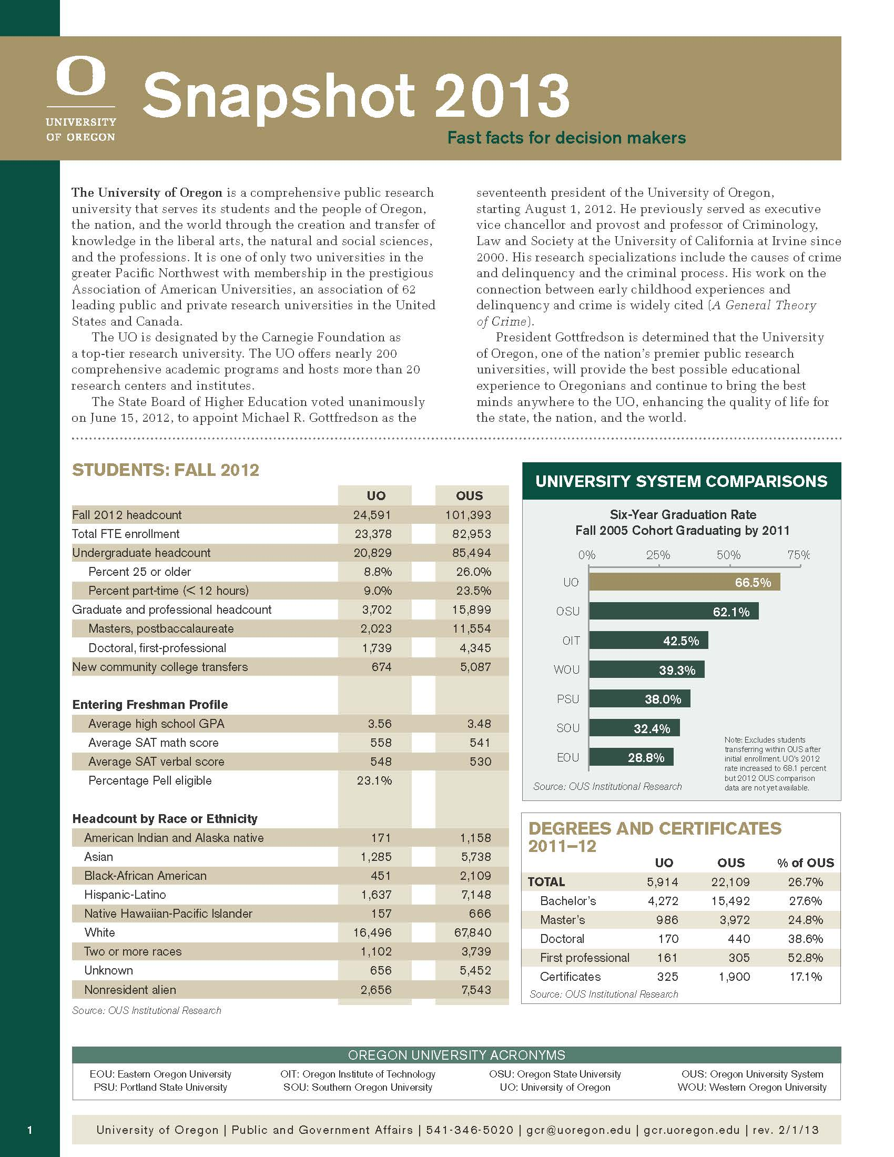

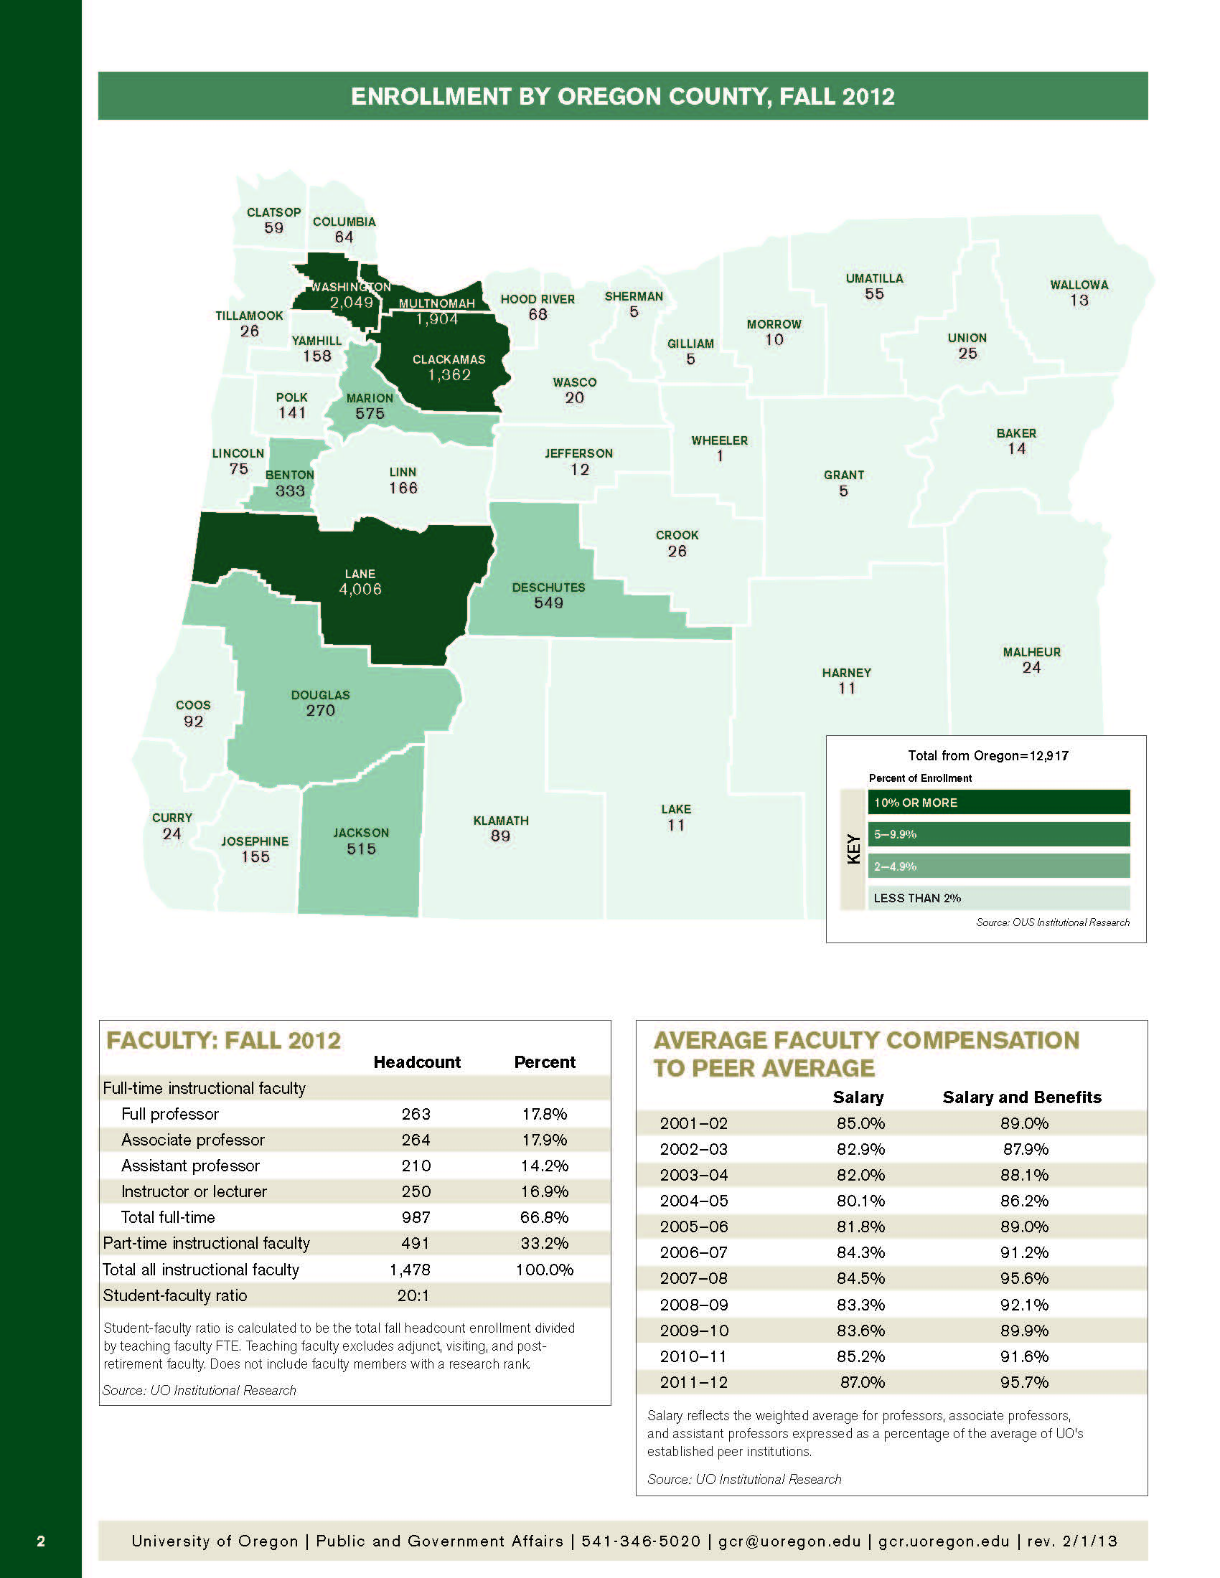

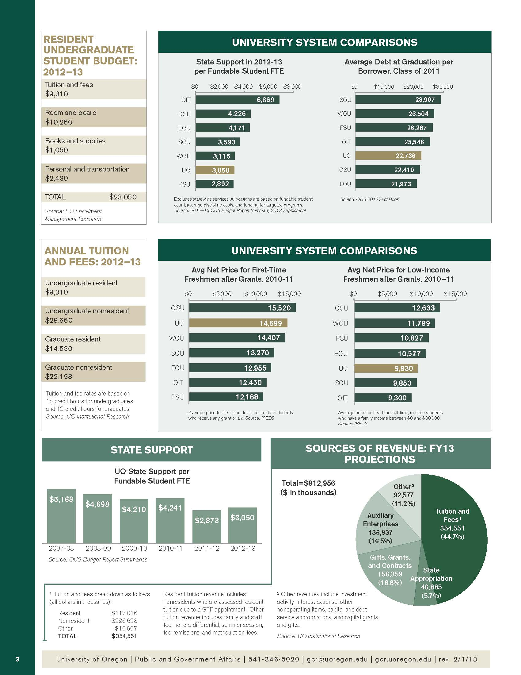

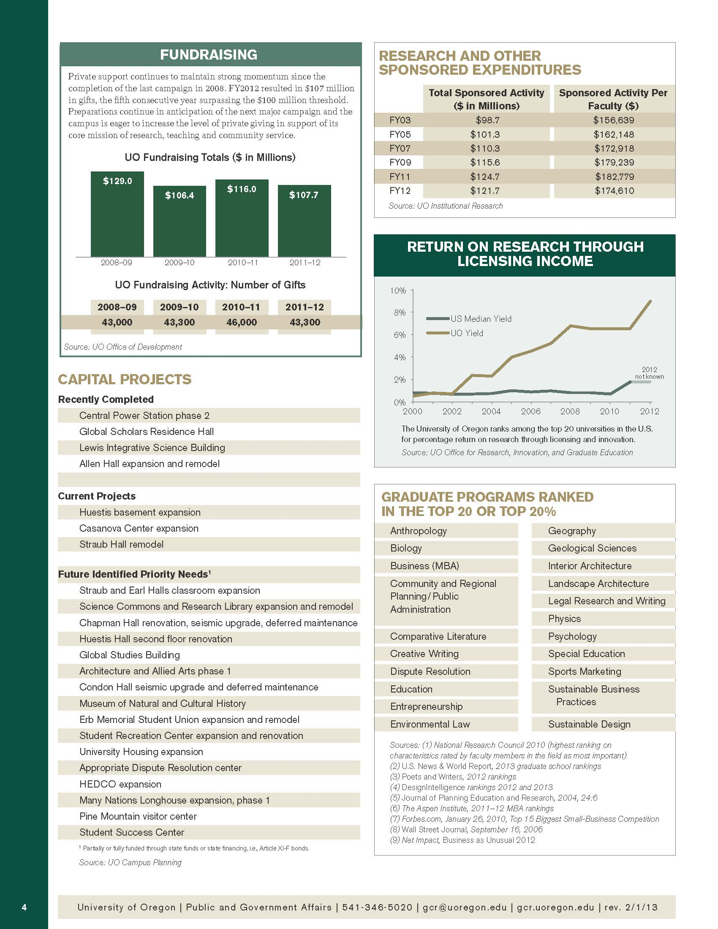

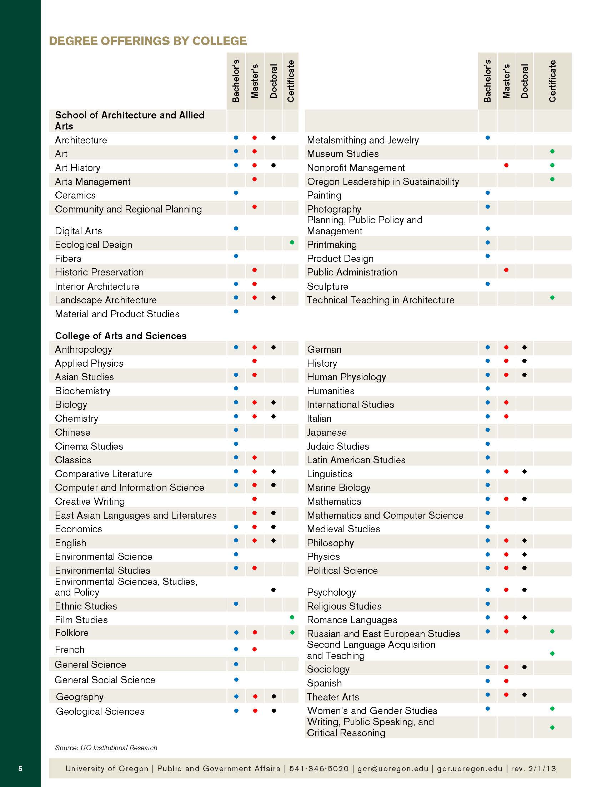

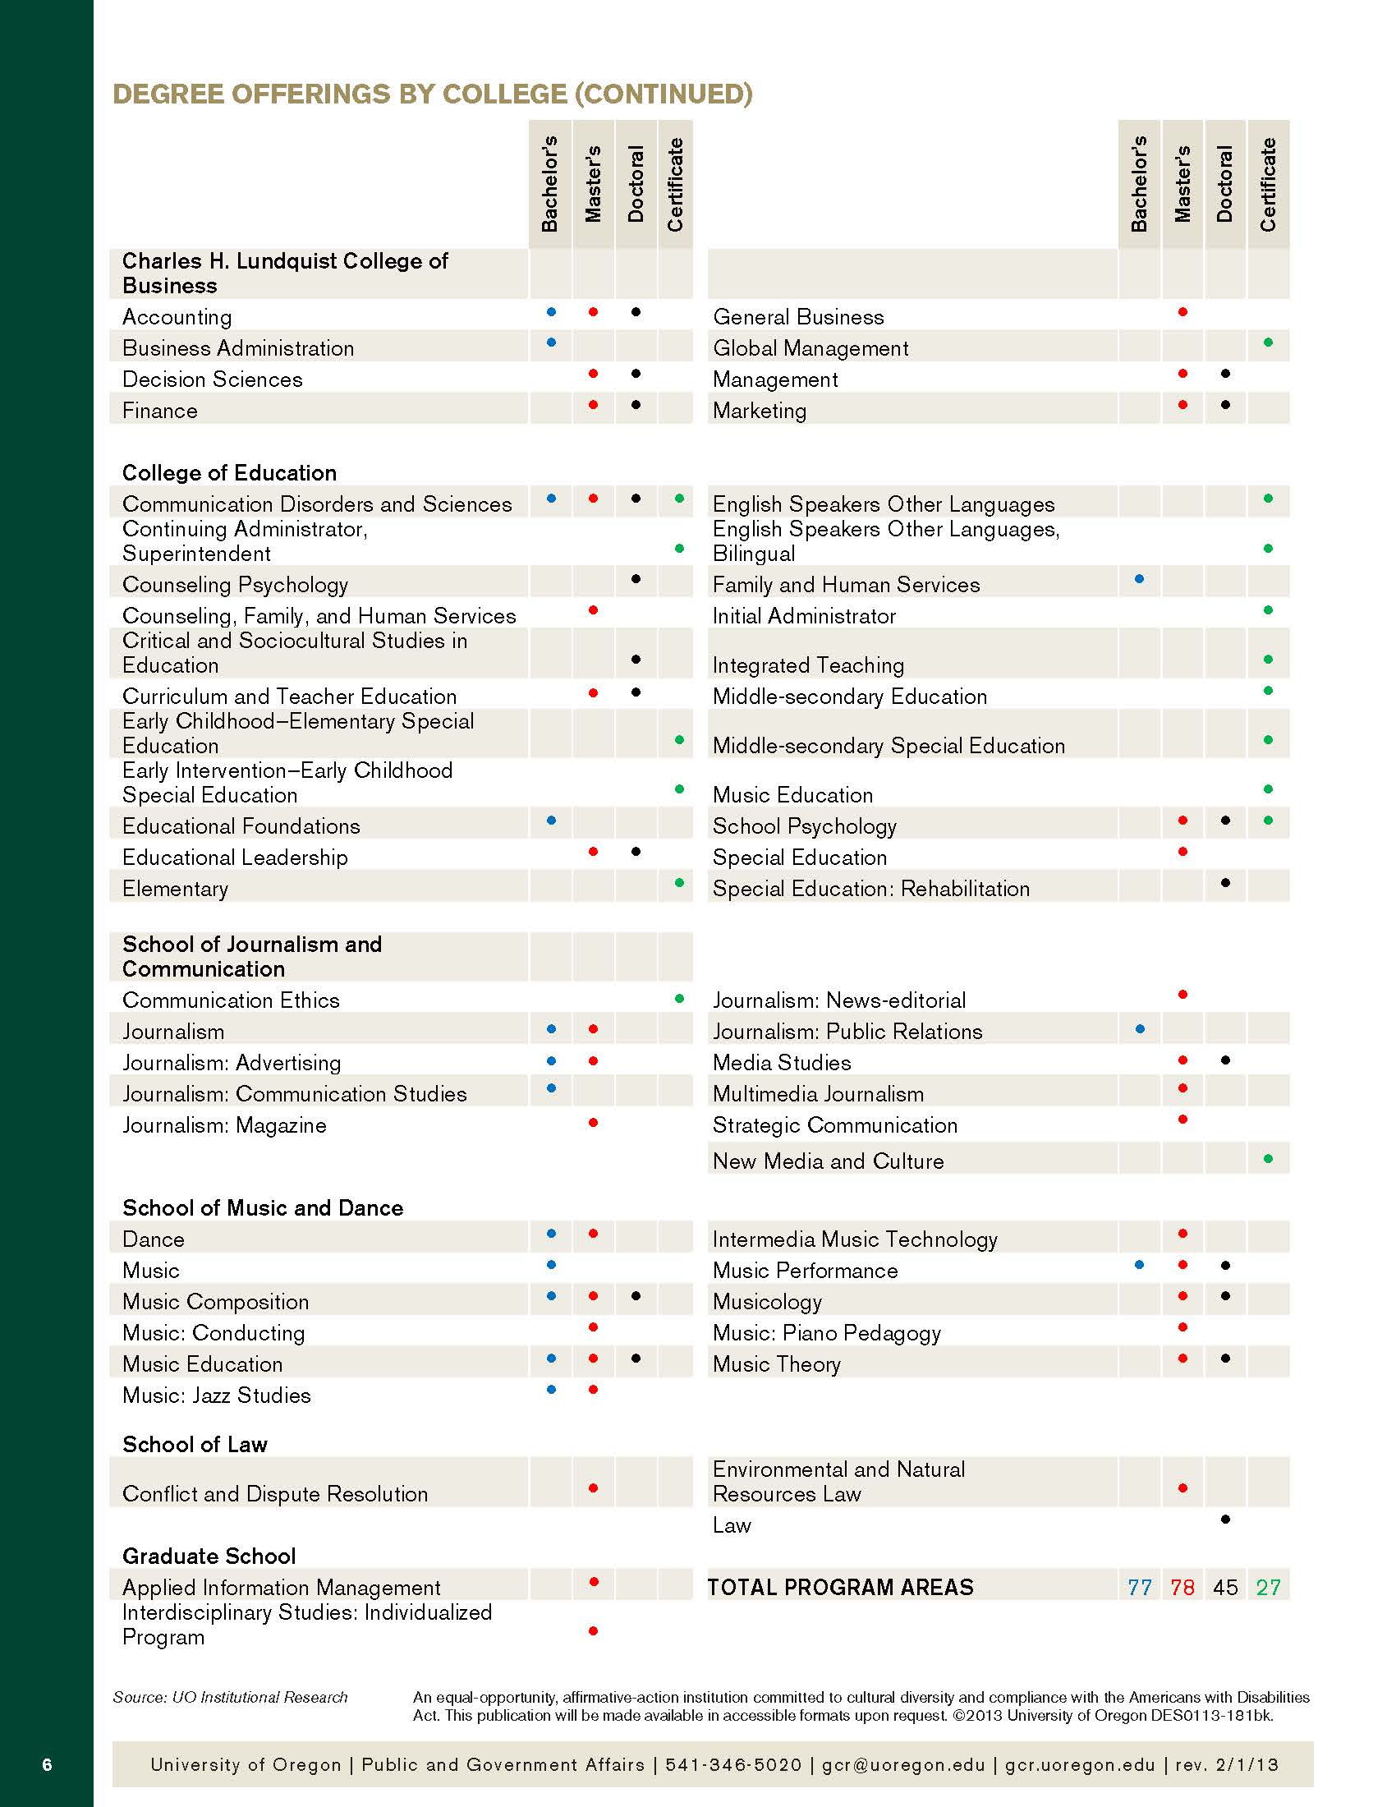

**ATTACHMENT B**

**POURING RIGHTS RFP**

**PCS No. 470000-0023-RFP**

**BEVERAGE VENDING MACHINE LOCATIONS**

|  |  |  |  |  |  |
| --- | --- | --- | --- | --- | --- |
| **Beverage Vending Machine Locations** | |  | |  |  |
|  |  |  | |  |  |
| **M #** | **Outlet/Machine Name** | **Dept.** | |  | **Est. Units** |
| 13622 | Friendly | Arts & Sciences | |  | 1,257 |
| 12918 | Columbia Hall | Geology | |  | 116 |
| 14444 | Knight Law Energy (also 17503) | Knight Law | |  | 199 |
| 14472 | Lillis | Bus Admin | |  | 3,147 |
| 14668 | Public Safety | EMU - per Allen | |  | 306 |
| 16470 | Military Science | Military Science | |  | 478 |
| 16589 | Education Bldg | Education | |  | 418 |
| 16662 | Education Bldg | Education | |  | 649 |
| 16701 | Rec Center | PARS | |  | 1,047 |
| 16705 | Knight Law | Law | |  | 922 |
| 16707 | Knight Library / D Grind | Library | |  | 1,653 |
| 16713 | EMU / Fishbowl | EMU | |  | 864 |
| 16714 | EMU / Fishbowl | EMU | |  | 727 |
| 16715 | EMU / Comp Ctr | EMU | |  | 1,448 |
| 16716 | EMU Basement | EMU | |  | 456 |
| 16717 | Columbia Hall | Geology | |  | 1,244 |
| 16722 | Earl | Housing | |  | 506 |
| 16723 | Graduate Village | Housing | |  | 383 |
| 16724 | Graduate Village | Housing | |  | 261 |
| 16725 | Earl | Housing | |  | 679 |
| 16726 | Walton / S Basement | Housing | |  | 476 |
| 16728 | Walton / N Basement | Housing | |  | 590 |
| 16729 | Riley | Housing | |  | 635 |
| 16731 | Pacific | Yamada | |  | 1,274 |
| 16732 | Bean | Housing | |  | 382 |
| 16733 | Bean | Housing | |  | 334 |
| 16734 | Pacific | Yamada | |  | 860 |
| 16735 | Sci Library / Onyx Brdg / G Floor | Sci Library | |  | 3,241 |
| 16736 | McKenzie | Comp Ctr | |  | 3,703 |
| 16737 | Lawrence/Columbia/Education | AAA | |  | 142 |
| 16738 | Oregon Hall | Admin | |  | 1,794 |
| 16740 | Walton / S Basement | Housing | |  | 153 |
| 16741 | Sci Library / Onyx Brdg / G Floor | Sci Library | |  | 951 |
| 16742 | Mckenzie | Comp Ctr | |  | 790 |
| 16759 | Oregon Hall | Admin | |  | 166 |
| 16760 | Onyx Bridge / 2nd Floor | Molec Biology | |  | 832 |
| 16761 | Onyx Bridge / 3rd Floor | Chemistry | |  | 256 |
| 16762 | Klamath | Chemistry | |  | 559 |
| 16764 | Huestis / S Ground Floor | Neuroscience | |  | 549 |
| 16765 | Huestis / S Ground Floor | Neuroscience | |  | 182 |
| 16767 | Condon | Anthropology | |  | 241 |
| 16769 | EMU / ASUO / Ground Floor | EMU | |  | 274 |
| 16770 | EMU / ASUO / Ground Floor | EMU | |  | 281 |
| 16771 | EMU / Mezzanine | EMU | |  | 404 |
| 16772 | EMU / Mezzanine | EMU | |  | 188 |
| 16774 | EMU / Mail Dock | EMU | |  | 2,756 |
| 16775 | EMU / Skylight | EMU | |  | 2,829 |
| 16776 | Susan Campbell | Chancellor | |  | 219 |
| 16777 | Straub | Psychology | |  | 849 |
| 16778 | Esslinger | PARS | |  | 281 |
| 16779 | Facilities Service | Phys Plnt-FS | |  | 2,147 |
| 16781 | Barnhart | Housing | |  | 829 |
| 16782 | PLC | Hist/Econ | |  | 1,611 |
| 16783 | PLC | Hist/Econ | |  | 721 |
| 16784 | Gerlinger | PARS | |  | 1,377 |
| 16785 | Gerlinger Annex | Dance | |  | 345 |
| 16787 | Clinical Services | CHD | |  | 549 |
| 16788 | Clinical Services | CHD | |  | 1,117 |
| 16789 | Hamilton | Housing | |  | 530 |
| 16790 | Hamilton | Housing | |  | 430 |
| 16795 | Deschutes | Comp Science | |  | 1,001 |
| 16798 | Hendricks | PPPM | |  | 333 |
| 16800 | Villard | Theatre | |  | 399 |
| 16801 | Johnson | Johnson Hall | |  | 644 |
| 16803 | Carson / 5th Floor | Housing | |  | 1,561 |
| 16806 | Gerlinger Annex | Dance | |  | 132 |
| 16809 | Rec Center | PARS | |  | 756 |
| 16810 | Allen | Journalism | |  | 143 |
| 16811 | Heustis / N Ground Floor | Biology | |  | 589 |
| 16814 | Villard | Theatre | |  | 450 |
| 16824 | Walton / Breakroom | Housing | |  | 837 |
| 16829 | Agate | Agate | |  | 967 |
| 16840 | Millrace | AAA | |  | 539 |
| 16875 | EMU/Fishbowl | EMU | |  | 3,563 |
| 16896 | Student Health Center | Health Center | |  | 1,170 |
| 16917 | Music | Music | |  | 2,892 |
| 16918 | Music | Music | |  | 867 |
| 16970 | Straub | Psychology | |  | 204 |
| 17112 | Printing Services | Printing/Mail Services | |  | 741 |
| 17315 | Willamette (also 17135) | Physics | |  | 4,627 |
| 17140 | Lillis (used as 17100 also) | Bus Admin | |  | 519 |
| 17210 | AAA Bldg | AAA | |  | 4,022 |
| 17309 | Hedco | Education Bldg | |  | 760 |
| 17500 | Rec Center | PARS | |  | 5,951 |
| 17737 | Hedco | Education Bldg | |  | 1,689 |
| 17761 | Knight Library / D Grind | Library | |  | 6,471 |
| 17764 | Knight Law | Law | |  | 846 |
| 17765 | EMU - Glass Fr | EMU | |  | 1,122 |
| 18717 | Student Health Center | Health Center | |  | 503 |
|  |  |  | |  |  |
|  |  | **Grand Total** | |  | 96,907 |
|  |  |  | |  |  |
| **Added machines since the end of FY12:** | | |  |  |  |
| Ford Alumni Center | |  | |  |  |
| UOPD East Facility | |  | |  |  |

**ATTACHMENT C**

**POURING RIGHTS RFP**

**PCS No. 470000-0023-RFP**

**SNACK VENDING MACHINE LOCATIONS**

|  |  |  |  |  |  |
| --- | --- | --- | --- | --- | --- |
| Snack Vending Machine Locations | |  |  |  |  |
| **M #** | **Outlet/Machine Name** | **Dept.** | **Gross Sales** | | **Est. Units** |
|  | RILEY HALL | RES HALL | 794.15 |  | 794 |
|  | NEW COLLEGE OF ED | College of Ed | 2,515.90 |  | 2,516 |
|  | HOUSING BEAN | RES HALL | 648.25 |  | 648 |
|  | PRINT SHOP HALLWAY | EMU | 16.20 |  | 16 |
|  | HOUSING HAMMIES | RES HALL | 860.25 |  | 860 |
|  | UNIVERSITY INN (BARNHART) | RES HALL | 706.50 |  | 707 |
|  | WALTON NORTH | RES HALL | 838.86 |  | 839 |
|  | WALTON SOUTH | RES HALL | 1,099.47 |  | 1,099 |
| 1237 | FRIENDLY 1A | ARTS & SCIENCE | 601.35 |  | 601 |
| 1011 | STRAUB HALL | CAS Psychology | 744.65 |  | 745 |
| 1090 | ESSINGLER | PARS | 267.75 |  | 268 |
| 1117 | LIBRARY LOUNGE/DAILY GRIND | Knight Library Department | 8,274.90 |  | 8,275 |
| 1147 | PHYSICAL PLANT | Physical Plant | 1,956.05 |  | 1,956 |
| 1234 | CLINICAL SERVICES | EDUC CHD | 1,294.81 |  | 1,295 |
| 1165 | EDUCATION | EDUC Dean Admin | 1,514.35 |  | 1,514 |
| 1124 | KLAMATH HALL 1ST | IMB Molecular Biology | 1,037.45 |  | 1,037 |
| 1023 | PACIFIC HALL | CAS Yamada Language Center | 2,295.95 |  | 2,296 |
| 1040 | ONYX BRIDGE 1ST | CAS Chemistry Staff | 3,696.95 |  | 3,697 |
| 1023 | HUESTES HALL | CAS Biology Coffee Fund | 981.15 |  | 981 |
| 1200 | COLUMBIA HALL | CAS Geology | 1,509.91 |  | 1,510 |
| 1014 | CONDON HALL 2ND FLR | CAS Anthropology | 487.50 |  | 488 |
| 1238 | STUDENT HEALTH CTR | SHC Student Health Center | 1,783.15 |  | 1,783 |
| 1107 | JOHNSON HALL | Johnson Hall | 867.90 |  | 868 |
| 1227 | PLC | CAS PLC Building | 1,133.25 |  | 1,133 |
| 1166 | MUSIC | School of Music | 5,419.00 |  | 5,419 |
| 1179 | LAW CENTER | Law Student Bar Assoc | 1,469.19 |  | 1,469 |
| 7292 | EMU LOBBY | EMU | 7,029.25 |  | 7,029 |
| 1015 | LAWRENCE 2ND | AAA Student Fund | 2,421.56 |  | 2,422 |
| 1002 | AGATE HALL | UA Agate Hall | 2,298.60 |  | 2,299 |
| 1040 | ONYX BRIDGE 2ND | CAS Biology Coffee Fund | 1,096.65 |  | 1,097 |
| 1038 | DESCHUTES | CAS Computer Info Science | 1,032.30 |  | 1,032 |
| 1148 | WILLAMETTE | CAS Physics Department | 2,327.75 |  | 2,328 |
| 7292 | ERB SKYLINE | EMU | 1,863.85 |  | 1,864 |
| 1178 | MCKENZIE HALL (Grayson Hall) | MCKENZIE | 4,405.05 |  | 4,405 |
| 1067 | OREGON HALL | Oregon Hall | 1,926.55 |  | 1,927 |
|  | LILLIS BUSINESS SCHOOL | LCB College of Business | 594.30 |  | 594 |
|  | STUDENT REC CENTER | PARS | 5,431.21 |  | 5,431 |
|  |  | **Grand Total** | **77,791.91** |  | **73,242** |
|  |  |  |  |  |  |
| **Added machines since the end of FY12:** | | |  |  |  |
| Ford Alumni Center | |  |  |  |  |
| 2BU Machine in EMU | |  |  |  |  |
| 2BU Machine in Rec Center | |  |  |  |  |

**ATTACHMENT D**

**POURING RIGHTS RFP**

**PCS No. 470000-0023-RFP**

**UNIVERSITY HOUSING – BEVERAGE REQUIREMENTS**

**I. Fountain Beverage Requirements.**

1. Fountain Beverage - Annual Purchases (2012)

Carson & Barnhart Cafeterias 2,000 gallons annually

Retail locations 4,500 gallons annually

**TOTAL 6,500 gallons annually**

1. Fountain Beverage – CUPS Branded Annual Purchases (2012)

22fl oz. Compostable Fountain Cups w/Lid 277,000 each annually

1. Fountain Beverage - Sales by Location – 22 fl oz.

|  |  |  |  |
| --- | --- | --- | --- |
| Common Grounds Cafe | FOUNTAIN SODA | EA | 3,214.00 |
| Fire n Spice Grill | FOUNTAIN SODA | EA | 19,986.00 |
| Grab n Go | FOUNTAIN SODA | EA | 40,199.00 |
| Big Mouth Burrito | FOUNTAIN SODA | EA | 57,708.00 |
| Late Night Carson | FOUNTAIN SODA | EA | 12,489.00 |
| Fresh Marketcafe | FOUNTAIN SODA | EA | 29,324.00 |
| DUX Bistro | FOUNTAIN SODA | EA | 33,951.00 |

**II. Fountain Beverage Equipment Needs by Location.** University will require separate accounts and invoices required for each unit of operation.

1. Carson Dining

1450 E. 13th

Eugene, OR 97403

* 1. 1 each – Cornelius Ice Bin Over w/6 flavor BIB fountain w/water

1. Barnhart Hall

1000 Paterson

Eugene, OR 97401

* 1. 1 each - Cornelius Ice Bin Over w/6 flavor BIB fountain w/water
  2. 1 each - 10 flavor BIB Bar Gun

1. Grab n Go Market

1650 E. 13th

Eugene, OR 97403

* 1. 2 each - Cornelius Ice Bin Over w/8 flavor BIB fountain w/water

1. Common Grounds Cafe

Same as above

* 1. 1 each – 10 flavor BIB Bar Gun

1. Big Mouth Burrito

Same as above

* 1. 1 each - Cornelius Ice Bin Over w/6 flavor BIB fountain w/water

1. Dux Bistro

Living Learning Center North, E. 15th

Eugene, OR 97403

* 1. 1 each - 8 flavor Follett under counter ice bin fountain w/water
  2. 1 each - 10 flavor BIB Bar Gun

1. Fresh! Marketcafe

Global Scholars Hall

1590 Moss St.

* 1 each - 8 flavor Follett under counter ice bin fountain w/water
* 1 each - 10 flavor BIB Bar Gun

**III. Retail Bottled Beverage Information.**

**III(A) Bottled Beverage Sales Locations and Equipment.** University will require separate accounts and invoices required for each unit of operation.

**Location**  **Beverage Coolers**

1. Barnhart Hall 2 open air mixed product coolers

1000 Paterson approximately 70 facings

Eugene, OR 97401

1. Grab n Go Market* 23 beverage cooler doors

1650 E. 13th approximately 900 facings

Eugene, OR 97403 (*all coolers are vendor provided)

1. Common Grounds Café 2 half beverage cooler doors

Same as above approximately 27 facings

1. Fire n Spice Grill 2 beverage cooler doors

Same as above approximately 113 facings

1. Dux Bistro 3 open air mixed product coolers

Living Learning Center North, E. 15th approximately 100 facings

Eugene, OR 97403

1. Fresh! Marketcafe 6 beverage cooler doors

Global Scholars Hall approximately 210 facings

1590 Moss St.

3 open air mixed product coolers

approximately 124 facings

1. University Catering Catering Event Sales Displays

Bean Hall - 1416 Columbia St

Eugene, OR 97403

**III(B) University Housing Annual Bottled Beverage Purchases (2012).**

|  |  |
| --- | --- |
| **Category** | **Units** |
| 1. Carbonated Soft Drinks | 63,177 |
| 1. Coffee Drinks | 26,112 |
| 1. Energy Drinks | 16,366 |
| 1. Bottled Juice | 162,180 |
| 1. Non-Carb Drinks | 56,375 |
| 1. Sports Drinks | 57,696 |
| 1. Bottled Tea | 73,174 |
| 1. Bottled Water | 92,920 |
| **Total** | **548,000** |

**IV. Beverage Product Category Requirements.** University Housing requires the following beverage categories to be supplied and supported as part of the **exclusivity** agreement under the pouring rights contract.

**Category Examples of Products**

1. Carbonated Beverages Cola & Related Beverages – Bottled &

Fountain

1. Pure Bottled Water Aquafina, Dasani
2. Enhanced Water Vitamin Water, Smart Water, Propel
3. Energy Drinks FRS, Red Bull, Amp, Rock Star, Monster
4. Fresh Juice Odwalla, Naked Juice
5. Juice from Concentrate Minute Maid, Tropicana, Ocean Spray
6. Juice BIB 100% Apple Juice, BIB Bar Gun
7. Protein Beverages Muscle Milk
8. Electrolyte/Isotonic Gatorade, Powerade, Allsport
9. Bottled/Canned Coffee Beverages Starbucks, Illy
10. Bottled/Canned Tea Beverages Lipton, Honest Tea

**ATTACHMENT E**

**POURING RIGHTS RFP**

**PCS No. 470000-0023-RFP**

**ERB MEMORIAL UNION (Food Services) – BEVERAGE REQUIREMENTS**

**I. Fountain Beverage Requirements.**

1. Fountain Beverage - Annual Purchases (2012)

Retail locations 970 gallons annually

**TOTAL 970 gallons annually**

1. Fountain Beverage – CUPS Branded Annual Purchases (2012)

22 fl oz. Compostable Fountain Cups w/Lid 65,000 each annually

1. Fountain Beverage - Sales by Location – 22 fl oz.

|  |  |  |  |
| --- | --- | --- | --- |
| The Fishbowl Grill | FOUNTAIN SODA | EA | 13,321 |
| The Marketplace | FOUNTAIN SODA | EA | 8,483 |
| Union Market | FOUNTAIN SODA | EA | 27,822 |
| Buzz Cafe | FOUNTAIN SODA | EA | 8,674 |
| Lillis Cafe | FOUNTAIN SODA | EA | 4,109 |
| Education Station | FOUNTAIN SODA | EA | 2,581 |
|  |  |  |  |

**II. Fountain Beverage Equipment Needs by Location.** University will require separate accounts and invoices required for each unit of operation.

1. The Fishbowl Grill

1228 University of Oregon

Eugene, OR 97403

* + 1 each – International Carbonic Ice Bin Over w/5 flavor BIB fountain

1. The Marketplace

1228 University of Oregon

Eugene, OR 97401

* + 1 each - Cornelius Ice Bin Over w/8 flavor BIB fountain w/water

1. The Buzz Cafe

1228 University of Oregon

Eugene, OR 97403

* + 1 each - International Carbonic Ice Bin Over w/7 flavor BIB fountain

1. Lillis Café

955 East 13th Ave

Eugene, OR 97403

* + 1 each – Service Vend Ice Generator Top w/6 flavor BIB fountain

1. Education Station (College of Education)
2. University of Oregon

Eugene, OR 97403

* 1. 1 each - Cornelius Ice Generator Top w/6 flavor BIB fountain w/water

**III. EMU (Food Services) – Retail Bottled Beverage Information.**

**III(A) Bottled Beverage Sales Locations and Equipment.** University will require separate accounts and invoices required for each unit of operation.

**Location**  **Beverage Coolers**

1. The Fishbowl Grill 1 beverage cooler door

1228 University of Oregon approximately 32 facings

Eugene, OR 97403

1. Union Market 16 beverage cooler doors

1228 University of Oregon approximately 550 facings

Eugene, OR 97403

1. The Buzz Cafe 1 beverage cooler door

1228 University of Oregon approximately 32 facings

Eugene, OR 97403

1. Daily Grind (Knight Library) 8 beverage cooler doors

1501 Kincaid approximately 251 facings

Eugene, OR 97403

1. Lillis Cafe 2 beverage cooler doors

955 East 13th Ave approximately 20 facings

Eugene, OR 97403

1. College of Education 6 beverage cooler doors

1225 University of Oregon approximately 163 facings

Eugene, OR 97403

1. College of Architecture 3 beverage cooler doors

1229 University of Oregon approximately 40 facings

Eugene, OR 97403

**III(A) EMU Food Services Annual Bottled Beverage Purchases (2012).**

|  |  |
| --- | --- |
| **Category** | **Units** |
| 1. Carbonated Soft Drinks | 73,715 |
| 1. Coffee Drinks | 6,741 |
| 1. Energy Drinks | 26,677 |
| 1. Bottled Juice | 72,388 |
| 1. Non-Carb Drinks | 4,884 |
| 1. Sports Drinks | 14,295 |
| 1. Bottled Tea | 16,296 |
| 1. Bottled Water | 17,248 |
| **Total** | **232,244** |

**IV. EMU Food Services – Beverage Product Category Requirements.** Currently, EMU Food Services requires the following beverage categories to be supplied and supported as part of the **exclusivity** agreement under the pouring rights contract.

**Category Examples of Products**

1. Carbonated Beverages Cola & Related Beverages – Bottled &

Fountain

1. Pure Bottled Water Aquafina, Dasani
2. Enhanced Water Vitamin Water, Smart Water, Propel
3. Energy Drinks FRS, Red Bull, Amp, Rock Star,
4. Fresh Juice Odwalla, Naked Juice, Columbia Gorge
5. Juice from Concentrate Minute Maid, Tropicana, Ocean Spray
6. Protein Beverages Muscle Milk
7. Electrolyte/Isotonic Gatorade, Powerade, Allsport
8. Bottled/Canned Coffee Beverages Starbucks, Illy
9. Bottled/Canned Tea Beverages Lipton, Honest Tea

**ATTACHMENT F**

**POURING RIGHTS RFP**

**PCS No. 470000-0023-RFP**

**THE DUCK STORE – BEVERAGE REQUIREMENTS**

|  |  |  |
| --- | --- | --- |
| The Duck Store |  |  |
| 856 Facings | 18 Cooler Doors | |
|  |  |  |
| Category | Units Sold FYTD |  |
| Carbonated Soft Drinks (CSD) | 23,340 |  |
| CSD Fountain | 2,794 |  |
| Coffee | 2,612 |  |
| Electrolyte/Isotonic | 4,593 |  |
| Energy Drinks | 14,038 |  |
| Enhanced Water | 3,580 |  |
| Juice | 7,585 |  |
| Protein Beverages | 1,102 |  |
| Pure Bottled Water | 13,674 |  |
| Ready to Drink Tea (RTD Tea) | 6,815 |  |
|  |  |  |
| Total | 80,133 |  |
|  |  |  |
| Campus Location | 696 Facings | 15 Cooler Doors |
| 895 E. 13th Avenue, Eugene |
| Court Café @ Knight Law Center | 80 Facings | 2 Cooler Doors |
| 1515 Agate Street, Eugene |
| The White Stag | 80 Facings | 2 Cooler Doors |
| 70 NW Couch Street, Portland |
|  |  |  |

**ATTACHMENT G**

**POURING RIGHTS RFP**

**PCS No. 470000-0023-RFP**

**MARKETING AND SPONSORSHIP OPPORTUNITIES**

1. Use of University’s Proprietary Marks. Subject to the terms and conditions of any awarded pouring rights contract, Contractor will have limited, non-exclusive license rights to use certain University marks, logos, and trade names to promote the products and services under the awarded pouring rights contract. Contractor is encouraged to do such promotion by using media, promotional materials, point-of-sale materials, signage, packaging, co-branding of product and other means of advertising. Notwithstanding the foregoing, all materials, including but not limited to, creative materials, catalogs, brochures, email, website content and other promotional and marketing materials, containing University’s marks, logos, trade names or other proprietary information must be approved in advance by University and must comply with University’s Style and Grammar Guide and University’s brand management strategy. University may disapprove for use any creative content that University deems, in University’s sole discretion, to be inappropriate or inconsistent with University’s branding.

2. EMU Student Union has several sponsorship elements to offer a contractor awarded a pouring rights contract, including events, marketing opportunities on-site and the branding of different educational and extracurricular campus programs.

Events taking place in association with the EMU Student Union offer the contractor the opportunity to reach students and their families on-site, through flyers, sampling, giveaways and various signage opportunities, as well as through advertising and messaging on campus social media, online, print, radio and TV. The following is a partial list of events that may be included as part of a pouring rights contract awarded under this RFP:

* Ducks After Dark is a weekly late-night movie event with a great reputation and growing fan base on campus.
* Intermingle is a freshmen introductory social night that attracts all incoming freshmen students and their families each year.
* The Break, a campus bar that is will open soon, provides sampling, branding, and various advertising elements.
* Pub Night is the annual responsible drinking party.
* Student Activities and Resource Center, or the campus group responsible for student ideas and events collaboration, is dedicated to running and hosting several events every month that appeal to students both academically and socially.

Various areas within the EMU Student Union offer a contractor awarded a pouring rights contract the opportunity to brand with signage and logo rights, to interact with students and attendees through giveaways, sampling and surveying, and to utilize campus media to promote, educate and drive awareness to any on-site events they would like to host. The following is a sampling of areas available for the mentioned sponsorship reach opportunities:

* Nine (9) markets associated with the EMU Student Union that offer cooler and banner advertising, product display opportunities, and integrated campus media.
* Various EMU Student Union areas provide ample opportunity for lounge and experiential area branding, window and wall branding, promotional table tents and receptacle branding.
* Ticket Office offers ads on ticket backs and envelopes as well as wall and window branding and campus media.
* Campus programs provide additional advertising and branding opportunities for different periods of the school year, and offer extremely integrated sponsorship elements reaching students, faculty and visitors.
* Club Sports programsinclude 48 member clubs playing over 200 events annually, and offer a contractor awarded a pouring rights contract the ability to brand every event through jersey logos, signage, sampling, giveaways and campus media.
* Willamette Valley Music Festival, an annual campus music festival taking place in May, includes branding opportunities for several stages and giveaways, as well as opportunities for additional sampling and campus media.
* Bike Share Network is a bicycle rental program with automated stations on campus that are available to brand and reach participants through sampling and giveaways and additional campus media.

3. University Housing is including sponsorship opportunities for a contractor awarded a pouring rights contract, such as associated event recognition and on-site branding all year long. All events associated with University Housing include sampling, branding on-site, and various campus media options. The following are some of the many such events:

* Unpack the Quack is move in day for students, and gives a contractor awarded a pouring rights contract the opportunity to reach students and their families through branding of volunteers as well as sampling, media and other branding options.
* Student events, activities and traditions may provide a contractor awarded a pouring rights contract the opportunity to reach students through coordinated sampling, media and other branding opportunities
* Community Conversations
* Crash Course
* LLC Block Party
* Hike to the “O”
* Learn Like a Duck
* Spirit Week
* Leadership Banquet and Retreat

Various areas and housing-network media opportunities offer attractive branding and integration opportunities with University Housing, such as:

* Room tours and Welcome Bags that all incoming students receive each year.
* Dining areas offer ample branding, digital and static advertising, sampling and product placement options.
* Room products, such as door hangers, dispensers, cups, and folders that students receive several times throughout the year.
* Fountains and coolers are ready for full branding.
* Recycling and trash receptacles and ready for full branding.

There are also several different programs affiliated with University Housing that a contractor awarded a pouring rights contract may help to coordinate and integrate branding to maximize a campus-wide sponsorship package.

4. The Department of Physical Education and Recreation features many on-site branding opportunities to reach attendees multiple times throughout the year, as well as specific event branding to reach different groups in creative ways. Various events associated with the Department of Physical Education and Recreation that will include pouring rights sponsorship recognition, media, giveaways and sampling include, but are not limited to:

* Fitness Week is a weeklong celebration of special fitness events.
* NC3 Climbing Competition is a regional rock climbing competition of top competitive climbers vying for spots on the national team.
* Faculty and Staff Walk/ 5K Run is a noon hour event that includes a walk and 5K run.
* Women on Weights is a special weekend weight training class that targets women.
* All Sizes Fit Week includes a partnership with the University Health Center offering a week of educational sessions, speakers, panel discussions and fitness events.

On-site branding, sampling, static and digital advertising, naming rights opportunities and integrated campus media are all part of the following sampling of sponsorship elements included into the pouring rights package:

* Facility signage on LCD advertising space, walls, and cardio equipment can reach over 7,500 people daily.
* Physical Education and Recreation branding include logos on sports pinnies, staff shirts, athletic training shirts, championship shirts, instructor shirts and sports camps shirts.
* Sport equipment branding includes logo on scoreboards, floors, portable basketball hoops, electric golf carts, balls used in various sports and course equipment.
* Facility branding includes promotional table tents, recycling and trash receptacle branding and locker room signage.

There are also several different programs affiliated with the Department of Physical Education that a contractor awarded a pouring rights contract may help to coordinate and integrate branding to maximize a campus-wide sponsorship package.

5. There are several sponsorship elements included for the campus Duck Store that can reach students, faculty and visitors throughout the school year through various on-site, sampling and media opportunities. The following sponsorship elements may be offered to a contractor awarded a pouring rights contract:

* Signage throughout the Duck Store.
* TV network advertisements that reach the Oregon campus as well as other networked Duck Stores in the region.
* Sampling within the campus Duck Store as well as the nearby credit union.
* Recycling and trash receptacles are ready for full branding.
* Product display dedicated to products provided by a contractor awarded a pouring rights contract.
* Co-branded giveaways to advertise and promote sustainability initiatives.

Along with branding elements, a contractor awarded a pouring rights contract will also have access to special events taking place around various Duck Store promotions, as well as programs aimed at reaching students and faculty throughout the school year.

In addition to the above four areas of campus, a contractor awarded a pouring rights contract will have access to substantially all University visitors, students, faculty and staff. , It is important to note that the University is open to adding additional sponsorship inventory into this agreement through both on-campus sampling, surveying and branding, as well as off-campus media and advertising integration controlled by University.

**ATTACHMENT H**

**POURING RIGHTS RFP**

**PCS No. 470000-0023-RFP**

UO STANDARD CONTRACT PROVISIONS

1. **ACCESS TO RECORDS.** Contractor will maintain records, sufficient to accurately document its performance of this Contract. University will have access to such records of Contractor for the purpose of determining compliance with this Contract. Contractor will retain all such records, for a minimum of six years following final payment under or termination of this Contract, or such longer period as may be required by applicable law or to conclude any audit, review, or controversy.
2. **INDEMNITY FOR INFRINGEMENT CLAIMS.** EXCEPT TO THE EXTENT ARISING FROM MATERIALS PROVIDED TO CONTRACTOR BY UNIVERSITY, WHICH MATERIALS ARE UTILIZED BY CONTRACTOR IN THEIR UNALTERED FORM AND WITHOUT LIMITING THE GENERALITY OF THE INDEMNIFICATION CLAUSE REFERENCED IN THE HOLD HARMELSS SECTION BELOW, CONTRACTOR EXPRESSLY AGREES TO INDEMNIFY AND HOLD HARMLESS UNIVERSITY AND ITS DIRECTORS, OFFICERS, EMPLOYEES, AND AGENTS FROM AND AGAINST ANY AND ALL CLAIMS, SUITS, ACTIONS, LOSSES, LIABILITIES, COSTS, EXPENSES, AND DAMAGES ARISING OUT OF OR RELATED TO ANY CLAIMS THAT THE DELIVERABLES INFRINGE ANY PATENT, COPYRIGHT, TRADE SECRET, TRADEMARK, TRADE DRESS, MASK WORK, UTILITY DESIGN, OR OTHER PROPRIETARY RIGHT OF ANY THIRD PARTY. The indemnity under this Section will not apply to the extent such alleged or actual infringement arises as a result of (i) modifications of such work made by University which were not approved by Contractor, or (ii) Contractor’s compliance with any of University’s designs, specifications or instructions. In the event that a court of competent jurisdiction determines in a final, nonappealable order that the work is infringing in a manner for which Contractor is obligated to indemnify University pursuant to this Section, Contractor will, at its option, (1) procure for University the right to continue using such infringing work; (2) replace the infringing work with a non-infringing item of like form, fit or function; or (3) modify the work so that it no longer infringes.
3. **HOLD HARMLESS.** Contractor will be responsible for all damage to property, injury to persons, and loss, expense, inconvenience, and delay which may be caused by, or result from any act or omission of Contractor, its subcontractors, agents, or employees. Contractor will indemnify and hold harmless University and its governing board and their directors, officers, agents, employees, and members from all claims, suits, and actions of any nature resulting from or arising out of the acts or omissions of Contractor or its subcontractors, officers, agents, or employees.
4. **INSURANCE.** Contractor will secure insurance at Contractor’s expense and keep that insurance in effect during the term of this Contract as indicated by University.
5. **INDEPENDENT CONTRACTOR STATUS.** The service(s) to be rendered under this Contract are those of an independent contractor. Contractor is not to be considered an agent or employee of University for any purpose, and neither Contractor nor any of Contractor's agents or employees are entitled to any of the benefits that University provides for its employees. Nothing in this Contract will be construed to create a partnership, joint venture, franchise, agency, or employment relationship between the Parties.
6. **OWNERSHIP OF WORK PRODUCT.**  All work product of Contractor that results from this Contract (“Work Product”) is the exclusive property of University. University and Contractor intend that such Work Product be deemed "work made for hire" of which University will be deemed the author. If for any reason the Work Product is not deemed "work made for hire," Contractor by this Contract irrevocably assigns to University all its right, title, and interest in and to any and all of the Work Product, whether arising from copyright, patent, trademark, trade secret, or any other state or federal intellectual property law or doctrine. Contractor will execute such further documents and instruments as University may reasonably request in order to fully vest such rights in University. Contractor forever waives any and all rights relating to the Work Product, including without limitation, any and all rights arising under 17 USC 106A or any other rights of identification of authorship or rights of approval, restriction or limitation on use or subsequent modifications.
7. **REPRESENTATIONS AND WARRANTIES.** Contractor represents and warrants that (1) Contractor has the power and authority to enter into and perform this Contract; (2) The individual signing for Contractor is authorized to execute this Contract on behalf of Contractor; (3) This Contract, when executed and delivered, will be a valid and binding obligation of Contractor, enforceable in accordance with its terms; (4) The work under this Contract will be performed in a good and workmanlike manner and in accordance with the highest professional standards; (5) Contractor will, at all times during the term of this Contract, be qualified, professionally competent, and duly licensed to perform the work; and (6) Contractor’s name, as it appears in this Contract, is Contractor’s legal name, as it will appear in the Contractor’s W-9, and if Contractor is an entity rather than an individual that the entity named in this Contract is validly existing and in good standing. The warranties set forth in this Section are in addition to, and not in lieu of, any other warranties provided.
8. **SUBCONTRACTS AND ASSIGNMENTS.** Contractor will not subcontract, assign, or transfer any of its interest in this Contract without obtaining prior written approval from University, which consent may be withheld by University in its sole discretion. As a condition to requesting prior written approval, Contractor must provide a written copy of any such proposed assignment or subcontract to University. University's consent to any assignment or subcontract will not relieve Contractor of any of its duties or obligations under this Contract. Any assignment or subcontract in contravention of this Section will be null and void.
9. **TERMINATION.** (a) This Contract may be terminated at any time by mutual written consent of both Parties. (b) University may at its sole discretion terminate this Contract in whole or in part upon thirty 30-days’ written notice to Contractor. (c) University may terminate this Contract effective upon delivery of written notice to Contractor, or at such later date as may be established by University: (i) federal or state laws, rules, regulations, or guidelines are modified or interpreted in such a way that any Deliverables or services to be provided by Contractor under this Contract are no longer allowable or appropriate for purchase by University or are no longer eligible for the funding proposed for payment authorized by this Contract; (ii) any license or certificate required by law or regulation to be held by Contractor to provide Deliverables under this Contract is denied, revoked, or not renewed for any reason; (iii) if Contractor becomes insolvent or admits in writing its inability to pay its debts as they mature, or makes an assignment for the benefit of creditors; (iv) if a petition under any foreign, state, or United States bankruptcy act, receivership statute, or the like, as they now exist, or as they may be amended, is filed by Contractor; or (v) if such a petition is filed by any third party, or an application for a receiver is made by anyone and such petition or application is not resolved favorably to Contractor within ninety (90) calendar days. (d) University may terminate by written notice of default (including breach of contract) to Contractor the whole or any part of this Agreement if: (i) Contractor fails to provide services called for by this Agreement within the time specified in this Agreement or any extension of this Agreement; or (ii) Contractor fails to perform any of the other provisions of this Agreement, or fails to pursue the Work so as to endanger performance of this Agreement in accordance with its term and, after receipt of written notice from University, fails to correct such failures within 10 days or such longer period as University may determine at University’s sole discretion. In addition to the right to terminate, in the event of a default by Contractor under this section, University will have all other rights and remedies at law or in equity.
10. **TERMINATION DUE TO NONAPPROPRIATION OF FUNDS.** University may terminate this Contract upon written notice to Contractor if University has not: (a) Received from the Oregon Legislative Assembly appropriations, limitations or other expenditure authority, or (b) Received allotments pursuant ORS Chapter 291 sufficient to allow University, in the exercise of its reasonable administrative discretion, to pay the amounts of this Contract.
11. **REMEDIES.** (a) In the event of termination pursuant to Section 9(b), 9(c)(i), or 10, Contractor's sole remedy will be a claim for the sum designated for accomplishing the work multiplied by the percentage of work completed and accepted by University, less previous amounts paid and any claim(s) which University has against Contractor. If previous amounts paid to Contractor exceed the amount due to Contractor under this subsection, Contractor will pay any excess to University upon demand. (b) In the event of termination pursuant to Sections 9(c)(ii) or (d), University will have any remedy available to it in law or equity. If it is determined for any reason that Contractor was not in default under these subsections, the rights and obligations of the Parties will be the same as if the Contract was terminated pursuant to Section 9(b). (c) Upon receiving a notice of termination of this Contract, Contractor will immediately cease all activities under this Contract, unless University expressly directs otherwise in writing. Upon termination of this Contract, Contractor will deliver to University all Work Product, documents, information, works-in-progress and other materials that are or would be deliverables or otherwise the property of University had the Contract been completed. Upon University's request, Contractor will surrender to anyone University designates, all documents, research or objects or other tangible things needed to complete the work.
12. **CONFLICT OF INTEREST.** Contractor covenants that it presently has no interest and will not acquire any interest, direct or indirect, which would conflict in any manner with or prohibit Contractor’s full performance of this Contract. Contractor also covenants that in the performance of this Contract no person having any such interest will be employed. Contractor further covenants that its performance of this Contract will not cause any employee or volunteer of University to violate ORS Chapter 244.
13. **NON-RESIDENT FOREIGN CONTRACTORS.** For non-resident foreign Contractors with U.S. sourced income, University will withhold Federal Tax at the applicable tax rate from Contractor's fee unless Contractor is eligible for tax treaty benefits, or qualifies for exemption under other areas of the tax code.  Contractor must provide a completed and signed US Internal Revenue Service (IRS) Form to claim tax treaty benefits (8233 or appropriate W8 form). Contractor must have a U.S. reporting Identification Number, a Social Security Number (SSN), IRS Tax Identification Number (ITIN), or Employer Identification Number (EIN) to be eligible for tax treaty benefits. If applicable, Contractor will enter the US in a legal status allowing Contractor to work for University as evidenced by the US Citizenship and Immigration Services (USCIS) I-94 stamped or attached to Contractor’s passport or this Contract is void.
14. **LIMITATION OF LIABILITIES.** UNIVERSITY WILL NOT BE LIABLE FOR (i) ANY INDIRECT, INCIDENTAL, CONSEQUENTIAL, OR SPECIAL DAMAGES UNDER THIS CONTRACT, OR (ii) ANY DAMAGES OF ANY SORT ARISING SOLELY FROM THE TERMINATION OF THIS CONTRACT IN ACCORDANCE WITH ITS TERMS.
15. **NOTICES.** Except as otherwise expressly provided in this Contract, any communications between the Parties or notices to be given under this Contract will be given in writing by personal delivery, facsimile, or mailing the same, postage prepaid, to Contractor or University at the address or number set forth on the signature page of this Contract, or to such other addresses or numbers as the Parties may from time to time direct in writing. Any communication or notice so addressed and mailed will be deemed to be given five days after mailing. Any communication or notice delivered by facsimile will be deemed to be given when receipt of the transmission is generated by the transmitting machine. To be effective against University, such facsimile transmission must be confirmed by telephone notice to University's supervising representative. Any communication or notice by personal delivery will be deemed to be given when actually delivered.
16. **CAPTIONS.** The captions or headings in this Contract are for convenience only and in no way affect the meaning or interpretation of this Contract.
17. **COMPLIANCE WITH APPLICABLE LAW.** Contractor will comply with all applicable federal, state, county, and local laws, ordinances, regulations, and University policies. Contractor also agrees to comply with all applicable laws prohibiting discrimination on the basis of race, sex, national origin, religion, age, sexual orientation, status as a veteran, or handicap.
18. **GOVERNING LAW; JURISDICTION; VENUE.** This Contract will be governed and construed in accordance with the laws of the State of Oregon without regard to principles of conflicts of law. Any claim, action, or suit between University and Contractor will be brought and conducted solely and exclusively within a Circuit Court for the State of Oregon. However, if any claim, action, or suit must be brought in a federal forum, it will be brought and conducted exclusively in the United States District Court for the District of Oregon. In no event will any part of this Contract be construed as a waiver by University of its sovereign and governmental immunities. BY EXECUTION OF THIS CONTRACT, CONTRACTOR CONSENTS TO IN PERSONAM JURISDICTION OF SUCH COURTS.
19. **RECYCLED PRODUCTS.** Unless expressly otherwise provided for in this Contract, all paper products will be sourced from mills using elemental chlorine-free processes and contain a minimum of 30% post-consumer waste.
20. **HAZARD COMMUNICATION.** Contractor will notify University prior to using products containing hazardous chemicals to which University employees may be exposed. Products containing hazardous chemicals are those products defined by Oregon Administrative Rules Chapter 437.
21. **SURVIVAL.** All provisions of this Contract that would reasonably be expected to survive the termination of this Contract will do so.
22. **SEVERABILITY.** If any term or provision of this Contract is declared by a court of competent jurisdiction to be illegal or in conflict with any law, the validity of the remaining terms and provisions will not be affected. The Parties agree to attempt to substitute for any illegal or unenforceable provision a valid or enforceable one that achieves the economic, legal and commercial objectives of the illegal and unenforceable provision to the greatest extent possible.
23. **SUCCESSORS IN INTEREST.** This Contract will be binding upon and will inure to the benefit of the Parties, and their respective successors and assigns.
24. **ECONOMIC OPPORTUNITIES.** Contractor will, when applicable, have made good faith efforts to work with or obtain materials to be used in performing the Contract from minority-owned, women-owned, and emerging small business enterprises.
25. **FOREIGN CORRUPT PRACTICES.** Contractor shall comply with all applicable laws relating to anti-corruption or anti-bribery, including, but not limited to, the requirements of the Foreign Corrupt Practices Act of 1977, as amended, (FCPA)(15 U.S.C. §§78dd-1, et. seq.), regardless of whether contractor is within the jurisdiction of the United States. Contractor shall not, either directly nor indirectly, pay, offer, give, or promise to pay or give, any portion of monies or anything of value received from the University to a public official or any person in violation of the FCPA and/or in violation of any applicable local laws relating to anti-corruption or anti-bribery.
26. **FEDERAL PROVISIONS**. If this Contract is federally funded in whole or in part, Contractor must comply with all applicable provisions of OMB Circular A-110. Further, if this Contract is funded with American Recovery and Reinvestment Act (ARRA) funds or if Federal Funding Accountability and Transparency Act (FFATA) applies, Contractor is required to submit certain information to University. If Contractor fails to timely submit such required information, University reserves the right to cancel this Contract or, if work has been performed, withhold payment until such required submittals have been received.
27. **DUAL PAYMENT.** Contractor will not be compensated by any other party for work performed under this Contract.
28. **NO THIRD PARTY BENEFICIARIES.** University and Contractor are the only parties to this Contract and are the only parties entitled to enforce its terms. Nothing in this Contract gives, is intended to give, or will be construed to give any benefit or right, whether directly, indirectly or otherwise, to third persons unless such third persons are individually identified by name and expressly described in this Contract as intended beneficiaries.
29. **TIME IS OF THE ESSENCE.** Contractor agrees that time is of the essence under this Contract.
30. **OVERDUE ACCOUNT CHARGES.** Payment of overdue account charges by University will be subject to OAR 580-061-0050.
31. **FOREIGN CONTRACTOR.** If Contractor is not domiciled or registered to do business in the State of Oregon, Contractor will promptly provide to the Oregon Department of Revenue and the Secretary of State, Corporation Division, all information required by those agencies relative to this Contract. Contractor will demonstrate its legal capacity to perform these services in the State of Oregon prior to entering into this Contract.
32. **FORCE MAJEURE.** Neither University nor Contractor will be held responsible for delay or default caused by fire, riot, acts of God, terrorist acts, or other acts of political sabotage, or war where such cause was beyond, respectively, University or Contractor's reasonable control. Contractor will, however, make all reasonable efforts to remove or eliminate such a cause of delay or default and will, upon the cessation of the cause, diligently pursue performance of its obligation under this Contract.
33. **WAIVER.** The failure of University to enforce any provision of this Contract will not constitute a waiver by University of that or any other provision.
34. **ATTACHMENTS.** All attachments, addenda, schedules and exhibits which are referred to in this Contract are incorporated in this Contract.
35. **MERGER.** THIS CONTRACT CONSTITUTES THE ENTIRE AGREEMENT BETWEEN THE PARTIES. THERE ARE NO UNDERSTANDINGS, AGREEMENTS, OR REPRESENTATIONS, ORAL OR WRITTEN, NOT SPECIFIED IN THIS CONTRACT REGARDING THIS CONTRACT. NO AMENDMENT, CONSENT, OR WAIVER OF TERMS OF THIS CONTRACT WILL BIND EITHER PARTY UNLESS IN WRITING AND SIGNED BY ALL PARTIES. ANY SUCH AMENDMENT, CONSENT, OR WAIVER WILL BE EFFECTIVE ONLY IN THE SPECIFIC INSTANCE AND FOR THE SPECIFIC PURPOSE GIVEN. CONTRACTOR, BY THE SIGNATURE TO THIS CONTRACT OF ITS AUTHORIZED REPRESENTATIVE, ACKNOWLEDGES HAVING READ AND UNDERSTOOD THE CONTRACT AND CONTRACTOR AGREES TO BE BOUND BY ITS TERMS AND CONDITIONS.
36. **COMMUNICATIONS STANDARDS AND ACCESSIBILITY REQUIREMENTS.** Contractor will conform to all applicable Web standards and Web accessibility requirements found at: <http://webcom.uoregon.edu/webstandards> as well as all University Communications Standards as set forth in the UO Style Guide available at: <http://des.uoregon.edu/uo-style-guide>.
37. **SMOKE AND TOBACCO FREE CAMPUS.** Contractor acknowledges and agrees University’s grounds and premises are smoke and tobacco free. Contractor and Contractor’s employees, agents and subcontractors, if any, agree not to smoke or use tobacco products while on University property.
38. **AMBIGUITIES**.  Each party has participated fully in the review and revision of this Contract and neither party shall be considered the “drafter” for the purposes of any rule of construction that might cause any provision to be construed against the drafter of the Contract.
39. **EXECUTION AND COUNTERPARTS.** This Contract may be executed in counterparts, and via facsimile or electronically transmitted signature (i.e. emailed scanned true and correct copy of the signed Contract), each of which will be considered an original and all of which together will constitute one and the same Contract. At the request of a Party, the other Party will confirm facsimile or electronically transmitted signature by delivering the Contract with an original signature to the requesting Party.

**WORKSHEET 1**

**POURING RIGHTS RFP**

**PCS No. 470000-0023-RFP**

**VENDOR PRODUCT PRICING WORKSHEET**

***(Use this Worksheet for Submitting your Product Pricing)***

**I.** **Post Mix Pop Price.** Price per gallon: $_______/gallon

Please complete the following table for all flavors of post mix pop available. Add additional rows as necessary.

|  |  |  |  |  |  |
| --- | --- | --- | --- | --- | --- |
|  | Product Flavor Name | Post-Mix Product Gallons | Fluid Content of Box/Cylinder | Ratio of Water to Syrup | Net Cost per Reconstituted Gallon |
| 1 | Cola |  |  |  |  |
| 2 | Diet Cola |  |  |  |  |
| 3 | Lemon Lime |  |  |  |  |
| 4 | Diet Lemon Lime |  |  |  |  |
| 5 | Root Beer |  |  |  |  |
| 6 |  |  |  |  |  |
| 7 |  |  |  |  |  |
| 8 |  |  |  |  |  |
| 9 |  |  |  |  |  |
| 10 |  |  |  |  |  |

**II. Canned/Bottled Pop Price.** Please complete the following two tables.

|  |  |  |  |
| --- | --- | --- | --- |
|  | Product | Price/Case | Units per Case |
| 1 | 24/12 fl oz. cans |  |  |
| 2 | 24/20 fl oz. bottles |  |  |
| 3 | 12/1 liter |  |  |

For all flavors of canned/bottled pop available, please complete the table by providing the product name and indicate what size containers it is available in. Add additional rows as necessary.

|  |  |  |  |  |
| --- | --- | --- | --- | --- |
|  | Product Name | 12 fl oz. can | 12 fl oz. bottle | 1 ltr bottle |
| 1 |  |  |  |  |
| 2 |  |  |  |  |
| 3 |  |  |  |  |
| 4 |  |  |  |  |
| 5 |  |  |  |  |
| 6 |  |  |  |  |
| 7 |  |  |  |  |
| 8 |  |  |  |  |
| 9 |  |  |  |  |
| 10 |  |  |  |  |

**III. Canned/Bottled Fruit Juice/Tea Prices.** Please complete the following two tables.

|  |  |  |  |
| --- | --- | --- | --- |
|  | Product | Price/Case | Units per Case |
| 1 | 24/11.5 fl oz. cans |  |  |
| 2 | 24/16 fl oz. bottles |  |  |

For all flavors of canned/bottled canned/bottled fruit juices/tea available, please complete the table by providing the product name and indicate what size containers it is available in. Add additional rows as necessary.

|  |  |  |  |  |
| --- | --- | --- | --- | --- |
|  | Product Name | 11.5 fl oz. can | 16 fl oz. bottle | Other |
| 1 |  |  |  |  |
| 2 |  |  |  |  |
| 3 |  |  |  |  |
| 4 |  |  |  |  |
| 5 |  |  |  |  |
| 6 |  |  |  |  |
| 7 |  |  |  |  |
| 8 |  |  |  |  |
| 9 |  |  |  |  |
| 10 |  |  |  |  |

**IV. Other Products (to be defined by Vendor).**

|  |  |  |  |
| --- | --- | --- | --- |
|  | Product | Price/Case | Units per Case |
| 1 | 24/11.5 fl oz. cans |  |  |
| 2 | 24/16 fl oz. bottles |  |  |

For all other beverage product available, please complete the table by providing the product name and indicate what size containers it is available in. Add additional rows as necessary.

|  |  |  |  |  |
| --- | --- | --- | --- | --- |
|  | Product Name | 11.5 fl oz. can | 16 fl oz. bottle | Other |
| 1 |  |  |  |  |
| 2 |  |  |  |  |
| 3 |  |  |  |  |
| 4 |  |  |  |  |
| 5 |  |  |  |  |
| 6 |  |  |  |  |
| 7 |  |  |  |  |
| 8 |  |  |  |  |
| 9 |  |  |  |  |
| 10 |  |  |  |  |

**WORKSHEET 2**

**POURING RIGHTS RFP**

**PCS No. 470000-0023-RFP**

**MARKETING AND SPONSORSHIP OPPORTUNITIES WORKSHEET**

***(Use this Worksheet for Submitting your Marketing and Sponsorship Proposals)***



**WORKSHEET 3**

**POURING RIGHTS RFP**

**PCS No. 470000-0023-RFP**

**REPRESENTATIONS, CERTIFICATIONS, AND ACKNOWLEDGEMENTS**

***(Must complete, sign and submit with your proposal by Closing Date and Time)***

By submitting this proposal in response to this RFP, Proposer represents and warrants that:

1. Proposer has read all of the terms and conditions of this RFP; Proposer understands that by signing below and submitting a proposal, if awarded the contract, Proposer will be bound by the terms and conditions of this RFP and its proposal.

2. **Prices quoted shall be firm for three months after the proposal due date and time**; and, if awarded the contract, Proposer must furnish any and all goods and/or services at the prices offered within the terms and time specified.

3. Proposer has the power and authority to enter into and perform the contract awarded as a result of this RFP.

4. The individual signing for Proposer is authorized to execute this proposal on behalf of Proposer.

5. Proposer is an independent contractor and not an employee, partner, or agent of University.

6. Proposer’s name, as it appears in this Proposal, is Proposer’s legal name, as it will appear in the Proposer’s W-9, and if Proposer is an entity rather than an individual that the entity named in this quote is validly existing and in good standing.’

7. Proposer has not discriminated against Historically Underrepresented Businesses (defined in OAR 580-061-0010) in obtaining any required subcontracts.

8. No officer, agent or employee of University has participated on behalf of University in preparation of the proposal, that the proposal is made in good faith, without fraud, collusion, or connection of any kind with any other proposer for the same work, and that the Proposer is competing solely in Proposer’s own behalf without connection with, or obligation to any undisclosed person or firm.

**Acknowledgment of Addenda**

🞏 By checking this box, Proposer acknowledges Proposer has received, reviewed, and agrees to the all terms and conditions added to this RFP via any addenda that was posted on the OUS website, under “Business Opportunities,” accessible at <https://secure.ous.edu/bid/>.

**Business Designation (check one):**

🞏 Corporation 🞏 Partnership 🞏 Sole Proprietorship

🞏 Governmental/Non-profit 🞏 Limited Liability Company

**Please indicate your Minority Women or Emerging Small Business (MWESB) Status:**

Women Owned  Self Report State Certified #

Minority Owned  Self Report State Certified #

Emerging Small Business  Self Report  State Certified #

Above information must be provided prior to the Closing Date and Time for the proposal to be considered responsive.

Signature: ______________________________________________

Dated: ______________________________________________

Name: ______________________________________________

Title: ______________________________________________

Firm: ______________________________________________

Address: ______________________________________________

______________________________________________

______________________________________________

E-mail: ______________________________________________

Phone: (____) ______________